IHO S121  
Product Specification for   
Maritime Limits and Boundaries

**Draft 2.3.8**

**Version 2.0**

**27 November 2016**

Overview

S121 is a product specification for Marine Limits and Boundaries for the administration of the marine domain. Its data model allows for the description of marine areas and their associated rights restrictions and responsibilities in alignment with the UN Convention of the Law of the Sea (UNCLOS) while also allowing freedom for States to represent their claims and views. Its exchange formats support charting description, legal declarations and more. The standard is based on S-100 and also in the ISO standard 19152 Land Administrative Domain Model.

IHO S121  
Product Specification for   
Maritime Limits and Boundaries

Revision History

|  |  |  |  |
| --- | --- | --- | --- |
| Version Number | Date | Author | Purpose |
| Draft 1 | April 14 | Australia | Initial Draft |
| Draft 2 | 7 Nov 16 | CHS | Revise BAUnit relationship |
| Draft 2.2 | 23 Nov 16 | CHS | Revise spatial relationships |
| Draft 2.3.7 | 27 Nov 16 | CHS | Overall review |
| Draft 2.3.8 | 01 Dec 16 | CHS | Remove Intrinsic Type |
|  |  |  |  |
|  |  |  |  |
|  |  |  |  |
|  |  |  |  |
|  |  |  |  |
|  |  |  |  |
|  |  |  |  |
|  |  |  |  |
|  |  |  |  |
|  |  |  |  |
|  |  |  |  |
|  |  |  |  |
|  |  |  |  |

IHO S121  
Product Specification for   
Maritime Limits and Boundaries

TABLE OF CONTENTS

Overview i

Introduction 1

1 Scope 5

2 Conformance Clause 5

3 Normative References 5

4 Terms, Definitions and Abbreviations 5

4.1 Use of Language 5

4.2 Terms and Definitions 6

4.2.1 Attribute 6

4.2.2 Class 6

4.2.3 Dataset 6

4.2.4 Feature 6

4.2.5 Object 6

4.3 Abbreviations 6

5 General Data Product Description 7

5.1 Title 7

5.2 Abstract 7

5.3 Spatial Extent 7

5.3.1 Description 8

5.4 Purpose 8

5.5 Data Product Specification Metadata 8

5.6 Product Specification Maintenance 9

6 Specification Scope 9

6.1 Scope General 9

6.2 Scope ID 10

6.3 Level 10

6.4 Level name 10

7 Dataset Identification 10

7.1 Title 10

7.2 Alternate title 10

7.3 Abstract 10

7.4 Topic category 10

7.5 Geographic description 10

7.5.1 Code 11

7.6 Spatial resolution 11

7.7 Purpose 11

7.8 Language 11

7.9 Classification 11

7.10 Spatial representation type 12

7.11 Point of contact 12

7.12 Use Limitation 12

8 Data Content and Structure 12

8.1 Introduction 12

8.2 Application schema 13

8.2.1 Feature catalogue 13

8.2.2 Dataset Types 13

8.2.3 Geometry 13

9 Coordinate Reference System (CRS) 14

9.1 Horizontal reference system 14

9.2 Vertical coordinate reference system 14

9.3 Temporal reference system 14

9.4 Coordinate reference system registry 14

10 Data Quality 15

10.1 Completeness 15

10.1.1 Commission 15

10.1.2 Omission 15

10.2 Logical consistency 16

10.2.1 Conceptual consistency 16

10.2.2 Domain consistency 16

10.2.3 Format consistency 16

10.2.4 Topological consistency 16

10.3 Positional accuracy 16

10.3.1 Absolute external positional accuracy 16

10.4 Temporal accuracy 17

10.5 Thematic accuracy 17

10.5.1 Thematic classification correctness 17

10.5.2 Non quantitative attribute accuracy 18

10.5.3 Quantitative attribute accuracy 18

11 Data Capture and Classification 18

11.1 Description 18

12 Maintenance 18

12.1 Maintenance and Update Frequency 18

12.2 Data Source 18

12.3 Production Process 18

13 Portrayal 19

14 Data Format (encoding) 19

15 Data Delivery 19

16 Metadata 19

Appendix A. Abstract Test Suite and Conformance Classes 21

A.1. Test case for attribute assignation to feature classes 21

A.2. Test case for attribute domains 21

A.3. Test case for UUID 21

A.4. Test case for data completeness 21

A.5. Test case for feature commission 22

A.6. Test case for omission 22

A.7. Test case for domain consistency 22

A.8. Test case for format consistency 23

A.9. Test case for topological consistency 23

A.10. Test case for data accuracy 23

Appendix B. Geodetic Datums 24

B.1. Overview 24

B.2. Horizontal Datums 24

B.3. Vertical Datums 25

Appendix C. Use Case Analysis 26

C.1. Overview 26

C.2. Use Cases 27

Appendix D. Feature Context 30

D.1. Overview 30

D.2. The Feature Concept Dictionary and Feature Catalogue 30

D.3. The Architectural Structure to Manage Context 32

D.4. Attribution 34

Appendix E. Managing Legal Rights 36

E.1. Overview 36

E.2. Conceptual Model 36

E.3. Features and Attributes in S121 37

E.4. Administrative Structure from ISO 40

E.4.1. Basic Administrative Unit Package 44

E.4.2. Feature Unit 46

E.4.3. Spatial Attribute 47

E.4.4. Party Unit Package 56

E.4.5. RRR Administrative Package 57

E.4.6. RRR Structure 59

E.4.7. Versioned Object 60

E.5. Using the S121 RRR Structure 61

Appendix F. Information Model 66

F.1. Overview 66

F.2. Feature Model 66

F.2.1. Generic Object Type 66

F.2.2. Feature Types 67

F.2.3. Feature Type Context 70

F.2.4. Attribute Types 71

F.2.4.1. Attributes of S121_FeatureUnit 71

F.2.4.2. MLB Location Objects and Attributes 72

F.2.4.3. MLB Limit Objects and Attributes 73

F.2.4.4. MLB Zone Objects and Attributes 75

F.2.4.5. MLB Space Objects and Attributes 77

Appendix G. Feature Catalogue 78

G.1.1. Name 78

G.1.2. Scope 78

G.1.3. Version number 78

G.1.4. Version Date 78

G.1.5. Producer 78

G.1.6. Language 78

G.2. Feature Catalogue Style 79

G.2.1. Format for the Representation of Feature Objects and Information Objects 79

G.2.2. Format for the Representation of Feature Object Attributes 79

G.3. Feature Catalogue Entries 80

G.3.1. S121 Feature Objects 80

G.3.2. S121 Information Objects 90

G.3.3. S121 Feature Attributes 92

G.3.4. S121 Information Object Attributes 95

G.3.5. S121 Listed Values 96

Appendix H. Encoding 107

H.1. Introduction 107

H.2. Explicit Text Format 108

H.2.1. Record structure 109

H.2.1.1. Delimiters 109

H.2.1.2. Encoded Records 110

H.2.1.2.1. Feature Type Record 110

H.2.1.2.2. Information Object Record 111

H.2.1.2.3. References Between Objects 112

H.2.1.2.4. Spatial Attribute 113

H.2.1.2.5. Source and Spatial Source 114

H.2.1.2.6. Versioned Objects 115

H.2.1.2.7. End of File 115

Appendix I. Bibliography 116

IHO S121  
Product Specification for   
Maritime Limits and Boundaries

Introduction

Our planet’s oceans are subdivided by international and national laws into many areas and zones. Certainty over the locations of these zones and the rights, restrictions and responsibilities that apply to them facilitates the development of the world’s ocean resources while providing for the protection of the marine environment and safety of navigation.

At the highest level, these zones define where States exercise sovereignty and sovereign rights, and identify areas beyond national jurisdictions that fall under international jurisdiction. Together, these entities describe the common framework for the Law of the Sea.

Maritime Limits and Boundaries (MLBs) are the constructs used to delineate maritime zones and forms the legal foundation of the marine domain. These maritime zones are established in law by their geographic limits and where such limit is delimiting two neighbouring States, this limit is described as a maritime boundary, hence the term Maritime Limits and Boundaries (MLBs).

To effectively distribute MLBs for the due publicity obligations under the Law of the Sea Convention and operational purposes, there needs to be a standard framework which ensures compatibility between users and encodes the legal character of the MLBs.

In January 2010, by adopting the S-100 Universal Hydrographic Data Model, the International Hydrographic Organisation (IHO) embarked on the development of a versatile standard framework aligned with the International Organization for Standardization (ISO) 19100 Geographic Information / Geomatics series of standards. The IHO S-100 standard aims to support a wide range of users by developing digital products and transfer standards for the marine community beyond the core hydrographic applications of the IHO. The standard opens the possibility of better marine administration by facilitating the integration of Hydrographic, Scientific and Legislative information.

The Maritime Limits and Boundaries standard - S121 represents an essential extension of S-100 for the administration of the marine domain. It enables MLBs to be described in terms of what they are, what they embody and what they are used for. S121 establishes a framework for communicating in a digital form the geographic extents of marine areas and the associated rights and restrictions that apply to them. The framework has been developed to rigorously apply the provisions of the United Nations Convention of the Law of the Sea (UNCLOS), while allowing sufficient flexibility to accommodate the diverse implementations of the Convention by States under domestic laws.

The primary purpose of S121 is to allow States to communicate official digital representations of their maritime limits and boundaries to the public and international community. The standard is designed to be acceptable as a method for States to fulfil their deposit obligations under the Convention. S121 is established to depict, describe and communicate national maritime limit or boundary positions without prejudice to maritime boundary disputes. S121 does not seek to resolve disputes between States: Where disputes exist, the standard will facilitate visibility of those disputes by allowing each party to publish its own position. The S121 secondary purpose is to provide a flexible and expandable framework able to support other maritime delimitation requirements such as defining areas of overlapping jurisdiction and Joint Development Areas, or any other management areas.

The current vision for this standard is to leverage the capabilities of the ISO 19152 Land Administration Domain Model. ISO 19152 supports the legal description of associated rights, restriction and responsibilities along with providing proper referencing through sourcing and versioning. This additional capability aligns the standard with legal practices of traceability. The use of the ISO 19152 standard leverages the significant community investment made in land administration, with which the management of maritime boundaries and limits has much in common. The use of ISO 19152 provides a foundation to extend S121 into the management of other regulated boundaries, such as marine reserves and fisheries. Alignment with the land domain model will facilitate consistent administration of the littoral zone for those states that adopt S121 for their marine spaces and ISO 19152 for their land jurisdiction.

The S121 standard is designed to provide a flexible management and communication solution that can support any type of MLBs for the broadest range of users including the Owner State, other States, the international community, government organizations, courts of law, private industry, academic institutions, and the general public. By construction, the standard also remains compatible with S-101 (Electronic Nautical Chart Product Specification) to allow for the depiction of the MLB information encoded by the standard to be displayed in electronic navigation charts.

The S121 takes a practical step toward achieving the vision of S-100 as it was established: to expend the user base and better accommodate the requirements of our digital world. By building on ISO 19152, the S121 framework provides the capacity to more efficiently and consistently administer across the land and maritime domains. It is essential that we evolve current practices to provide a foundation for sustainable administration of the world’s blue economy. Use of the S121 standard will reduce costs of enforcement and compliance, and will support the extension of the digital economy into the offshore.

This document is a product specification compliant with the relevant International Organization for Standardization (ISO) and International Hydrographic Organization (IHO) standards.

The product specification for Maritime Limits and Boundaries defined in this standard is based directly on IHO S-100. The propose data model makes use of S-100 geometry and S-100 feature and attribute structure. It defines several new feature types and attributes types. The approach used in this standard is the creation of several information object types that behave as attributes to the features by reference. This allows relations to be established between the information objects permitting a complete description of a legal environment, which information objects structure is based on the ISO 19152 Land Administration Domain Model.

Built on top of the data model structuring the information, there is a need for several encodings (exchange format) to support key usages. (1) MLB objects may be used as a source for some elements of navigation products such as ENC and would follow an S-101 encoding. (2) A separate encoding would be needed for a stand-alone MLB product or the use of MLB objects in a Marine Cadaster. (3) This standard also establishes a structured text exchange format that is both readable and comprehensive by both the human eye and a computer. This exchange format is designed to support the description of legal aspects of the MLB objects in a manner so that they can easily be presented in a court or other legal venue. This data needs to look similar to the current text in treaties and laws.

MLB objects need to have four major components:

1. The party component which defines the different actors and the role associated with an object.
2. The geospatial component which defines the location and type of the object.
3. The legal component, which supports the description of the associated jurisdictions, and rights, associated with objects.
4. Reflect the object administrative or spatial sources such as treaties, legal documents, charts and other sources.

In addition to these components the MLB data is surrounded by additional requirements. MLB are not static and evolve in time, this management effort put even more pressure on the standard sourcing, data context description, and versioning capacities. Historical tracking (versioning) of an object’s evolution is also a required in legal or political disputes to justify the representation of a particular MLB object. The output of such additional data is considered in this product specification.

This document is structured as a Data Product Specification as defined in the ISO standard ISO 19131 Geographic Information – Data Product Specifications and IHO S-100 Part 11. One general product specification is defined, with five conformance classes defined in Appendix A. These conformance classes invoke different parts of the product specification allowing for the generation of five distinct products.

This product specification contains 9 Appendices, some of which are normative parts of the document. Others provide additional information to assist in the understanding of the document. The Appendices are summarized below:

Appendix A – **Abstract Test Suite and Conformance Classes**   
A description of the tests required to determine conformance with the product specification.

Appendix B – **Geodetic Datums**   
A description of the horizontal and especially vertical datums to which data described in accordance with the product specification is referenced.

Appendix C – **Use Case Analysis**   
A description of a set of use cases for the product specification from which the conformance classes are derived.

Appendix D – **Feature** **Context**   
A description of the how features have meaning only within specific contexts.

Appendix E – **Managing Legal Rights**The use of the Rights, Restrictions, Responsibilities and Parties to manage the legal attributes of features. This is inherited from the standard ISO 19152.

Appendix F – **Information Model**   
A model of the features and associated attributes used to define MLB objects.

Appendix G – **Feature Catalogue**A listing of all of the feature types and attribute types used for MLBs

Appendix H – **Encoding Specification**A description of the different encodings to be used with each of the outputs defined by the conformance classes. Different encodings are appropriate in different situations.

Appendix I – **Bibliography**

IHO S121  
Product Specification for   
Maritime Limits and Boundaries

# Scope

This document describes a product specification for the provision of geographic information for Maritime Limits and Boundaries, in compliance to:

* ISO19131:2007 – Geographic information – Data product specification
* IHO S-100 Universal Hydrographic Data Model.

# Conformance Clause

Any data set claiming conformance with this Product Specification shall pass the requirements described in the abstract test suites in Appendix A.

# Normative References

The following referenced documents are indispensable for the application of this document.

**IHO S-100:2010** Universal Hydrographic Data Model, edition 1.0

**ISO 3166-1:1997** Codes for the representation of names of countries and their subdivisions – Part 1: Country codes

**ISO 19107: 2003** Geographic Information – Spatial Schema

**ISO 19108: 2002** Geographic Information – Temporal Schema

**ISO 19115: 2003** Geographic Information - Metadata[1]

**ISO 19152: 2012** Geographic Information - Land Administration Domain Model (LADM)

# Terms, Definitions and Abbreviations

## Use of Language

Within this document:

* “Must” indicates a mandatory requirement.
* “Should” indicates an optional requirement, that is the recommended process to be followed, but is not mandatory.
* “May” means “allowed to” or “could possibly”, and is not mandatory.

## Terms and Definitions

For the purposes of this document, the following terms and definitions apply.

### Attribute

Characteristic of a **feature**. For example, number of lanes or pavement status.

In UML “a classifier that describes a range of values that instances of the classifier may hold. [ISO/TS 19103:2005 – adapted from ISO/IEC 19501]

### Class

Description of a set of **objects** that share the same attributes, operations, methods, relationships, and semantics.

Note: A class does not always have an associated geometry (e.g., address range class).

[ISO/TS 19103:2005 – adapted from ISO/IEC 19501]

### Dataset

Data collection identifiable for a specific region.

### Feature

Abstraction of real-world phenomena.

[ISO 19101:2002]

### Object

An object is an instance of a **class**.

In UML “entity with a well-defined boundary and identity, which encapsulates state and behaviour [ISO/TS 19103:2005 – adapted from ISO/IEC 19501]

## Abbreviations

CEDA Category of Estimated Data Accuracy

CRS Coordinate Reference System

ENC Electronic Nautical Chart

EEZ Exclusive Economic Zone

EPSG European Petroleum Survey Group

GML Geography Markup Language (ISO standard 19136:2007)

ID Identifier

IHO International Hydrographic Organisation

ISO International Organization for Standardization

KML Keyhole Markup Language

LADM Land Administration Domain Model

LOS Law of the Sea under the UNCLOS treaty

MLB Maritime Limits and Boundaries

MOU Memorandum of Understanding

MSDI Marine Spatial Data Infrastructure

OPG International Association of Oil and Gas Producers

UNCLOS United Nations Convention on the Law of the Sea

UML Unified Modeling Language

UUID Universal Unique Identifier

WMS Web Mapping Service

# General Data Product Description

## Title

IHO S121 - Product Specification for Maritime Limits and Boundaries

## Abstract

This document describes a product specification for Maritime Limits and Boundaries (MLB) data as part of the suite of IHO S-100 standards. The purpose is to support the legal aspects of marine data providing a legal structure of sourced and versioned objects that is compatible with the ISO 19152 Land Administration Domain model structure. This integration bridges both the land and maritime domain structurally and provides to the S-100 series a standard which effectively supports the description of legal objects. This product specification aims is to facilitate the exchange of MLB information and to do so defines several profiles established as conformance classes to this specification that address several distinct use cases as described in Appendix C. Structures are provided for the distribution of data as part of other hydrographic chart products, or as a stand-alone data product on maritime limits. Also structures support data development and verification and the management of intellectual property and the provision of all the rigorous description of MLB data in a manner to support legal proceedings.

Datasets that conform to this product specification comply with one of five conformance classes defined in Appendix A. These are profiles of this product specification in alignment with the use cases identified in Appendix C.

## Spatial Extent

This product specification applies to the area of maritime interest, the boundaries of which are described as an instance of the ISO Metadata element EX_Extent as an EX_GeographicBoundingBox in clause 5.3.1.

### Description

The IHO S121 - Product Specification for Maritime Limits and Boundaries contains a set of MLB expressed as set of objects compliant with the IHO S-100 Universal Hydrographic Data Model. Although existing object and attribute definitions from the IHO object catalogue are used where possible, a number of new objects and attributes have also been defined where required. The objects and attributes used in this product specification are described in Appendix G

The product specification also includes metadata derived from both S-100 and from ISO 19115:2003 Geographic Information – Metadata. In addition to general discovery metadata and descriptive metadata, there are metadata elements used to describe the quality of the data.

#### West Bound Longitude

-180

#### East Bound Longitude

180

#### South Bound Latitude

-90

#### North Bound Latitude

+90

## Purpose

The purpose of the data presented in this standard is to cover legal objects through a structure that bridges the land and marine domain and facilitate data exchange. To do so, the data described can be attributed to specific party, rights, restrictions, responsibilities and sources to satisfy and properly reflect the legal description, usage and maintenance of marine legal objects. In this standard, points (locations), lines (limits) and areas (zones) are considered objects. Zones may be defined by several limit objects and limit objects may be shared between different adjacent zones.

## Data Product Specification Metadata

The following metadata shall be included in each instance of a Maritime Boundary data product.

|  |  |  |  |  |  |
| --- | --- | --- | --- | --- | --- |
|  | **Item Name** | **Description** | **Multiplicity** | **Type** | **Content** |
| 1 | title | Title of the data product specification | 1 | CharacterString | IHO S121 - Product Specification for Maritime Limits and Boundaries |
| 2 | S-100 version | The version of S-100 upon which the product is based | 1 | CharacterString | Version 1.0.0 |
| 3 | version | Version of the data product specification | 1 | CharacterString | Version 1.0 |
| 4 | date | Date the product specification was created / last updated | 1 | Date | 31 March 2016 |
| 5 | language | Language(s) of the data product specification, e.g. translations | 1..* | CharacterString | Eng  This does not exclude instances of data being in multiple languages. |
| 6 | classification | Security classification code on the data product specification | 0..1 | MD_Classification Code (ISO 19115) | The default value is “unclassified” however any value from the code list MD_ClassificationCode may be used, see clause 5.9. |
| 7 | contact | Party responsible for the data product specification | 1 | CI_Responsible Party (ISO 19115) | International Hydrographic Bureau  4b quai Antoine 1er B.P. 445 MC 98011 MONACO CEDEX  Telephone: +377 93 10 81 00 Telefax: + 377 93 10 81 40 Email: info@iho.int |
| 8 | URL | Online-address where the resource is downloadable | 0..1 | URL | <<https://www.iho.int/srv1/index.php?option=com_content&view=article&id=448&Itemid=345&lang=en> > |
| 9 | identifier | Persistent unique identifier for a published version of the product specification. | 1 | CharacterString | S121 |
| 10 | maintenance | Description of the maintenance regime for the product specification. | 1 | MD_Maintenance Information  (ISO 19115) | IHO S121 project team, part of the IHO S-100 Working Group |

**Table 5‑1 – Data Product Metadata**

## Product Specification Maintenance

This data product is managed by the S121 Project Team of the IHO S-100 Working Group. The maintenance of the S121 compliant data is done by the various nations that have implemented this standard or have developed their own national profiles of this standard.

# Specification Scope

## Scope General

This product specification describes the S121 data product for Marine Limits and Boundaries which contains a set of feature objects to which can be attributed to specific party, rights, restrictions, responsibilities and sources to satisfy and properly reflect the legal description These features may be used as a theme or may be combined in other products such as in a navigational chart.

## Scope ID

Global

Note: "Global" means that this scope refers to all parts of this data product specifications.

## Level

This scope refers to the following level according to the ISO 19115 standard:

006 - series

## Level name

S121

# Dataset Identification

## Title

IHO S121 - Product Specification for Maritime Limits and Boundaries

## Alternate title

S121

## Abstract

This document describes a product specification for Maritime Limits and Boundaries (MLB). The dataset can be expressed based on several profiles defined in this product specification, which are established as conformance classes, to cover different use cases as described in Appendix C.

## Topic category

Main topics for the product, as defined by the ISO 19115:

003 - boundaries

012 - inland waters

013 - location

014 - oceans

## Geographic description

The extent element of MD_DataIdentification is conditional; either the EX_GeographicBoundingBox or the EX_GeographicDescription subclass of extent’s geographicElement Role shall be included if the dataset is spatially referenced. If necessary both may be used. If a code is used then the following applies.

### Code

Code of the geographical region covered by the product according to the ISO 3166-1:1997

Any code from ISO 3166-1 may be used to identify different national areas of interest. This IHO standard is suitable for addressing Maritime Limits and Boundaries for the whole world.

## Spatial resolution

Spatial resolution of the data:

Maritime limits and boundaries normally are calculated to a high accuracy based on control points that themselves are normally determined to a high accuracy. The product specification does not require high precision, but allows it. At high precision most computation operation will be done at the cm level, but the effective spatial resolution shall be set at the mm level, to allow for any sub-centimetric data to be stored in the system. The mm resolution thus requires DD°MM’SS.SSSSS” or DD.DDDDDDDDD°. However, each data element or group of elements shall be accompanied with an accuracy and precision value for that particular element or group.

## Purpose

The S121 MLB data provides authoritative, accurate, and accessible data to describe a specific set of marine legal object (zone, limit or location). MLB objects may be considered as an independent data set, or the data may serve as a foundation for the production of other data products such as navigational charts. The conformance class used by the dataset is indicative of its intended usage and purpose.

## Language

Data sets for exchange internationally will be in English. Nations may also maintain data sets in any other language. Other language information will be included as required as "locale" information (See ISO 19115:2003 Annex J).

## Classification

The default value of the Maritime Boundaries and Limits data is “forOfficialUseOnly”; however, any value from the code list MD_ClassificationCode may be used. Certain types of data may be “Unclassified’, “sensitiveButUnclassified”, “protected” or of “limitedDistribution”. The full list of classification codes from ISO 19115 are:

* unclassified,
* restricted,
* confidential,
* secret,
* topSecret,
* sensitiveButUnclassified,
* forOfficialUseOnly,
* protected,
* limitedDistribution.

## Spatial representation type

Type of spatial representation for the product, as defined by the ISO 19115

001 - vector

## Point of contact

International Hydrographic Bureau

4b quai Antoine 1er

B.P. 445

MC 98011 MONACO CEDEX

Telephone: +377 93 10 81 00

Telefax: + 377 93 10 81 40

Email: info@iho.int

## Use Limitation

The allowed uses of the data are defined in clause 8.1 in accordance with the use cases as defined in Appendix C.

# Data Content and Structure

## Introduction

The S121 suite of data products consists of the following sub-products. Each is defined in a conformance class in Appendix A.

|  |  |  |  |  |
| --- | --- | --- | --- | --- |
|  | **Dataset Type** | **Description** | **Limitations** | **Example** |
| 1 | Administration | A set of all the data elements used to generate the other data outputs. | Available only for internal use within nations. | * Support UNCLOS zones. * Support all maritime jurisdiction zones of a State. * Support the marine cadaster dataset * Support the Marine protected areas. * Support Marine Separation Schemes as a single continuous entity. * Internal database transfer for either backup. |
| 2 | Production | An approved dated set of MLB data for use in production of other data products. | Available to other groups for inclusion in the production of charts or maps. | * Support Electronic Nautical Chart creation. * Support Raster Nautical Chart creation. * Support the creation Additional Military Layers. |
| 3 | Legal Declaration | Official or unofficial legal declaration of MLB object(s). | Usage may be limited depending on the implementation policies associated with the State’s governance procedures. | * Provide human and computer readable file to support the creation of legal declarations. * Support data submission to the UN. |
| 4 | Client Specific | A specific extraction from the Administration Dataset to address specific client needs. | Restricted to the data types identified in the client agreement.  This may include production data available to other agencies or nations. | * Support Court case for a specific location in time. * Justify MLB constructs and evolutions in time. * Provide the results of specific MLB evaluations. |
| 5 | General Public Release | An approved dated set of MLB data that may be distributed to the general public for use. | Released publically - MLBs may be reduced in resolution, and could include a limiting legal usage statement. | * Provide GML, KML, Text, and manufacturer specific data formats (such as Shapefiles) |

**Table 8‑1 – Data Content and Structure**

## Application schema

The conceptual model of the S121 Product Specification is provided in Appendix F.

Every feature instance shall be assigned a UUID.

### Feature catalogue

The feature catalogue, entitled S121 Feature Catalogue, edition 1.0, is provided in Appendix G.

### Dataset Types

The S121 Product Specification contains a specific set of features related specifically to MLBs. This is a scale independent set of data, dependent upon the use case. It is not necessarily a complete set of data and it may be combined with other data.

### Geometry

The S121 Product Specification consists of a set of point, curve and surface primitives in accordance with S-100 Level of Geometry level 3a.

Each feature type is independent and Maritime Boundaries may cross other Maritime Boundaries or zones (areas). A particular feature may be a **zone** represented by a geometric surface, a **limit** represented as curves (polylines) or a **location** represented by a point.

The geometry of each feature type and the feature types referenced by it shall form a consistent geometric complex; however, other independent features or complexes of features may also exist in the same data set.

It has to be said that the object information structure brought in by the LADM, is allowing for the description of conceptual features which can only be represented graphically through the established geometry of its related features. Such conceptual feature would not be found in a charting exchange format but the related features could.

# Coordinate Reference System (CRS)

## Horizontal reference system

Spatial data are expressed in latitude (φ) and longitude (λ) geographic coordinates in reference to the one of the reference horizontal reference systems defined in Appendix B.2 Table B1.

The longitude is stored as a negative number to represent a position west of the prime meridian (0°). Latitude is stored as a negative number to represent a position south of the equator.

Different reference systems are used by various nations. Because the coastline and baseline are linked to the land, the reference systems used to define national sets of MLBs tend to be the land based reference systems that are associated with various continents and other land masses. International data may be referenced to a world reference system such as WGS 84, but in such cases the transformations parameters to local land based reference systems may also be required.

MLB data is geographic data and therefore is not projected.

## Vertical coordinate reference system

Vertical position is expressed in meters above or below a vertical reference. There are several Vertical Reference systems used, as described in Appendix B.3 Table B2.

The IHO S-100 object catalogue included vertical datums as registered attributes, although IHO also indicates that S-100 is not an exhaustive or authoritative definition. The IHO vertical datum codes are also included in Appendix B.

## Temporal reference system

Time is measured by reference to Calendar dates and Clock time in accordance with ISO 19108:2002 Temporal Schema clause 5.4.4.

## Coordinate reference system registry

The International Association of Oil and Gas Producers (formally the EPSG) has established a register of Coordinate Reference Systems that has been recognized by the International Organization for Standardization Technical Committee TC211. This register is not the authoritative definition of the CRS but it establishes a code that may be used to identify a CRS. These codes have been included in Appendix B. The registry containing the register is available at <http://www.epsg-registry.org/> or < [http://www.opg.org](http://www.epsg.org).uk >.

The IHO S-100 object catalogue also included horizontal datums as registered attributes, although IHO also indicates that S-100 is not an exhaustive or authoritative definition. The IHO code for NAD83 is HORDAT_75. These codes are also included in Appendix B.

# Data Quality

## Completeness

An S121 product contains a quality geometric and attributive description (current, accurate, consistent), homogeneous and standardised of the entire set of MLB managed by the organization which issued the data set.

A data set of Maritime Limits and Boundaries could consist of:

* Shoreline & Coastline
* Internal Waters
* Archipelagic Waters
* Territorial Sea
* Contiguous Zone
* Exclusive Economic Zone
* Continental Shelf
* International Boundaries

See Appendix G for more information.

### Commission

MLB data is legal data and therefore redundant and oversampled data elements are not permitted. Oversampling means more

Evaluation methods used for the detection of data in excess of the required data consist of two cases:

* Redundant data will be identified and considered an error;
* Oversampled source data will be reduced to sample accuracies by the data producer.

Duplicate instances of features are not permitted. Multiple instances of feature classes shall be differentiated by means of attributes or metadata.

### Omission

The description of jurisdictions zones through the definition of MLBs is often done through conceptual descriptions which can either be complete or incomplete. For the sake of clarity the feature object defined in Appendix G have very strict geometric primitive to ensure that when an object is defined its geometries match the objects definition a legally binding requirement, but in order to also support conceptual description, these features also supports to be described textually or by reference to other object. This standard is extremely permissive conceptually, but quite clear and exhaustive at the feature level which do possess geometries a condition needed to support S-101 requirements. For geometrically defined object certain objects types; such as geodetic lines or loxodromes, shall meet densification requirements.

## Logical consistency

### Conceptual consistency

The conceptual model of S121 can be found in Appendix F. Data sets conforming to this product specification shall also conform to the standard ISO 19152 as it is expressed in Appendix E

The physical implementation of the S121 product aligns with the conceptual model according to the conformance classes defined in Appendix A. The conceptual model remains the same for all conformance classes except that different objects and attributes are included in the data set under each conformance class, and the accuracy of the attributes may be reduced for different product.

### Domain consistency

The attributive values are validated to ensure they are within defined range. The allowed ranges are defined in the feature catalogue in Appendix G.

### Format consistency

S121 data formats for the various conformance classes conform to the S-100 standard, and are generated by GIS software that complies with this standard.

### Topological consistency

The spatial relations of the entities of S121 datasets are systematically validated by means of commercial GIS software implementing ISO 19107-Geographic Information-Spatial Schema.

The validation performed consists in detecting and correcting within reasonable measures: adjacency and connectivity calculations to avoid any inadvertent misconnections, slivers, or crosses.

## Positional accuracy

### Absolute external positional accuracy

The positional accuracy of objects is the difference between the measured position found in the dataset and their true positions on the datum of reference. The accuracy may vary from one object to another.

When a sufficient number of measurements are available the absolute external positional accuracy is provided in an attribute for each feature occurrence and is expressed according to the CMAS.

Standard Circular Error: c = 0.7071 (x2 + y2)½

x : standard deviation in the X-axis

y : standard deviation in the Y-axis

Circular Map Accuracy Standard: CMAS = 2.1460 c

Because this document is defined to manage hydrographic data, which are often composed of unique measurements, this often makes the error measurement impossible; therefore such accuracies can only be estimated.

The estimation of those errors is based on the positioning method and equipment used to perform the measurements. The table below is then used to associate the object with a Category of Estimated Data Accuracy (CEDA).

|  |  |  |
| --- | --- | --- |
| **CEDA** | **Position Accuracy** | **Data types example** |
| 0 | Milimetric of better (<=mm) | Milimetric precision is described here but will be used to describe rare datasets. (Control points measured very precisely such as the VLBI stations). |
| 1 | Centimetric or better (<=cm) | Most precise data accuracy typically needed in hydrography. Data example would be some computation results like construction lines, surveying results, and control points locations. |
| 2 | Decimetric or better  (<=dm) | Data example would be lidar surveys |
| 3 | Metric (to the meter) or better (<=m) | Data example would be aerial photographs |
| 4 | Decametric or better  (<=dam) | Satellite Imagery (Landsat) |
| 5 | Hectometric or better  (<=hm) | Coastline form land data sets. |
| 6 | Kilometric or better  (<=km) | Historical data (Frobisher, Cpt. Cook, etc.) |
| 7 | Worst then Kilometric  (>km) | Some data found on old horizontal datum |

**Table 10‑1 – Absolute external positional accuracy**

The horizontal accuracy of this specification is meant to support the best available data with milimetric accuracies; even so such precision may be exaggerated. The MLB objects have accuracies that can vary greatly based on source type, acquisition date and so forth and can range between cm to km accuracies.

The computed operations, the objects accuracies can be sub-mm to m accuracies based on the situation, operation type and software algorithm used.

Because different data and methodologies can be grouped to generate larger objects, these objects are to be attributed to ranges of CEDA.

## Temporal accuracy

Constituent of data objects may be collected at different dates. A single creation date may be assigned to a component object derived from different sources.

## Thematic accuracy

### Thematic classification correctness

Each of the standardized objects will have an IHO code to serve as a linkage to proper depiction based on the IHO S-100 Feature Concept Dictionary. When an object will be realised into a specific object the corresponding IHO code shall be linked to the object to ensure that the proper thematic classification is used. Through such automation, no further verification is needed.

### Non quantitative attribute accuracy

The method used for evaluating the accuracy of the non-quantitative attribute values with respect to reality is determined by the type of data and its method of acquisition, and thus rely on the metadata information, and data description provided at the time of the dataset integration.

### Quantitative attribute accuracy

The method used for evaluating the accuracy of the quantitative attribute values with respect to reality is determined by the type of data and its method of acquisition, and may be calculated in accordance with clause 10.3.1 or may rely on the metadata information.

# Data Capture and Classification

## Description

The MLB data is primarily acquired form multiple external and internal sources. Data is acquired from the best available sources, which may be existing chart data, land map databases, satellite imagery, lidar surveys, etc. Critical points may be defined in treaties and other agreements. The S121 source object is design to support these descriptions and relationships.

# Maintenance

## Maintenance and Update Frequency

Maintenance of the S121 data is done by the nation issuing the data set based on input received from either internal or external data sources. The frequency of maintenance updates of the database is driven by the availability of new or better data.

In order to help S121 data users in their management of the various update releases, updates shall be packaged and distributed by change effects (addition, retirement, modification, confirmation).

Versioning capacities are established for all objects within the model, both information and feature objects.

## Data Source

Data source are multiple and diverse. Each nation that implements S121 will be responsible for its own data sources, which can be described and put in relation with the associated objects using the S121_source object.

## Production Process

One important production aspect of the S121 Product Specification is that it shall serve through an exchange format only the dataset that are in compliance with S-100 with properly defined metadata.

# Portrayal

Portrayal will be in compliance with the S-100 standards where they apply. Some of the output use cases do not require a portrayal specification because the data is internal or defined according to client requirements. The Publicly Released Dataset will use S-100 portrayal or Web based portrayal such as in a Web Based Service[2]. Some new symbology maybe required for the portrayal of specific objects unique to MLBs.

# Data Format (encoding)

The data format for the data provided is dependent upon the use case.

1. **Administration** - Data is internal and not transferred. It is in the form of a GIS system or database structure and is encoded only as part of maintenance in a manner proprietary to the system.
2. **Production**– An approved dated set of MLB data for use in production of other data products. Data is formatted in S-100 format (or in some cases in S-57 format) in a manner supported by the production GIS system.
3. **Legal Declaration** – Data is provided as official (or unofficial) legal declaration of MLB objects including supporting information that can be used to verify the correctness of the data. It is important that legal support data be simple to interpret. Since only sections of the data will be extracted and examined the efficiency of the data format is not important. The data may be verbose, but it must be easy to read by humans examining the data.
4. **Client Specific** – A specific extraction from the MLB data to address specific client needs in accordance with a client agreement, typically an S-100 or S-57 file or a GIS compatible file.
5. **General Public Release** – An approved dated set of MLB data that may be distributed to the general public for use. Data is provided as an S-100 dataset encoded as a GML or KML file, in a GIS vendor specific file format or through an MSDI service.

# Data Delivery

Multiple encodings and product delivery mechanisms for the data are permitted. The GML (ISO 19136) encoding is identified as a neutral encoding[3].

# Metadata

The S121 Product Specification makes use of the IHO S-100 and ISO 19115:2003 metadata. The Metadata in this dataset complies with the S-100.[4]

The metadata for an entire data product data set is defined in Table 5‑1, clause 5.5 in this document. Additional metadata may be defined to be associated with any feature instance in a dataset.

1. Abstract Test Suite and Conformance Classes

**(Normative)**

* 1. Test case for attribute assignation to feature classes

1. Test purpose: Verify that all attributes associated to feature classes are provided.
2. Test method: Check that all attributes that are defined for each feature class in the feature catalogue are provided.
3. Reference: Appendix G
4. Test type: Basic.
   1. Test case for attribute domains

a) Test purpose: Verify that attribute domains respect feature catalogue definition.

b) Test method: Check that all attribute domains defined in the feature catalogue are respected.

c) Reference: Appendix G

d) Test type: Basic.

* 1. Test case for UUID

1. Test purpose: Verify that a UUID attribute is defined for all feature instances.
2. Test method: Check that UUID exists for all feature instances in the Administration database (and therefore for all other use cases) and check that no duplication exists. This will be done by database tools used to implement the Administration database.
3. Reference: Clause 8.2
4. Test type: Basic.
   1. Test case for data completeness
5. Test purpose: Verify that all features include all the feature types required for the specific conformance class. Five conformance classes have been defined in accordance with the Use Cases defined in Appendix C. Each described in a sub-test case in table A-1.
6. Test method: Check that each feature required by the use case is available.
7. Reference: Section 10.1
8. Test type: Basic.

Sub test cases establishing the conformance classes are defined in the following table.

|  |  |  |  |
| --- | --- | --- | --- |
|  | **Dataset Type** | **Conformance Class** | **List of allowed Features and Attributes.** |
| 1 | Administration | Adm. Conformance Class | All available Features and Attributes in the S121 product Specification. See C.2.1 |
| 2 | Production | Prd. Conformance Class | Features and Attributes with official status required for publication of charts. See C.2.2 |
| 3 | Legal Declaration | Lgl. Conformance Class | All available Features and Attributes required to support legal proceedings. See C.2.3 |
| 4 | Client Specific | Cli. Conformance Class | Features and Attributes required to support client agreements. See C.2.4 |
| 5 | General Public Release | Gen. Conformance Class | Limited selection of Features and Attributes allowed for release to the general public. See C.2.5 |

Table A- 1 – Conformance Class Elements

* 1. Test case for feature commission

1. Test purpose: Verify that feature is not duplicated with another feature from the same class.
2. Test method: Check that each feature is not duplicated with itself. Multiple feature instances from the same class shall not be duplicated. If two instances of a feature class exist they must be differentiated by means of attributes or metadata.
3. Reference: Clause 10.1.1
4. Test type: Basic.
   1. Test case for omission
5. Test purpose: Verify that data is not missing.
6. Test method: Check that geometrically defined linear features are logically continuous using in-house software and that geometrically defined area features are bounded by as set of boundary objects. Selected objects that have a required density, as specified in Appendix G, shall be defined accordingly.
7. Reference: Clause 10.1.2 and 10.2.1
8. Test type: Basic.
   1. Test case for domain consistency
9. Test purpose: Verify that attribute values are within specified ranges.
10. Test method: Check that attribute values are within range by means of in-house software. Authorized combinations of attribute values are validated by means of in-house software.
11. Reference: Clause 10.2.2
12. Test type: Basic.
    1. Test case for format consistency
13. Test purpose: Verify that format is compliant with the formats allowed under S-100. The formats allowed depend upon the use cases.
14. Test method: The format consistency test is done by the GIS software producing the data.
15. Reference: Clause 10.2.3
16. Test type: Basic.
    1. Test case for topological consistency
17. Test purpose: Verify that object topology is consistent and in alignment with the data model.
18. Test method: The object topology consistency test is done by the GIS software.
19. Reference: Clause 10.2.4
20. Test type: Basic.
    1. Test case for data accuracy
21. Test purpose: Verify that objects and attributes are represented to the accuracies specified in the metadata associated with the data types within the data set.
22. Test method: Verify that all data elements are associated with metadata elements that describe the accuracy in terms of the CEDA value.
23. Reference: Section 10.3
24. Test type: Basic.
25. Geodetic Datums

**(Informative)**

* 1. Overview

A geodetic datum defines a specific coordinate system and a detailed knowledge of the horizontal and vertical datums are critical for establishing MLBs. The earth is not a perfect sphere and is best approximated by an ellipsoid; however, even an ellipsoidal surface is only an approximation of the shape of the earth, and there sometimes can be significant errors. Different datums are referenced to the centre of the earth and to the two foci that establish the reference ellipsoid. Many different datums exist and have been defined for good reasons. The earth is constantly moving and the continents drift, which means that the reference systems also drift, so they need to be established at specific dates (or epochs).

Local datums establish a best fit of the local geography to the ellipsoid. Very local datums may be established for high accuracy surveying for applications such as drilling an oil well. Although there may be many such local datums defined they are not widely used. Two types of datums are in wide use, world-wide datums such as WGS84, and continent wide datums such as NAD83 (North American Datum 83) and ETRS89 (European Terrestrial Reference System 1989). NAD83 is referenced to the North American continental plate and ETRS89 is referenced to the Eurasian plate. Even islands move with respect to adjacent landmass. The OSGB36 (Ordinance Survey of Great Britain 36) datum is referenced to the island mass of Great Britain. For example the European plate drifts with respect to the North American plate by approximately 2 cm per year. In addition the continental plates rotate and the spin of the earth precesses meaning that the position of true North changes. It can only be known with respect to a specific reference system at a given time. A world-wide system such as WGS84 or ITRF 2008 is needed for global mapping and applications such as the establishment of satellite orbits that have a global scope.

The earth is also not of constant density and is spinning, so the gravitational pull across the earth is uneven. The surface of constant gravitational pull is called the geoid. The level of the sea, in the absence of tides currents and weather adjusts to this constant gravitational surface, so sea level is dependent upon the geoid. Of course the sea is dynamic and the influence of tides, weather and currents always exists, so there are many different ways of measuring sea level. Some are deliberately biased the lowest tides and other conditions to make navigation safer. Others represent different conditions.

In establishing MLBs, countries must work with their neighbours. For example, the United States is referenced to the same North American tectonic plate system as is Canada and uses NAD83, (and sometimes its predecessor NAD27) as the horizontal datum. Greenland is geologically part of North America, but it is a major island and there may be minor differences in its reference framework.

* 1. Horizontal Datums

This product specification makes use of horizontal datums of used by various nations.

Codes are assigned to identify the various horizontal datums in the EPSG Geodetic Parameter Registry. This registry is available at < <https://www.epsg-registry.org/> >.

* 1. Vertical Datums

The hydrographic vertical datums are given in Table B.1.

In addition, a continuous vertical datum maybe referenced to the adjacent land and continues into the sea. Actual water level must be referenced with respect to such an ellipsoidal-based vertical datum.

|  |  |  |  |
| --- | --- | --- | --- |
| **1** | **MHW** | Mean High Water | Ordinary, usual or customary water level of medium high tide between high spring and high neap tides.* Associated with High Water Mark (HWM) and Ordinary High Water Mark (OHWM). *There is no fixed time element (e.g. a tidal day, a tidal month, etc.) for the determination of the MHW because the emphasis is on locating the "mark" on the shore. |
| **2** | **MLW** | Mean Low Water | Ordinary water level of medium low tide between low spring and low neap tides. |
| **3** | **HWS** | High Spring tide | Tide of increased range occurring near the times of full Moon and new Moon resulting from tidal forces of the Sun and Moon acting in the same direction. |
| **4** | **LWS** | Low Spring tide | Tide of increased range occurring near the times of full Moon and new Moon resulting from tidal forces of the Sun and Moon acting in the same direction. |
| **5** | **HWN** | High Neap tide | Tide of decreased range occurring near the times of first and third (last) quarters of the moon when the tidal forces of the Sun and Moon are opposed. |
| **6** | **LWN** | Low Neap tide | Tide of decreased range occurring near the times of first and third (last) quarters of the moon when the tidal forces of the Sun and Moon are opposed. |
| **7** | **HHWLT** | Higher high water large tide | The average of the highest high waters, one from each of 19 years of predictions. |
| **8** | **HHWMT** | Higher high water mean tide | The average from all the higher high waters from 19 years of predictions. |
| **9** | **LLWLT** | Lower low water large tide or Lowest normal tide or Chart datum | The average of the lowest low waters, one from each of19 years of predictions. Synonymous with LLWLT (on older charts it may refer to a variety of low water chart datums). Chart Datum is the plane of vertical reference to which all charted depths and drying heights are related. |
| **10** | **LLWMT** | Lower low water mean tide | The average of all the lower low waters from 19 years of predictions. |
| **11** | **MWL** | Mean water level | The average of all hourly water levels over the available period of record. |
| **12** | **LAT** | Lowest Astronomical Tide | The lowest level that can be predicted to occur under average meteorological conditions and under a combination of astronomical conditions. |
| **13** | **LLWST** | Lowest Low Water Spring Tide | The average of the lowest low water observations of spring tides, over a specified period. |
| **14** | **HW** | High tide | The highest level reached at a place by the water surface in one oscillation. Also called high water. |
| **15** | **LW** | Low tide | The lowest level reached at a place by the water surface in one oscillation. Also called low water. |

**Table B- 1 – Hydrographic Water level references[5]**

1. Use Case Analysis
   1. Overview

This product specification for MLBs addresses several different diverse use cases. The basic underlying model remains the same however there are some variations in the extent of the data distributed under different use cases. This is addressed in this document by the establishment of separate conformance classes in Appendix A for each use case. These conformance classes align with the use cases defined in this Appendix.

The **Administration Use Case** addresses the establishment and maintenance of MLB data. It aggregates of all the working data that is needed to support the creation of the released datasets. It is used to develop, maintain and calculate the MLBs and update them as new information becomes available. These calculations involve the use and integration of other external datasets such as the coastline, the shoreline, and other boundaries into the administration environment.

Each of the **use cases** described below address the need for different output datasets that form a subset of the information found in the administration environment. It is expected that these released dataset be associated with respective and distinct stages of testing and approval defined by the State.

The output data sets are:

1) **Administration Dataset** – Contains all the data elements used to generate the other data outputs, some of which may be available only for a State’s internal use. This dataset may also contain all the Party, Rights, Sources information used to maintain and update the MLBs Such a dataset can be used to describe all maritime jurisdiction zones of a State, marine cadaster dataset, marine protected areas, marine Separation Schemes as a single continuous entity.

2) **Production Dataset** – An approved dated set of MLB data for use in production of other data products, such as Electronic Nautical Chart, Raster Nautical Chart, or Additional Military Layers.

3) **Legal Declaration Dataset** – An Official or unofficial legal declaration of MLB object(s) extracted directly from the administration environment at a specific date and time. Its usage may be limited depending on the implementation policies associated with the State’s governance procedures. This dataset is a human and computer readable file formatted to contain all elements to be considered a valid legal declaration. Such dataset can be used to support a State create, manage and update official legal declaration defining MLB objects and can be used to submit data to the UN.

4) **Client Specific Dataset** – A client specific extraction from the administration environment at a specific date and time. This extraction would be restricted to the data types identified in the client agreement. Through this usage, specific data can be made to other agencies, departments or nations, and can also be used to support the State position in court cases, to justify MLB constructs and evolution in time or provide the results of specific MLB evaluations.

5) **General Public Release Dataset** – An approved dated set of MLBs that may be distributed to the general public for use. This dataset may be reduced in resolution, and could include a special limiting legal usage statement in its metadata.

* 1. Use Cases

**Use Case #1**

|  |  |
| --- | --- |
| **Items** | **Description** |
| **Name** | Data Administration |
| **Number** | 1 |
| **Description** | Allow the maintenance, edition and computation of all of the Maritime Limits and Boundaries in a form ready for distribution and use. The portion of the data holdings which form the base for the calculations of the MLBs is called the Administration Dataset. |
| **Output** | The output of this use case is a maintained **Administration Dataset** within a database or GIS system. |
| **Primary Actors** | The national authority in various countries responsible for the S121 MLB data. |
| **Precondition** | Initial data loading, and input of external data sources |
| **Access rights** | Read, Write and Modify on all data and all metadata related to the data content within the Administration Dataset. |
| **Required Products** | All |
| **Activity and usage description** | Edit and update all Maritime Line Limits and Boundaries.  Verify all external data sources and ready them for internal usage.  Create and update all metadata. Release all official products. |
| **Note** | Only members of the national authority responsible for the data set are permitted to modify the data content.  Security parameters are required to insure the integrity of the Maritime Lines, limits and Boundaries data in the Administration Dataset. |

**Use Case #2**

|  |  |
| --- | --- |
| **Items** | **Description** |
| **Name** | Production |
| **Number** | 2 |
| **Description** | Allow access to officially released Maritime Limits and Boundary data for use in the **production** of other data products. This is only a subset of the available data in the Administration Dataset. |
| **Output** | The output of the this use case is an approved and time stamped set of Maritime Limits and Boundary data for use in production of other data products. |
| **Primary Actors** | The national authority responsible for the S121 MLB data together with the organizations responsible for dependent products (such as the use of some MLB data in an S-101 nautical chart). |
| **Precondition** | Initial data loading, and input of external data sources |
| **Access rights** | Read access only to the official set of MLB data for use in production of other data products. |
| **Required Products** | All |
| **Activity and usage description** | The relevant parts of the official data and their associated official metadata. |
| **Note** | In many countries production data is not allowed to represent the baselines, or the contiguous zone on the charts. |

**Use Case #3**

|  |  |
| --- | --- |
| **Items** | **Description** |
| **Name** | Legal Support Data |
| **Number** | 3 |
| **Description** | Allow the gathering of information that pertains to specific legal cases, involving official data and metadata release, linkages between release editions or computation dependencies between the different products. |
| **Output** | The output of this use case is an extract from the Administration Dataset at a specific date and time as well as all the supporting information that can be used to verify the correctness for use in a court of law. The data must be easy to read by legal practitioners and may consist of structured text with a possible associated image. Since only a small portion of the data will ever be examined manually, the efficiency of this output is not important. What is most important is that the data is presented in a clear and unambiguous manner. |
| **Primary Actors** | Court experts or case preparations for court cases |
| **Precondition** | There needs to be a specific request made to define criteria used in the data extraction from the database to support the requirements of the particular court case for use in legal proceedings. |
| **Access rights** | Read access only to all court release data sets, official release data sets for production and official releases for other purposes. |
| **Required Products** | The entire official legal support data and all associated official Metadata plus additional legal references, documentation and computational relationship between the data elements. |
| **Activity and usage description** | Consultation purposes. |
| **Note** | Some material may be covered by legal protection orders or other legal restrictions and security needs to be maintained. |

**Use Case #4**

|  |  |
| --- | --- |
| **Items** | **Description** |
| **Name** | Client Data (Intellectual Property) |
| **Number** | 4 |
| **Description** | Allow the gathering of information that pertains to specific requests, involving further computation and work. These requests maybe subject to license agreements (MOU and DULA) and involve intellectual property rights. |
| **Output** | The output of the this use case is an extract from the Administration Dataset at a specific date and time as well as all specific additional information maintained to support specific data for a **client** under an agreement. |
| **Primary Actors** | Clients |
| **Precondition** | Have a signed and valid agreement in place. |
| **Access rights** | Read access only to the relevant IP Release dataset only |
| **Required Products** | The entire official legal support data and their associated official Metadata plus additional data elements identified in the agreement between the national authority and the Client organization. |
| **Activity and usage description** | Consultation purposes. |
| **Note** | Any material covered by intellectual property restrictions requires security to be maintained. |

**Use Case #5**

|  |  |
| --- | --- |
| **Items** | **Description** |
| **Name** | General Public Release |
| **Number** | 5 |
| **Description** | Allow for the distribution of data approved for releases to the general public. The data and metadata will be subject to legal approval for distribution for general use only. |
| **Output** | The output of this use case is an approved dated set of MLB that may be distributed for the **General Public Release**. Some additional data elements may also be required to complement the data to close areas and zone along the coastline or other feature elements that come from other sources than the Maritime Limits and Boundaries. |
| **Primary Actors** | General Public |
| **Precondition** | The data must be approved for open distribution. |
| **Access rights** | The general public would have no direct access rights to the data, however select data for general release may be made available through other distribution channels. |
| **Required Products** | A version of the official release data that have been approved for general distribution, possibly downgraded with lower resolution. This product is not intended for production. |
| **Activity and usage description** | The data would be distributed through separate channels than the other output products to facilitate public access, while isolating the database from public access. For example the data may be made available through an MSDI. |
| **Note** | The General Public Release data may be made available as WMS layers. |

1. Feature Context

**(Normative)**

* 1. Overview

A feature is an “abstraction of a real world phenomenon”, but it only has meaning within a particular information context. The meaning changes if the context changes. This is literally semantics in the linguistic sense. Initially, IHO was only addressing one information context: eNavigation, so there have been no issues of semantic misunderstanding between the meaning of features in different contexts. Marine Cadastre and Marine Limits and Boundaries are separate (though closely related) information themes within a legal information context and are distinct from eNavigation.

The definitions of features cannot simply be put together. The same line object, for example a boundary, may have one meaning in a navigation environment, a second meaning in a context such as United Nations Convention on the Law of the Sea (UNCLOS) with specific sovereign legal implications tied to UN conventions, and a third in a Marine Cadastre with specific civil legal rights and responsibilities tied to a particular nation’s laws. The context needs to be described, with the feature definition and the relationship between similar features described.

Marine Limits and Boundaries are closely related to UNCLOS, but there are other boundaries that may be purely national, or may be for other purposes. The UNCLOS includes feature objects that are used in S-101 as Navigational object but the navigation context applies a different semantic meaning than UNCLOS. The domain context addresses Navigation, Marine Ecosystem Management, and Maritime Limits & Boundaries.

This appendix describes the management of context.

This part of the S121 Product Specification is described in an Appendix so that it can be explicitly referenced by other product specifications that define themes with a legal or other context.

* 1. The Feature Concept Dictionary and Feature Catalogue

Context is described in detail for any application area within an Application Schema. Separate Application Schemas are required for each product specification. This means that the S-101 Electronic Nautical Chart, S121 Marine Limits and Boundaries, etc. are separate and distinct. Each Application Schema must define the objects and attributes that are used within that product specification. The details of how the features are used are described in a Feature Catalogue that selects the feature objects and binds the attributes that may be used with that feature object.

The definitions for the features, attributes and code lists are described in a Feature Concept Dictionary. As stated in S-100 “… a feature concept dictionary does not make associations or bind attributes to features”.

The intent is to keep the various application themes separate but ensure they are all using the same base S-100 Registry. Application areas may overlap but object integrity needs to be maintained.

Figure D1 shows the relationship of an Application Schema, Feature Catalogues and the Feature Concept Dictionary.

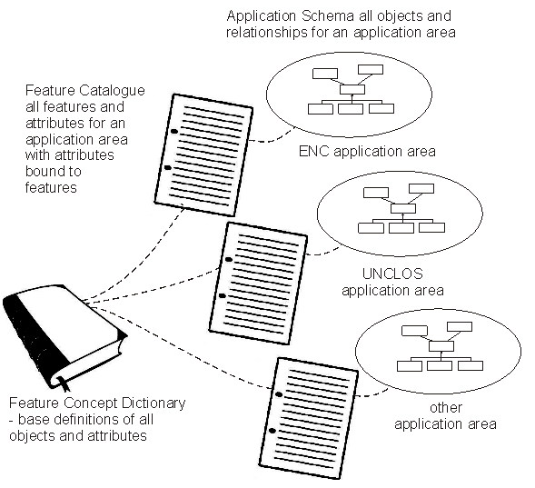

Figure D1 – Application Schema, Feature Catalogues and Concept Dictionary

The Feature Concept Dictionary needs to contain the generic definition of all feature objects, attributes and applicable code lists and enumerations; however, it also needs to carry a description of the context in which the definition(s) are applicable. This is what happens in current language dictionaries where the words with multiple meanings or subtle variations on meaning are defined in their various contexts.

* 1. The Architectural Structure to Manage Context

The definition of context adds structure to the general feature model. The IHO S-100 Universal Hydrographic Data Model builds upon this ISO General Feature Model and adds several new concepts such as an S100_GF_NameType class an Information Type Object (S100_GF_InformationType). S-100 also deliberately constrains the representational geometry to a few geometry types. This was introduced into the S-100 model to support eNavigation applications. To support other contexts such as legal attributes additional constructs need to be defined.

Figure D1 shows three separate application areas each with their own Feature Catalogues, and Application Schema.

The current S-57 (and S-101) Feature Catalogue is a one application area specific feature catalogue. Other feature catalogues for other application areas may select the same feature types from the Feature Concept Dictionary, but bind different attributes to the feature types. For example rights, restrictions and responsibility and versioning attributes may be applied in the Marine Cadaster or Marine Limits and Boundaries context but not in the ENC context. A Product Specification may also refine the definition of the feature for the specific application domain context. The issue of context specific meanings needs to be identified in the Feature Catalogue. Since context affects the meaning of most features, one cannot simply add new feature definitions to the concept dictionary where a context specific interpretation is needed. The dictionary definition needs to be general enough to allow the various context specific interpretations, and the feature catalogue(s) need to narrow the meaning to a specific context. The Feature Concept Dictionary needs to allow for the interpretation of concepts in different contexts.

Figure D5 shows a Feature Concept Dictionary with three types of entries, a Feature Type, an Attribute Type and a Code List / Enumeration. A Code List / Enumeration is a set of listed values that may be used in an attribute.

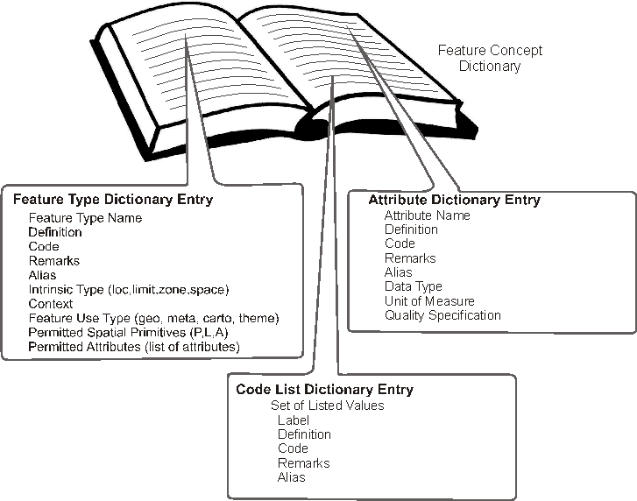

Figure D5 – Feature Concept Dictionary Contents

UNCLOS is an important but very specific context. It builds upon S121 Maritime Limits and Boundaries, but it may also build in part upon some aspects of a Marine Cadastre, Marine Protected Areas and fishery information. Maritime Limits and Boundaries, Marine Protected Areas, fisheries, UNCLOS and Marine Cadastre are all separate but overlapping themes within a legal context.

The Feature Concept Dictionary elements to be defined for S121 are shown in Figure D6.

The contexts in which a feature may be applied may optionally be described in the Feature Concept Dictionary. The Feature Catalogue associated with an Application Schema may define the context in more detail.

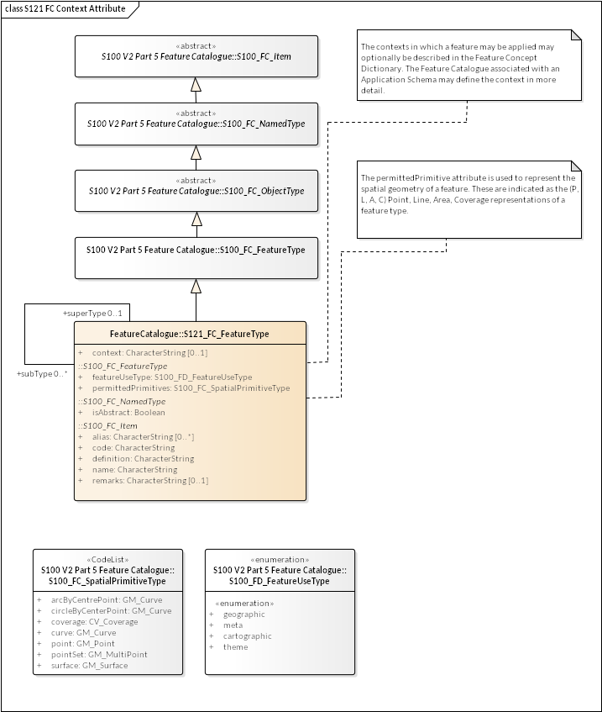

Figure D6 – S121 Feature Concept Dictionary Entries with Context

* 1. Attribution

**The** attribution **for nautical charts is based on the long history of nautical charting. However, as new products develop new features and attributes will need to be defined. Some of the identified products are coverage data such as bathymetry. In coverage data, the grid (or other coverage function) is a value matrix and is the attribute of the data. However for vector type coverages such as S121 Maritime Limits and Boundaries, S-122 Marine Protected Areas, Marine Cadastre and other Product Specifications, great care is needed to define the appropriate features and attributes. Introducing legal attributes is important for these products, but legal attributes need to be rigorously defined. A good approach is to make use of the attributional model in the Land Domain Administrative Model established in the standard ISO 19152. This also supports a Marine Cadastre.**

**The S121 Product Specification is based on S-100 and uses the same general feature model, attribute structure and spatial schema as is used in S-100. S121 defined features and their direct attributes can be used in other S-100 based products and will work directly. However, in S121 a number of information objects have been defined. These objects carry thematic attributes (as permitted in the S-100 General Feature Model). These objects act as attributes by reference to the S121 Features; that is, they define a structure for the legal attributes and sources that is referenced by the S121 Features. In short, the use of information objects to describe the legal attributes and sources avoids the need to define attributes on attributes.**

A Marine Limits and Boundaries is built upon the ISO 19152 Land Domain Administration Model. Although the title of the ISO standard says “Land” the scope statement of the ISO standard includes water.

The method by which the Rights, Restrictions and Responsibility structure from ISO 19152 is integrated into S121 is described in Appendix E.

1. Managing Legal Rights

(Normative)

* 1. Overview

The suite of standards developed to support electronic marine navigation (eNavigation) is a consistent information context. However, the S-100 Universal Hydrographic Model also allows for the representation of other aspects of the marine environment. These other types of data may be compatible with the eNavigation information, but there are some fundamental differences. Marine resources maps, fisheries maps, a marine cadaster, political and jurisdictional maps and marine limits and boundaries include concepts of rights, ownership, and legal aspects. The theme behind some of these additional types of marine data is legal rights. These types of marine data need to incorporate and accurately depict the concepts of rights, restrictions and responsibilities. Experience in this area does not derive from marine navigation but it largely is based on the methods by which these legal rights issues are addressed in terrestrial mapping. However, there is still an important marine component that can be quite different than land mapping.

This appendix describes the model for managing legal rights within the context of S-100. The high level conceptual model is based on the General Feature Model defined in ISO 19109 and on the conceptual model defined in IHO S-100. The model is similar to that defined for any S-100 compliant feature based data model. The major distinguishing characteristic is the introduction of the Rights, Restrictions, Responsibilities and Parties structure derived from ISO 19152.

The conceptual model for managing legal rights is described in this appendix to S121 so that it may be cited in other IHO standards that need to manage legal rights. To distinguish the classes from those defined in S-100, class names begin with "S121" followed by the name of the class.

* 1. Conceptual Model

The Land Administrative Domain Model (LADM) standardized in ISO standard 19152 establishes a rigorous mechanism for handling legal Rights, Responsibilities and Restrictions (RRR) for individuals, groups or other parties. This mechanism can be used in the IHO standard S121 Marine Limits and Boundaries and in other marine application areas such as a Marine Cadaster. The title of the ISO standard says “Land Administrative Domain Model“ but the scope says "“including those over water and land, and elements above and below the surface of the earth”[6].

This appendix outlines how Maritime Limits and Boundaries and other marine application areas can be handled in alignment with the RRR and Party structures inherited from ISO 19152. The goal of the Universal Hydrographic Model defined in S-100 is to cover all aspects of hydrographic and marine information. In the land domain there are also new structures being standardized, in ISO and other forums, to address areas such as land cadaster, road networks, land cover, etc. Integrating other information domains for the marine environment that include legal, economic and management aspects related to the ocean can build upon this work in ISO. The work is being done in parallel, so that new capabilities introduced in one area can be reused in another increasing the level of interoperability.

It is very important for associated legal attributes to be used together with Maritime Limit and Boundary (MLB) information so that one can determine under whose authority, or international treaty a particular limit or boundary is defined. Similar processes of defining MLBs exist in many countries; however, they are not exactly the same so that there may be differences in how information is defined in various jurisdictions. The IHO standard S121 on Maritime Limits and Boundaries must be general enough to satisfy the requirements of all nations since boundary information involves more than one state actor. Accurate calculation and representation of the resultant boundaries and original legal sources are of great importance. There can be significant legal and political implications resulting from errors.

Maritime Limits and Boundaries information may be used in many different ways. Additional information may also be required in legal or political disputes to justify the representation of a particular maritime boundary line.

One aspect of wide reaching importance is the definition of the coast which is often used as part of the boundary of a maritime area. The oceans are constantly in motion due to tides, weather and seasonal variations. The level of rivers can change even more due to seasonal variations such as spring flooding. For this reason sea level is based on an average, and there are many different way to calculate this average.

Because there may be several different state actors involved with different technological approaches and levels of sophistication in their system implementations, the management of legal rights needs to be very flexible. This Appendix describes the structure upon which Product Specifications such as Marine Limits and Boundaries, Marine Cadastre, MSDI, etc. will be based, since all information found within the extensions depends upon the legal and administrative entities described here.

* 1. Features and Attributes in S121

The ISO suite of geographic information standards and the derivative IHO S-100 Universal Hydrographic Data Model are built upon an object structure. A real world feature is an object that has properties. These properties are represented as attributes and associations. The attributes are of two types, Spatial Attributes describing its geometric representation, and Thematic Attributes describing its nature. There may also be constraints placed upon an attribute or association. The IHO S-100 has added to the ISO General Feature Model the concept of Named Types, to allow for Feature Types and also Information Types.

A feature has existence in the real world. A particular feature instance could be a buoy or a segment of coast line. Limits and Boundaries are also features with existence in the real world.

An information object is an object with no real geographic spatial position. In a navigational chart it may be something like a note that can appear on a chart. Information objects can have thematic attributes and so they can be used to implement the Administrative Objects defined to describe Rights, Restrictions and Responsibilities and Parties derived from the ISO 19152.

Figure E1 Shows a Feature Object and its Associated Attributes taken from the IHO S-100 standard.

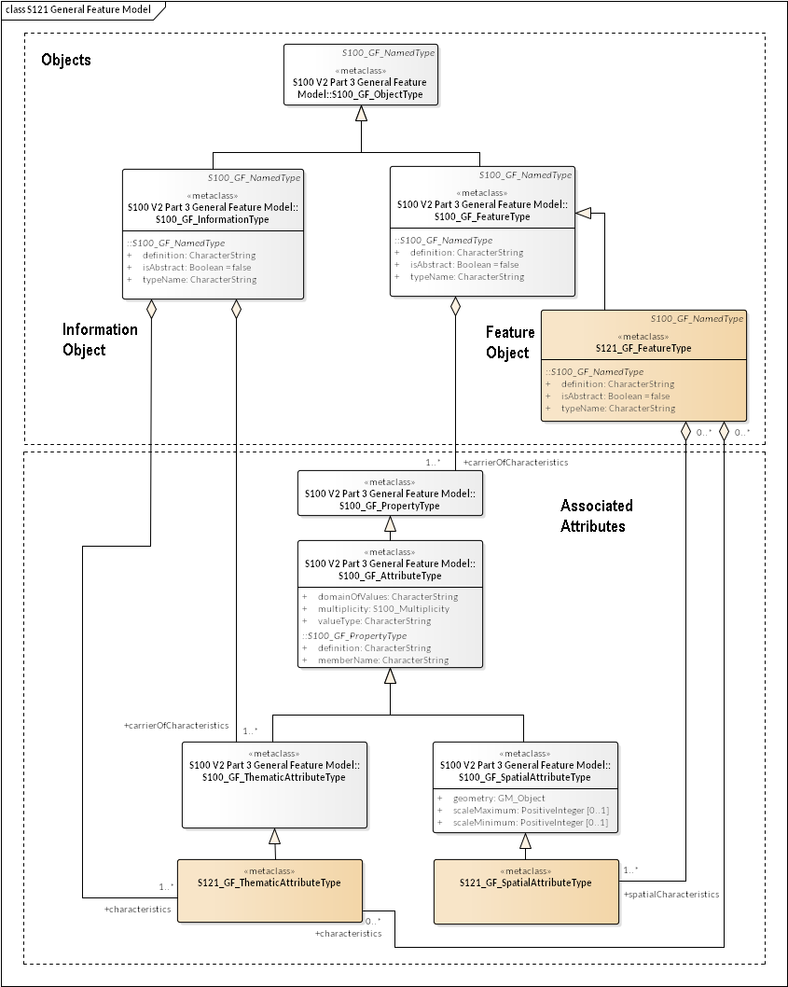

Figure E1 – General Feature Model with Legal Attribute Specialized Classes

The General Feature Model is a metamodel; that is, it is a template upon which actual Application Schema are defined. Every data set has an Application Schema that defines the allowable objects and attributes and the allowed relationships for that particular type of data set. There is a hierarchy of models ranging from the abstract metamodel template to the specific application schema and to the specific set of instance data corresponding to a particular instance of a data set. S121 defines two new classes at General Feature Model (template metamodel) level. It specializes S100_GF_FeatureType and S100_GF_ThematicAttributeType in order to add relationships to the Administrative Structure (Rights, Restrictions and Responsibilities, and Basic Administrative Unit), which is inherited from the ISO 19152 standard.

The feature type object takes its definition from the S-100 object S100_FC_FeatureType. All of the inherited attributes are shown in the S121_FC_FeatureType object together with the associated code lists.

An important restriction is that S-100 limits the types of spatial primitives that may be used to represent the object to GM_Point, GM_MultiPoint, GM_Curve, GM_Surface, CV_Coverage, GM_Curve (arcByCentrePoint and circleByCentrePoint). This is a simplification from the more extensive set of primitives available in ISO 19107 Spatial Schema upon which both the ISO 19152 LADM and the IHO S-100 is based. This subset makes the implementation of systems such as an ECDIS system easier by limiting the types that need to be implemented. This restriction is important in S-100 because navigations systems must be testable to ensure safety. For compatibility this same restriction carries through to other marine application areas such as a Maritime Limits and Boundaries and a Marine Cadaster.

* 1. Administrative Structure from ISO

Attributes provide detail that establish context for a feature. S-100 defines two types of attributes that may be associated with a feature. These are spatial attributes and thematic attributes. The spatial attribute references GM_Object from ISO 19107 for the geometry, but the types of geometry are limited by the Spatial Primitive Types defined in S-100.

Thematic attributes have their definitions recorded in the Feature Concept Dictionary and Feature Catalogue. The elements recorded in the Feature Catalogue are shown in Figure E2.

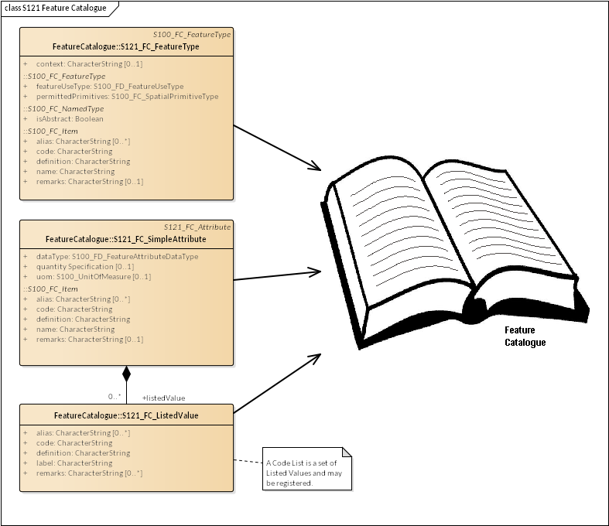

Figure E2 – Objects Recorded in the Feature Catalogue

There are two types of attributes, simple attributes and complex attributes. Both have a name, definition and code. In addition a simple attribute has a data type and optionally a unit of measure and quality. A simple attribute may have a set of listed values, which are also defined in the Feature Catalogue. A complex attribute has a set of bindings that link attributes and listed values. This structure derives directly from S-100 and is illustrated in Figure E3. This structure allows the recording of attributes and code lists / enumerations (sets of listed values) in the Feature Concept Dictionary and in the Feature Catalogue.

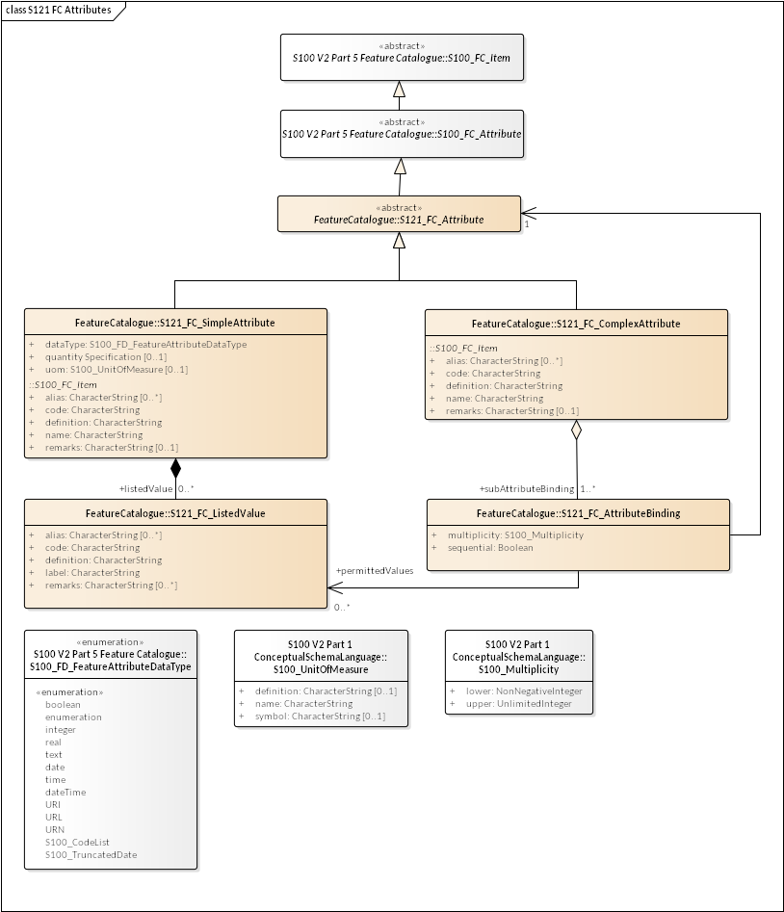

Figure E3 – Feature Catalogue Attributes

For the establishment of the Electronic Nautical Chart (ENC) data product and for specific other data products, the definition of attributes has been guided by a wealth of experience in creating paper navigational charts, and scientific experience in bathymetry, currents, tides etc. However, when one broadens the scope to more general objects which IHO intends to cover, such as Marine Limits and Boundaries, Cadaster, resource management and general spatial data infrastructure, the definition of attributes becomes more involved. There are many ways to describe the same conditions and some consistency is required. This is especially true of attributes that involve legal rights where consistency is very important.

Experience in this area comes from land administration, and this experience has been documented in the Land Domain Administrative Model (LADM) standardized in ISO. The standard ISO 19152:2012 Geographic information -- Land Administration Domain Model (LADM) “defines a reference Land Administration Domain Model (LADM) covering basic information-related components of land administration (including those over water and land, and elements above and below the surface of the earth)”. The LADM “provides an abstract, conceptual model with four packages related to parties (people and organizations); basic administrative units, rights, responsibilities, and restrictions (ownership rights); spatial units (parcels, and the legal space of buildings and utility networks); spatial sources (surveying), and spatial representations (geometry and topology)”.

Whereas hydrographic information, and MLB information in particular has its own spatial units, spatial sources and spatial representations derived from IHO S-100, there is a need for consistency that the LADM parties (people and organizations) and basic administrative units, rights, responsibilities, and restrictions provide. Since the LADM and IHO S-100 are both built on the ISO TC211 suite of Geographic Information standards, these elements are compatible and can be inherited into IHO.

Figure E4 illustrates the Domain Administrative Area Classes defined in the LADM. The basic administrative units (LA_BAUnit) are the basic elements of the legal attribute structure. They relate to features and attributes (LA_SpatialUnit), which may be defined in several ways. The explicit geometry used is S-100 is compatible. Rights, restrictions and/or responsibilities (LA_RRR) relate parties (LA_Party) to the basic administrative units (LA_BAUnit). The ISO Domain Administrative Model standard uses the same types (LA_BAUnit) and spatial geometry (LA_SpatialUnit) as all of the other ISO standards, but it adds the rights, restrictions and responsibilities related to parties or groups of parties. The LA_SpatialUnit corresponds to a feature in the ISO 19109 General Feature Model and the LA_BAUnit is a collection object that allows the expression of the relationships between the Rights, Restrictions, Responsibilities and Parties to the features.

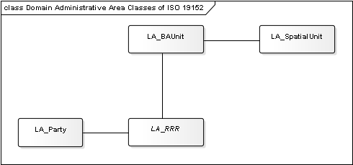

Figure E4 – Domain Administrative Classes

ISO 19152 also provides the capability to version objects. This Versioned Object structure is extremely valuable in the MLB application area (and in other application areas such as Marine Cadastre). In the area of nautical charts, both paper charts and ENCs, the whole chart or data set is versioned. This is an appropriate approach for this type of data product; however, for Marine Limits and Boundaries and for Marine Cadastre it is necessary to be able to manage the version of features and attributes at the individual object level. For example, the rights to a fishing zone may change without altering anything else. Individual versioning of objects allows changes to be managed at a fine level. Versioning at the object level is also appropriate in a Marine Spatial Data Infrastructure (MSDI).

* + 1. Basic Administrative Unit Package

The Basic Administrative Unit as defined for S121 is derived from the class LA_BAUnit defined in ISO 19152. The BA Unit is a collection object to “which (one or more) unique and homogeneous rights, responsibilities or restrictions are associated”. This class does not take on spatial attributes itself, but is related to the S121_FeatureUnit, which corresponds to a feature and may take on spatial attributes. S121_BAUnit is a realization of the class S121_ThematicAttributeType. For example a collection of features represented by several S121_FeatureUnit objects may have a relationship to the same set or rights, restrictions and/or responsibilities and parties. It “carries the characteristics” expressed by the administrative structure and relates it to the feature. The S121_BAUnit object also inherits from ISO 19152 VersionedObject. This allows the definition begin and end lifespans for an object and also provides optional quality and source references. This is illustrated in Figure E5.

Realization relationships are used to prevent double inheritance. The relationship between LA_BAUnit and S121_BAUnit is a “realize” relationship because only some of the attributes are inherited. One attribute *type* is overwritten with a different code list that is appropriate for a marine environment since the list from ISO 19152 is land oriented. Attribute values such as basicPropertyUnit and leasedUnit are only needed in a land cadaster.

The relationship between S121_GF_ThematicAttributeType and S121_BAUnit is also a “realize” relationship. Since S121_GF_ThematicAttributeType is a metaclass only some of the attributes are required. The *definition*, *valueType, domainOfValues* and *multiplicity* attributes are recorded in the Feature Concept Dictionary and are not required as part of S121_BAUnit. The *memberName* attribute is inherited and is renamed as *name*.

The primary source for the model is IHO S-100. This provides direct compatibility with other IHO product specifications. The inheritance from ISO 19152 allows for compatibility with Land Cadastre and land based limits and boundaries. Those structures and attributes from the Land Administrative Domain Model that do not apply to a marine environment are not inherited.

The attribute uID is used in relationships between instances of the S121_BAUnit and Rights, Restrictions and/or Responsibilities (LA_RRR) and parties (LA_Party) information objects.

The attribute *type* makes use of the code list S121_BAUnitType. This code list includes types of administrative units.

The attribute *name* is realized from LA_BAUnit. It establishes name for an instance of a BAUnit.

The attribute *context* allows the context for an instance of a BAUnit to be described. This would include other information that would be included with a logical administrative unit in a legal document.

Both the attribute *name* and *context* support multilingual character strings in accordance with the ISO TC211 PT_Locale structure.

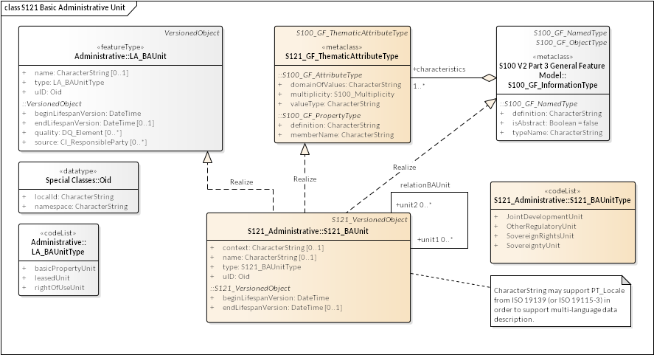

Figure E5 – S121 Basic Administrative Unit Inheritance

* + 1. Feature Unit

The Feature Unit as defined for is a realization of the class S121_FeatureType and as such the definition of the feature type can be included in the Feature Concept Dictionary. For example the feature type “Territorial Sea”, which would be used in a Maritime Limits and Boundaries Product Specification (S121), would have a registered definition in the Feature Concept Dictionary. This feature type would also be able to take on the rights, responsibilities and restrictions and party administrative attributes through a relation to S121_BAUnit.

The name of the feature is defined in the attribute *typeName*. The *definition*, and *isAbstract* of the feature are recorded in the Feature Concept Dictionary so do not need to be included in attributes.

The attribute *fuID* is the feature unit identifier that is referenced by the other elements of the administrative attribute structure.

The attribute *type* describes the type of the feature: Marine Limit and Boundary (MLS) or A76 from UNCLOS.

The attribute *label* provides a short textual description of the feature unit.

The attribute *context* describes the legal or administrative aspects of the feature object.

The attribute *releasability* is used to differentiate between "official", "development", "internal use" or "in construction" status for particular features. This may be a code list in the future. The Feature Unit may be associated with one or more S121_SpatialAttributeTypes; that is, the geometry may be shared. This is the same shared geometry construct as established for all feature types defined using IHO S-100.

ISO 19152 allows spatial units to be organized into groups or layers. Since this capability of grouping already exists in S-100 it is not necessary to inherit a duplicate structure from ISO 19152.

Figure E6 shows the inheritance relationship for S121_FeatureUnit. Note that S121_FeatureUnit is also a versioned object.

There are two constraints on the relation from S121_FeatureUnit to S121_SpatialAttributeType. The multiplicity constraint states that only one Spatial AttributeType version may be associated with one FeatureUnit instance at one time. The type constraint states that all Spatial Attribute Types associated with a FeatureUnit shall be of the same geometric type Point, Curve or Surface. Versioning allows the Spatial Attribute instance to be changed, but not its type.

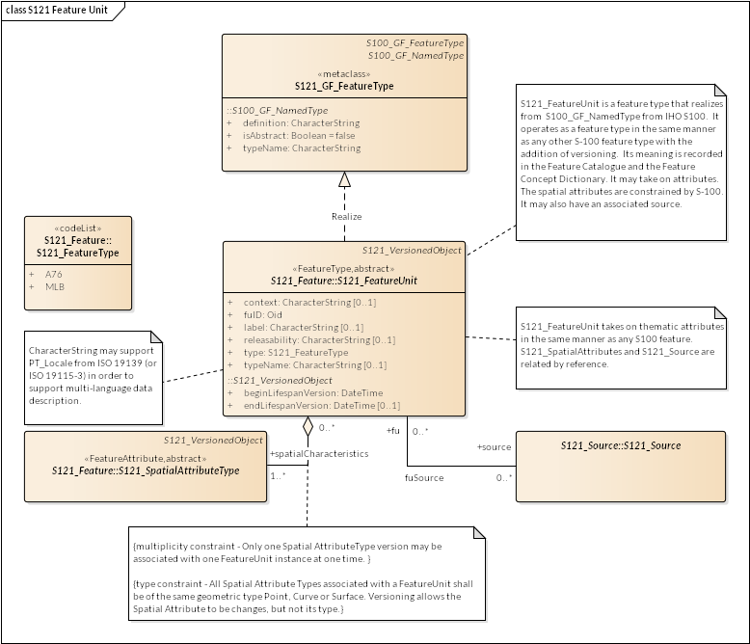

Figure E6 – S121 Feature Unit

* + 1. Spatial Attribute

The S121_SpatialAttributeType describes the spatial properties of an S121_FeatureUnit. It inherits from S121_GF_SpatialAttributeType and from the S100 geometry model. This means that the geometry types inherited from S-100 apply. Only the geometry types GM_Point, GM_MultiPoint, GM_Curve, GM_Surface, CV_Coverage, GM_Curve (arcByCentrePoint and circleByCentrePoint) may be used.

The ISO 19152 class LA_SpatialAttributeType makes use of the ISO spatial primitives GM_MuliCurve and GM_MultiSurface. IHO does not use the GM_Multi primitives except for GM_MultiPoint (for soundings). S-100 does support GM_Curve and GM_Surface, therefore the S121_SpatialAttributeType class supports these primitives. The composition is handled at the feature level through S121_FeatureUnit.

Figure E7 shows the inheritance relationship for S121_SpatialAttributeType. S121_SpatialAttributeType implements the metaclass S121_GF_SpatialAttributeType through a Realize relation. That is the attributes of the metaclass allow one to construct S121_SpatialAttributeType. Note that S121_SpatialAttributeType is also a versioned object.

The attribute *saID* is the spatial attribute identifier that is referenced by the S121_FeatureUnit.

The attribute *locationByText* allows a spatial attribute to be a textual description. This allows locations, limits, zones or spaces that are not fully described geometrically to be included.

The attribute *label* provides a short textual description of the feature attribute type.

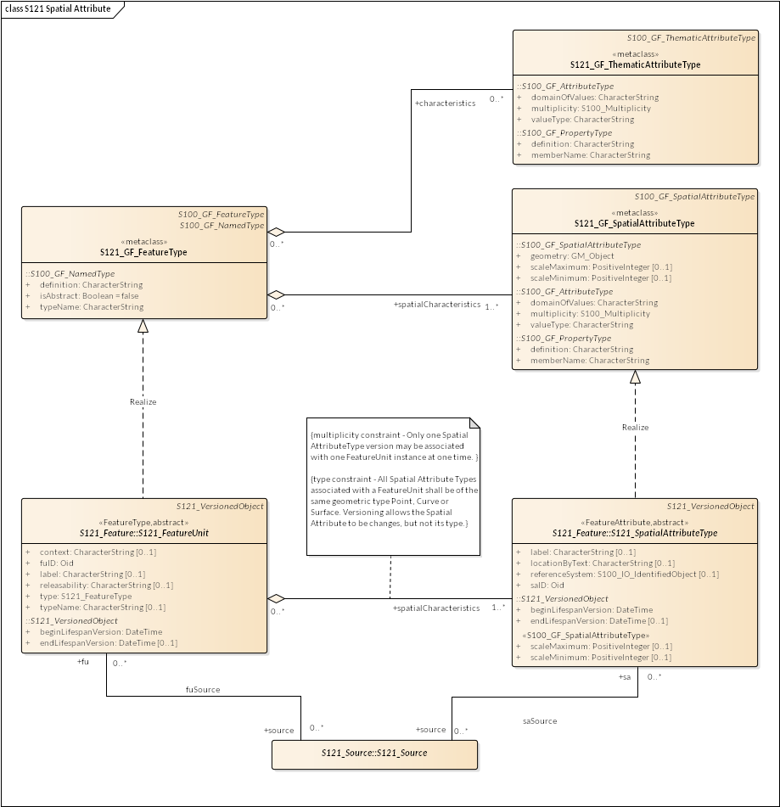

Figure E7 – S121 Spatial Attribute Type

The attribute *referenceSystem* allows a CoordinateReferencingSystem (CRS) to optionally be specified at the S121_SpatialAttributeType level. In many other S-100 based products the CRS is only defined at the metadata level and applies for the whole data set; however, in S121 it is necessary to detail it right down to the specific instances of geometry since treaty points and lines may come from different sources such as different treaties that may use different CRS. Figure E8 shows the S-100 classes used by the *referenceSystem* attribute.

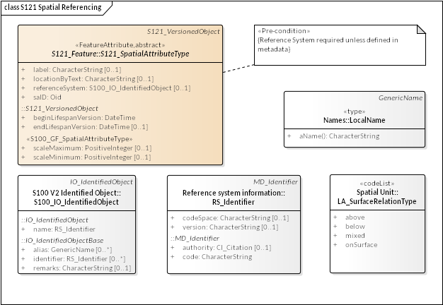

Figure E8 – S121 Reference System Attribute

Figure E9 shows an example of the use of the Multi-primitive GM_MultiSurface in a land cadaster environment. A farm land parcel object is crossed by a power line. In the land cadaster environment the farm would be one feature object that is defined by two surfaces using a GM_MultiSurface construct. In the marine environment there is a requirement from S-100 that each spatial primitive (except soundings) be a simple primitive. In this case one would generate two spatial attribute objects each with a single GM_Surface geometry. These two simple geometries would be combined into a complex with two parts. Both constructs are equivalent. In the marine environment the geometry is simpler whereas in the land cadaster environment the feature structure is simpler.

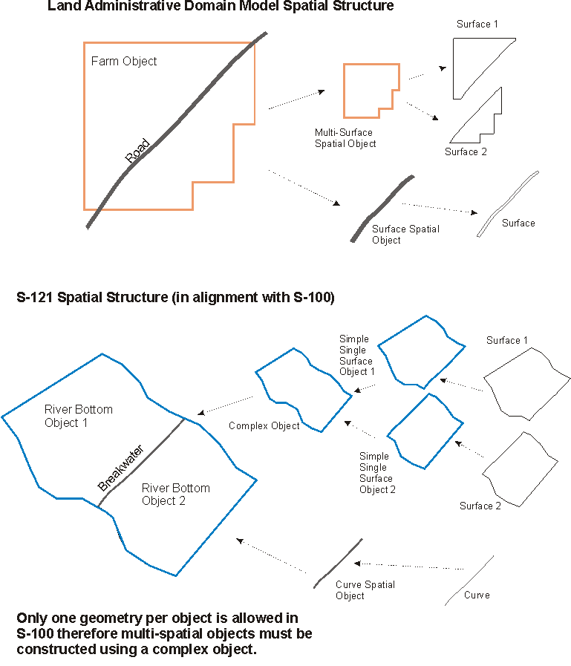

Figure E9 – Multi Element Spatial Structure

Since S-100 does not include any 3D spatial primitives support for space primitives must be constructed in the S121 and in a Marine Cadaster. This is done by defining 3D objects as 2D objects with a height description. This can be done through attribution defining the vertical position and height of the object. The domain of rights for some of the UNCLOS**[7]** feature objects has different vertical extents.

Figure E10 shows spatial geometry at the feature type level. The four feature types Location, Limit, Zone and Space have different relations to the ISO 19152 spatial elements. They also carry different primitives. The ISO 19152 LADM has a very different structure for its spatial geometry designed to support land cadaster. The spatial and feature elements are combined in single feature type objects. S-100 separates features types and spatial attribute types. Figure E10 shows the realization of attributes, some to S121_FeatureUnits and some to S121_SpatialAttributeTypes.

An important attribute is *locationByText*. This allows a spatial attribute to be described textually instead of geometrically. This situation occurs within treaties or other MLB authoritative documents and must be represented. Sometimes it is because a Location, Limit, Zone or Space is not known or sometimes it is because of legal or political reasons where there is no agreement and the use of coordinates may be prejudicial. If both special geometry and text are both provided then the geometry may be considered as an approximation and the text as descriptive.

*LocationByText* is necessary because it is often the case in treaties, laws or other administrative documents where some information, usually the defining points, are provided geometrically and other information, such as the description of some limits and zones is only provided textually. For example a Territorial Sea may be described as an area bounded by a Territorial Sea Outer Limit and the coastline and baseline. The only geometry provided may be the baseline points and coastline geometry. The Territorial Sea Outer Limit object may have a *locationByText* description saying that it is 12 miles seaward according to a calculation. No actual geometry may be given. From this amount of information one cannot draw the Territorial Sea Outer Limit object, but it is the information in the treaty and must be represented in the standard.

Optional feature to feature relations are provided between the Location, Limit, Zone and Space objects to allow objects such as the Territorial Sea to be associated with their defining Limits and Location points. Where fully described geometric relationships between geometric spatial attributes they take precedence over the feature to feature relations. The feature-to-feature relations are required where the geometry for spatial attributes is not fully described. Since administrative attributes such as Rights only apply to Zones and Spaces it is necessary to have a mechanism to relate a Zone or a Space to Limits and Location points when the geometric elements are not described.

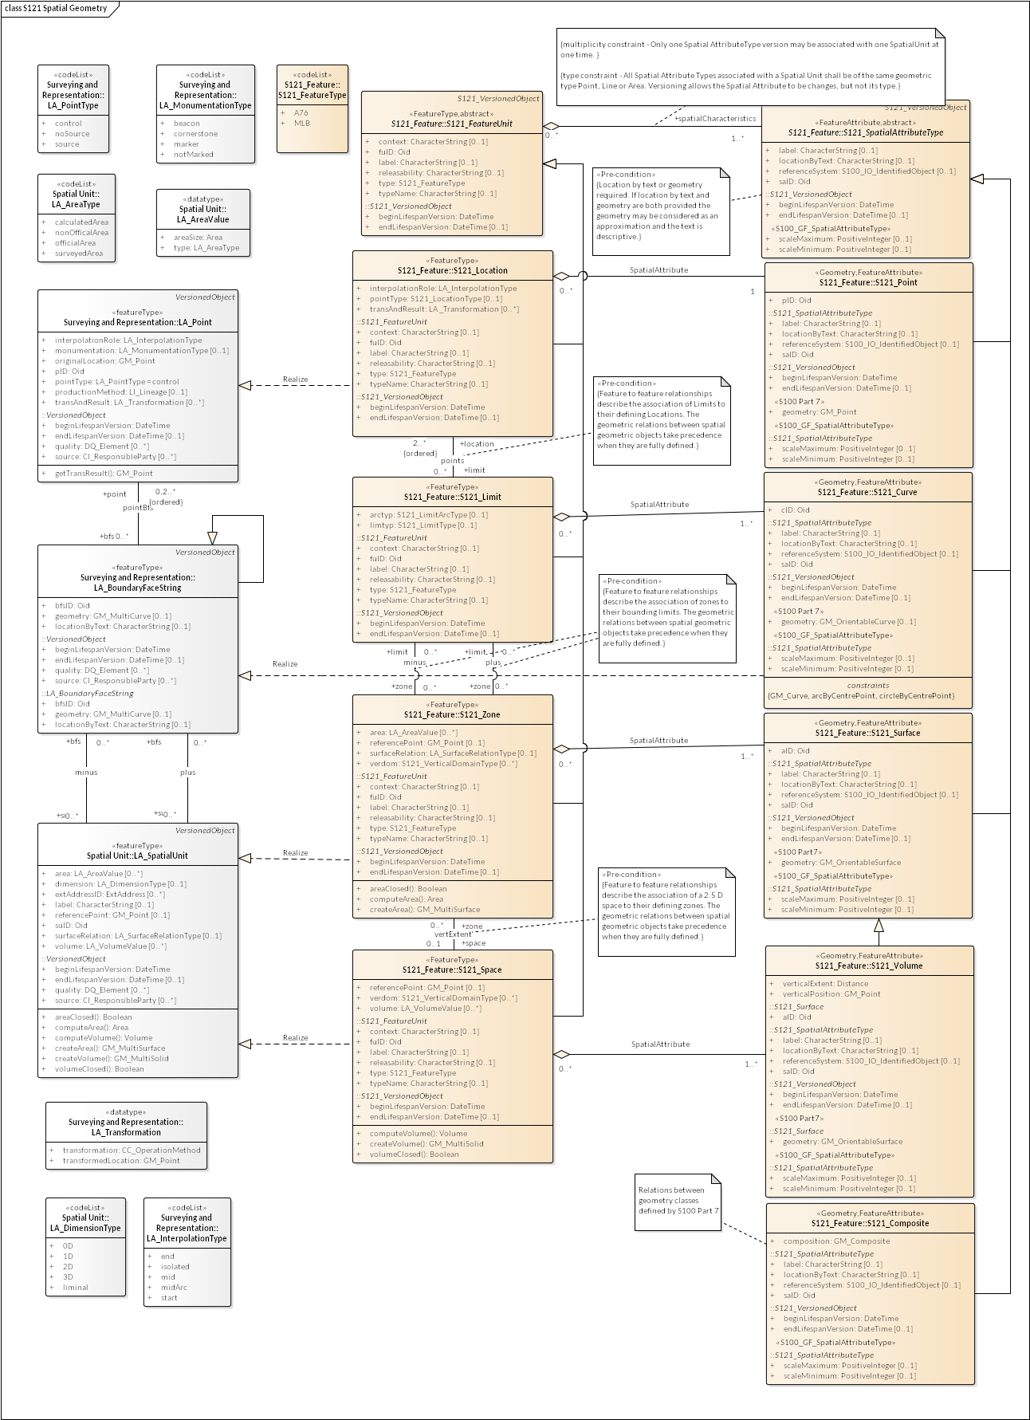

Figure E10 – Spatial Geometry

The Basic Administrative Unit (S121_BAUnit) relates to the S121_FeatureUnit to provide administrative attributes of Rights, Restrictions or Responsibilities. These are attributes by reference of the FeatureUnit through the S121_BAUnit and S121_RRR information objects. As indicated in Appendix D, only Zones or Spaces can carry Rights, Restrictions or Responsibilities. This is expressed as a constraint on the relation between S121_BAUnit and S121_FeatureUnit. It can also be shown as direct relations to the feature types Zone and Space. This is shown in Figure E11.

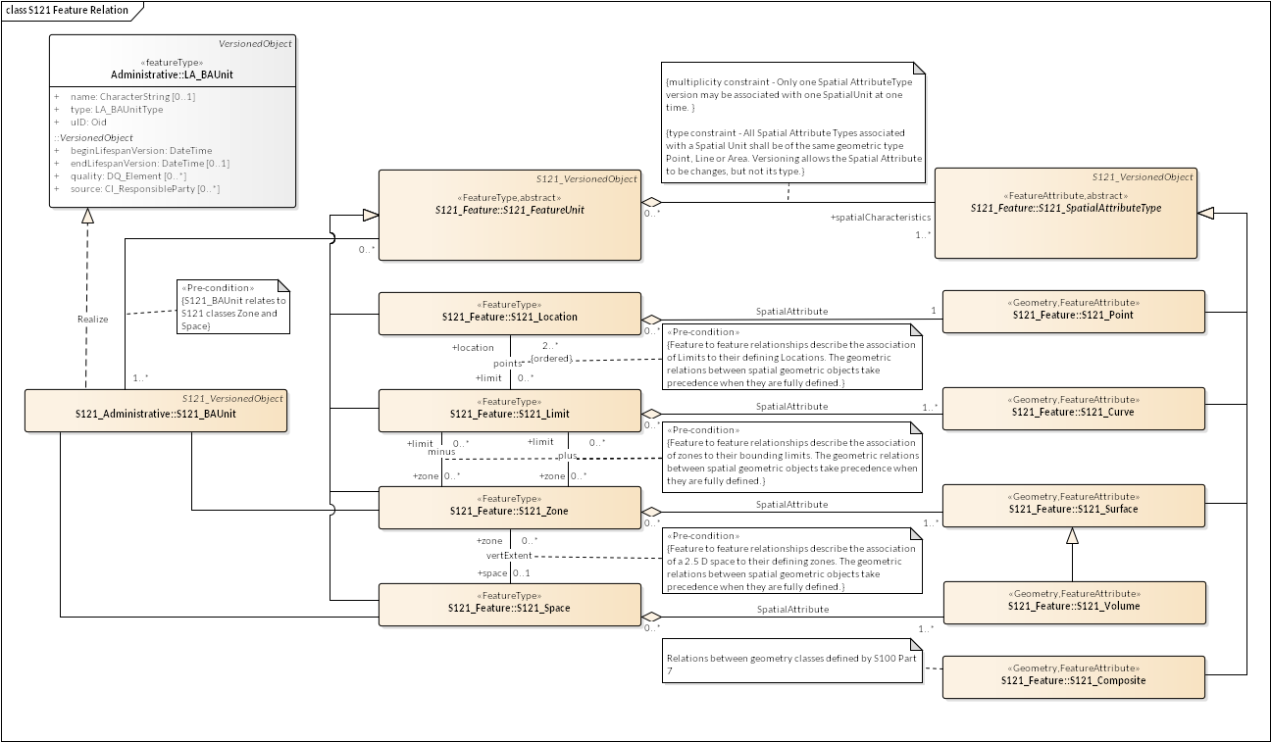

Figure E11 – Relation of Administrative Structure to Feature Unit

As illustrated in Figure E7 a source may optionally be defined for a feature and a spatial attribute. Source may also be defined for a Basic Administrative Unit, Rights, Restrictions and Responsibilities and Parties in the Administrative attribute structure. Figure E12 shows details of the S121_Source and its derivation from the ISO 19152 classes. There are two subtypes of source S121_SpatialSource and S121_AdministrativeSource. These are essentially the same except for the attribute *type* that identifies different code lists. The code lists are Maritime Limits and Boundaries specific.

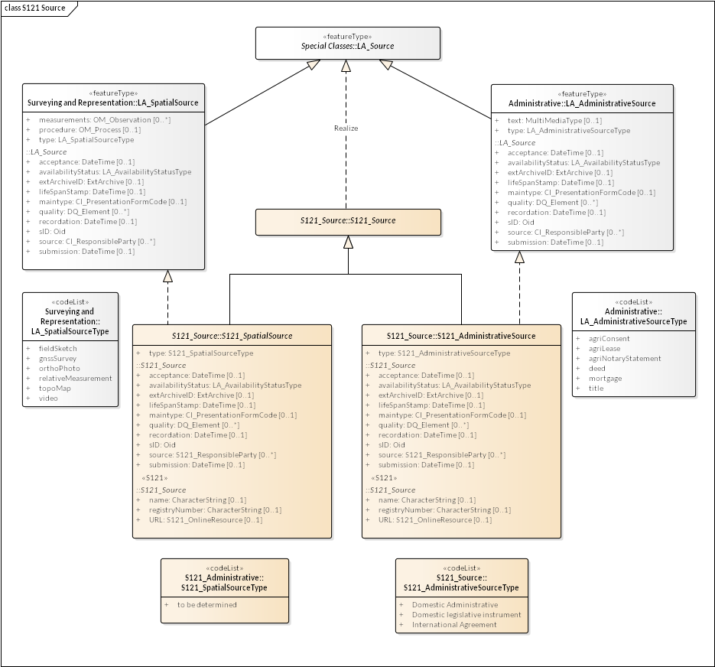

Figure E12 – Source

Figure E13 shows the S121_Source object with all of the associated code lists and associated support classes. A set of attributes, stereotyped S121, explicitly describe the information pertinent to source documents in a legal environment. These are:

* **name** – Document name - for example the document (legislation, treaty, title) that defines the object;
* **URL** – official URL (or equivalent online resource) where the document is distributed;
* **registryNumber** – Unique official identifier of the record in a registry. For example,  in states with registers of legislative instruments, versioning is controlled by the registry ID;

The ISO class LA_Source invokes a number of other ISO classes. These are:

* **DateTime** – a data type for recording clock time;
* **LA_AvabilityStatusType** – a code list identifying the status of a source archive;
* **EX_Archive** – metadata about an external archive;
* **CI_PresentationFormCode** – a code list identifying the mode in which the source data is represented;
* **DQ_Element** – a metadata class describing data quality of the source data;
* **DQ_EvaluationMethodTypeCode** – a code list of the method used to evaluate data quality;
* **DQ_Result** – results of the data quality evaluation;
* **CI_RoleCode** – a code list of information about the function performed by the responsible party for the source data;
* **CI_OnlineFunctionCode** – a code list of the online function performed by an online resource as part of a contact for a responsible party for a source;

In addition the ISO metadata class CI_ResponsibleParty has been realized in S121 to be S121_ResponsibleParty. This includes the classes S121_Contact, S121_OnlineResource and S121_Address that are realizations of the ISO classes CI_Contact, CI_Address and CI_OnlineResource. The attributes and inheritance of S121_Source are shown in Figure E13.

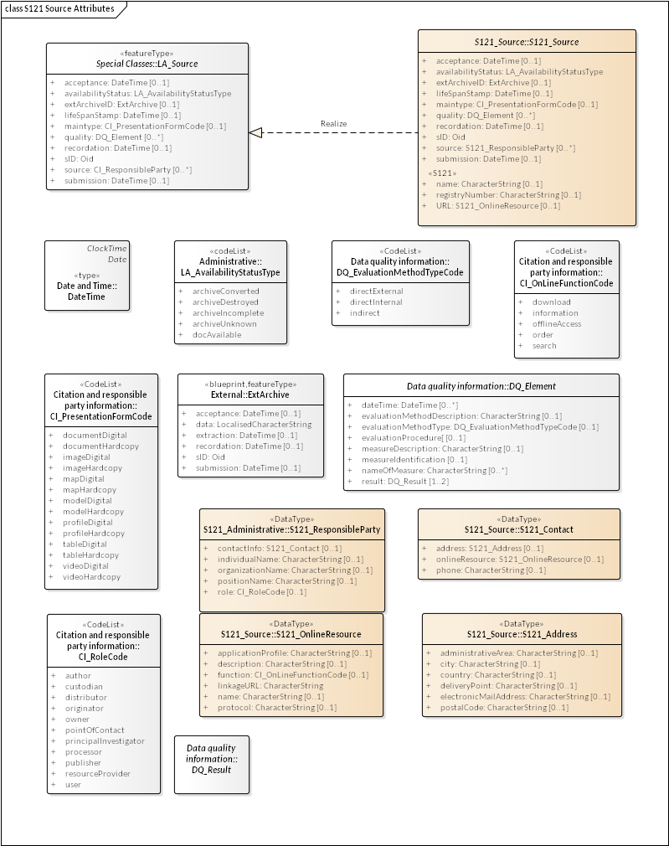

Figure E13 – S121_Source Attributes

* + 1. Party Unit Package

A party is “a person or organization that plays a role in rights[8]”. A Party is considered as an object. ISO 19152 has a Party model that allows for the establishment of groups as well as individual parties as individual objects. This is shown in Figure E14 which is based on the model in ISO 19152.

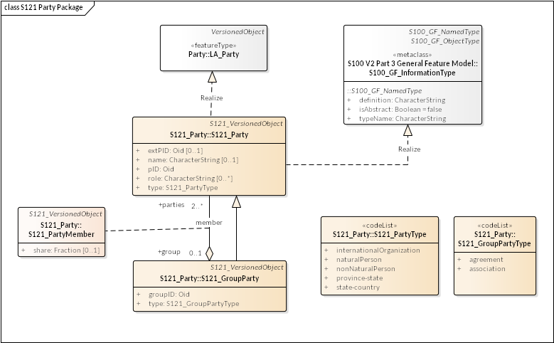

Figure E14 – S121 Party Package

ISO 19152 states that “The basic class [is] LA_Party (with party as an instance). LA_Party has a specialization: LA_GroupParty (with group party as an instance). Between LA_Party and LA_GroupParty there is an optional association class: LA_PartyMember (with party member as an instance). … A group party, being a specialization of party, is also a party.” This means that the aggregation relationship between S121_Party and S121_GroupParty in Figure E11 creates group parties with (registered) parties as constituents. An individual may be a member of a group, and a group as a whole can be treated as a party. "Every party, being a constituent of a group party, may then be registered as a party member of class LA_PartyMember[9]". This structure allows instances of individuals and groups to be uniquely identified. The S121_PartyMember class is effectively an optional attribute on the relationship of membership (members).

The relationship between Parties, Group Parties, Rights, Restrictions and Responsibilities and feature objects (S121_BAUnit) is by reference through the Oid (Object ID). pID is the identifier of the party and optionally exPID is an identifier of the party in an external registration.

The attributes type describes the S121_PartyType and the S121_GroupPartyType.

* + 1. RRR Administrative Package

ISO 19152 defines an administrative package that associates parties with BA_Units. Most of this package also applies to S121 (and also to Marine Cadaster and a Marine Spatial Data Infrastructure).

An aggregate class LA_RRR is defined in ISO 19152 that has three specializations.

1. LA_Right, with rights as instances. Rights are primarily in the legal domain. A cadastre may define ownership rights. ISO 19152 provides code lists to support ownership within a national legal structure.

2. LA_Responsibility, with responsibilities as instances.

3. LA_Restriction, with restrictions as instances. Restrictions usually apply to objects independent of the rights; that is, the related party can change and the restriction remains.

Rights, responsibilities and restrictions appear as attributes for an S121_BAUnit. These are subtypes of the collection class S121_RRR. In the S121 model these classes are realizations of the ISO 19152 RRR classes.

In the ISO 19152 Land Administration Domain Model there are code lists which assign type to the rights, responsibilities and restrictions classes. These are land oriented types. For the marine environment these code lists have been replaced with code lists specialized to the marine environment.

Note: These code lists are currently generic and the contents need to be defined as part of the S121 project development. Code lists are used, rather than character strings in order to ensure consistency. This is a requirement from ISO 19152.

Also classes particularly aimed at Land Cadastre applications (such as mortgage) have not been expressed in the model. Since this is a realization, any of the ISO classes could be introduced into the S121 (or Marine Cadaster) model if they are needed.

These objects are realizations of the S100_GF_InformationType. That is, they are object that may be referenced by other objects, but they do not carry spatial attributes. This is a preferable structure to introducing rights, responsibilities and restrictions as attributes of feature objects. Feature objects may point to the appropriate information objects using the Oid (Object ID) attribute. For example if a particular restriction applies to a fishing zone, then all features that invoke the restriction would point to the information object that establishes that restriction. If the restriction is changed it only needs to be changed once, not through the attributes in possibly hundreds of feature objects.

Figure E12 shows the S121 Administrative Rights, Responsibilities and Restrictions.

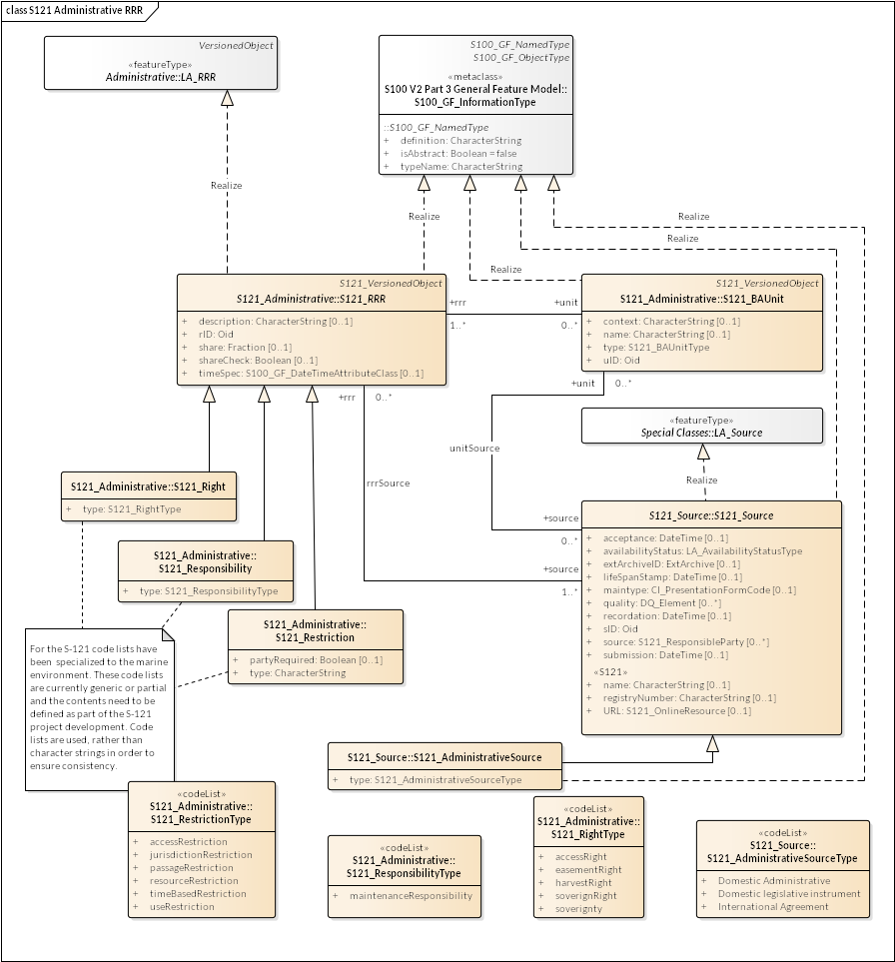

Figure E15 – S121 RRR Administrative Package

* + 1. RRR Structure

Figure E16 shows the combined structure of the attribute classes realized from the ISO 19152 LADM model. The Rights, Responsibilities and Restrictions provide guidance on how to define attributes that are included in the Feature Catalogue attributes as described in Figure E2. Each Right, Responsibility, and Restriction will be included in the Feature Catalogue as a separate simple or complex attribute.

The S121_Party and S121_GroupParty are non-spatial objects which are extensions beyond S-100. The S121 Party classes are not features and do not need to be included in the Feature Catalogue. Individual parties are identified by the attribute values of the party classes.

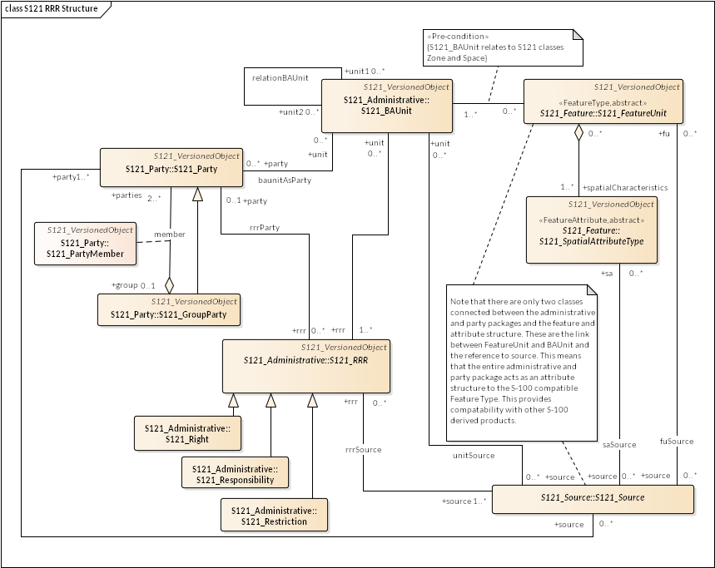

Figure E16 – S121 Party and RRR Structure

* + 1. Versioned Object

The versioned object capability in ISO 19152 LADM allows objects to include a set of versioning attributes. These attributes consist of begin and end dates. This object has been realized from ISO. The optional quality and source attributes are not inherited.

IHO S-100 allows for many feature types to be non-versioned. For example, features in an ENC would follow the S-101 Product Specification and would be non-versioned; however, whole ENC data product would be versioned. Versioned and non-versioned objects may be combined. A particular Product Specification would incorporate versioning by using the classes identified in Figure E17, which shows the S121 objects that inherit the versioning attributes.

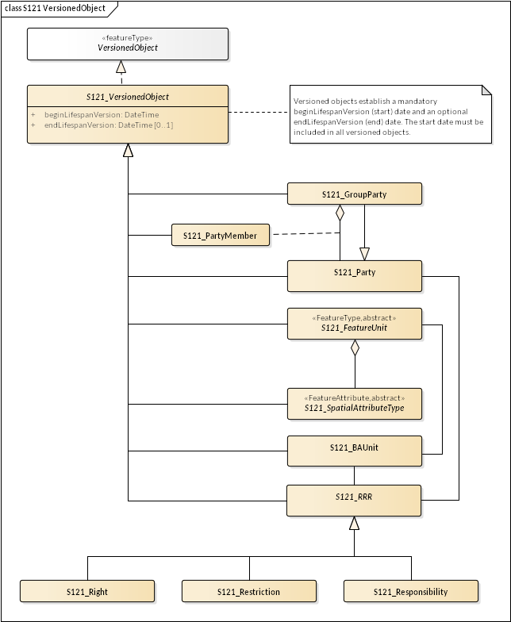

Figure E17 – Versioned Objects

* 1. Using the S121 RRR Structure

ISO 19152 is a conceptual model standard. It provides elements that can be used in other standards such as the IHO S-100 standard series to structure data so that communities of interest can communicate using a shared vocabulary. ISO 19152 reflects the social relationship regarding rights, restrictions and responsibilities to a geographic area. This allows legal rights to be expressed.

The implementation of the S121 Party Unit Package and the S121 Administrative Package is done through the use of information objects. These information objects correspond to the classes in the S121 Party Unit Package and the S121 RRR Administrative Package. Each has an object identifier (Oid) so that it can be referenced. This means that, for example, an S121_RRR versioned object can reference an S121_Party through a pointer implementing the *rrrParty* relationship (see Fig E16). The other relationships between Party and RRR objects are implemented as pointers between information objects are *members* relating an S121_Party to an S121_GroupParty, *rrrSource* relating an S121_RRR information Object to an S121_AdministrativeSource information object and *conveyancerSource* relating an S121_Party information Object to an S121_AdministrativeSource information object.

These elements are implemented as information objects for two reasons. First of all, the fact that Rights, Responsibilities and Restrictions are information objects allows for the multiplicity available in the ISO 19152 conceptual model. A Feature Type, represented as an S121_FeatureUnit can reference any number of Rights, Responsibilities and Restrictions or Parties through the S121_BAUnit. Also Rights, Responsibilities and Restrictions and Parties can be shared. The same right can apply to many objects. If a restriction changes, a new version of the S121_Restriction object can be generated and all of the objects that pointed to the old version of the restriction can be updated together.

Figure E18 presents a complete implementation model for the S121 structure. This is a simplification of the model shown in Figure E16 with relations navigable in one direction. This means that an implementation can use pointers in an exchange standard such as XML that allows repetition or simple single ended join tables in a database implementation. The direction of the pointers emanate from the Feature Type object ImplementationClass::S121_FeatureUnit to the feature spatial attributes and legal attribute structure. That is, the Feature Type object is the central object (as it is in S-100), and the legal administrative structure serves as an attribute structure. The administrative structure is more than a simple attribute but the reference is a simple reference that can be implemented in a simple attribute.

The object oriented structure of S-100 and the ISO 19152 standard allow for the integration of these two structures in a simple non-interfering manner. There are only logical connections between the Feature Type object (called S121_FeatureUnit) and the S121 Administrative structure derived from ISO 19152. This means that the whole administrative structure acts as a separate entity referenced by the feature object carrying spatial and other feature thematic attributes.

The integration of objects from S121 into another S-100 based product such as S-101 is very simple. The versioning needs to be resolved to a single instance in time (since S-101 and many other types of data are versioned at the data set level), and those attributes from the S121 administrative structure relevant in an S-101 environment need to be converted to thematic attributes of the feature. The Feature Type and spatial attributes should be directly usable. For example, if a producer wishes to include an EEZ boundary in an electronic chart, the feature object from the S121 data “Exclusive Economic Zone Limit” with its spatial attributes could be used directly or converted to whatever feature type name was appropriate in the S-101 context. The spatial attributes could also be used directly. The S121 feature would have a pointer to an S121_BAUnit object and then on to Right, Responsibility and Restriction and Party classes. Selected information from these classes, such as the sovereign right and country, could be converted into an attribute on the feature used in S-101. This gives us exactly what we have in S-101 at the present time. The S121 structure addresses the more rigorous legal environment and the eNavigation environment takes what it needs into the simpler S-101 environment.

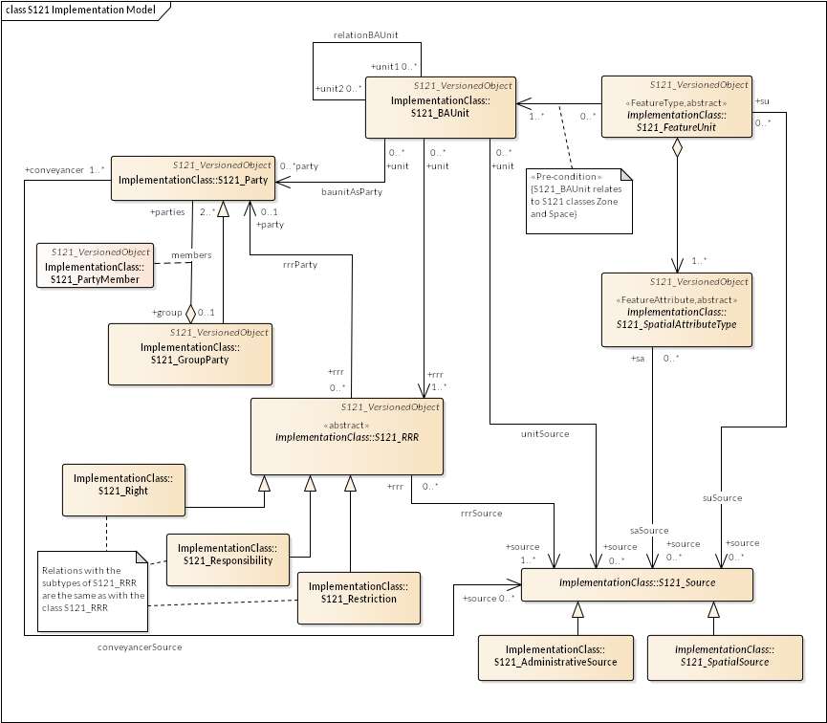Figure E18 – Full S121 Implementation Model

The implementation model shown in Figure E18 is simple. It contains only 10 instantiable classes and all relations are navigable and unidirectional meaning that they can be represented as pointers (or single ended join tables in a database). There are four groups of classes, the Feature/Attribute Group (inherited from S-100), the Source Group, the Administrative Group and the Party Group.

**Feature/Attribute Group** - The class “ImplementationClass:: S121_FeatureUnit” is a feature in the same way as any other feature in S-100, and it can take on both spatial attributes and other (non-legal) attributes in the same way as any S-100 feature. The class “ImplementationClass:: S121_SpatialAttributeType” is the same as any spatial attribute in S-100.

**Source Group** - The classes “ImplementationClass:: S121_Source and its two subtypes “ImplementationClass:: S121_SpatialSource” and “ImplementationClass:: S121_AdministrativeSource” are simple information objects that are only pointed to. They can be implemented as tables. The pointers are simple attributes in the classes that point to them. They take on attributes that describe source.

**Administrative Group –** The administrative group carry the legal attributes and the relations to parties. The class “ImplementationClass:: S121_BAUnit” is a table that is pointed to by the S-100 compatible Feature. That is, the pointer can be considered as a simple referenced attribute of the S-100 compatible feature object. This is the only link from the S-100 environment to the Legal Administrative environment (except for the simple attributes for version and source). The class “ImplementationClass:: S121_BAUnit” also points to the RRR objects “ImplementationClass:: S121_Right”, “ImplementationClass:: S121_Responsibility” and “ImplementationClass:: S121_Restriction”, “ImplementationClass:: S121_AdministrativeSource”, and “ImplementationClass:: S121_Party”. The pointer to “ImplementationClass:: S121_Party” is there for completeness to match the ISO model, but is seldom needed.

The classes “ImplementationClass:: S121_Right”, “ImplementationClass:: S121_Responsibility” and “ImplementationClass:: S121_Restriction” can also be implemented as simple tables with attributes. Each is the same and have two pointers, one to “ImplementationClass:: S121_AdministrativeSource” and another to “ImplementationClass:: S121_Party”.

**Party Group –** The class “ImplementationClass:: S121_Party” is also a simple table with attributes. Its relation is a more complex structure because a party can be a group of individuals rather than just a single individual (or state). For example the signatories to a treaty could in some cases be a group. This is represented by a second class called “ImplementationClass:: S121_GroupParty”. Since it is a subtype of class “ImplementationClass:: S121_Party” the pointer from “ImplementationClass:: S121_Right”, “ImplementationClass:: S121_Responsibility” and “ImplementationClass:: S121_Restriction” could also point to “ImplementationClass:: S121_GroupParty”. The class “ImplementationClass:: S121_GroupParty” simply points to “ImplementationClass:: S121_Party” with a second attribute (or set of attributes) from “ImplementationClass:: S121_PartyMember”. This could be implemented as a pointer to a table implementing class “ImplementationClass:: S121_PartyMember” or be inline attributes in “ImplementationClass:: S121_GroupParty”. S121_GroupParty is seldom used and may be omitted in most implementations.

Figure E19 illustrates a simple implementation that only uses Party and Right and Restriction. There is no relation established between the BAUnit and Party. The abstract class RRR is not shown, and the relations are direct between BAUnit and Right and Restriction. This is common case.

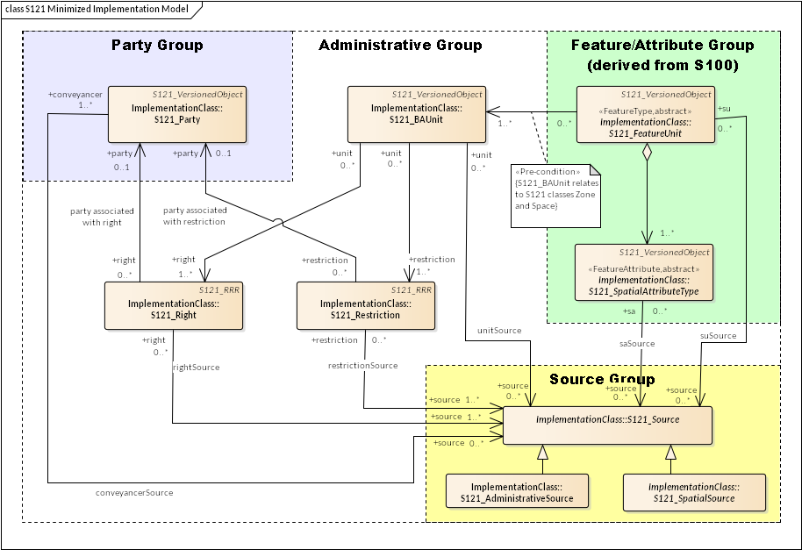Figure E19 – Minimized S121 Implementation Model

1. Information Model

(Normative)

* 1. Overview

The S121 information model is based on the General Feature Model defined in ISO 19109 and on the conceptual model defined in IHO S-100. At the high level the model is similar to that defined for any S-100 compliant feature based data model. The major distinguishing characteristics of the S121 model are the hierarchical structure for the classes of feature objects. These are defined in groups and subtyped to describe the particular location, limit and zone objects.

* 1. Feature Model

The S121 information model is defined as a single set of data objects organized into groups. Because of the possible legal nature of S121 data it is important that feature types be of a distinct and consistent geometry. One is not permitted to establish mix geometry types (Point, Line, Area) for a single object type. Any ambiguity of the meaning and definition of objects must be avoided to guarantee proper legal interpretation. Each object defined in the S121 Feature Model has a Location, Limit, Zone, or a Space. When used in a data set the object may be represented using a geometry type (Point, Curve/Line, Surface/Area). The allowable geometry types that may be used to represent an object are also recorded with the object (P,L,A). For a “Space” objects the geometric representation may be as a Surface/Area with an elevation attribute. These are the measure of the minimum elevation and the maximum elevation. That is, Space type objects are represented in what is known as 2 ½ dimensions. An example of a “Space” type object might be a marine protected area that extends from the bottom to 10 m from the bottom. Above that depth navigation is permitted.

* + 1. Generic Object Type

The conceptual model leads to the definition of four generic object types Location, Limit, Zone, or a Space. These carry a set of defining attributes. From these generic S121 object types and the defining attributes any S121 object may be defined. This provides great flexibility, and allows any required feature to be developed by specializing the generic objects. This approach is required because every nation will have different detailed requirements based on the treaties and laws that apply. Any specialized legal feature can be created in the Feature Catalogue associated with a national product specification. Nations will need to manage the use of specialized generic objects.

The generic objects also provide consistency for internationally standardized features. The defining attributes are shown in the model as optional with a constraint. The defining attributes are conditional. These attributes must be expressed in any MLB object that is created from the generic objects (since this is the only way that a system can know what the created object is). In the predefined objects the defining attributes must be included in the definition of the objects recorded in the Feature Concept Dictionary and Feature Catalogue in the Application Schema, but they need not be expressed in instances of the object.

Figure F1 shows the S121 Generic Feature Type object structure. The core object is an S121_FeatureUnit. This object inherits the attributes shared by all S121 objects inherited from the classes S121_GF_FeatureType, VersionedObject, and S100_GF_NamedType. The subtype S121_Location adds the defining attribute pointType and the subtype S121_Limit adds the attributes limtyp and arctyp.

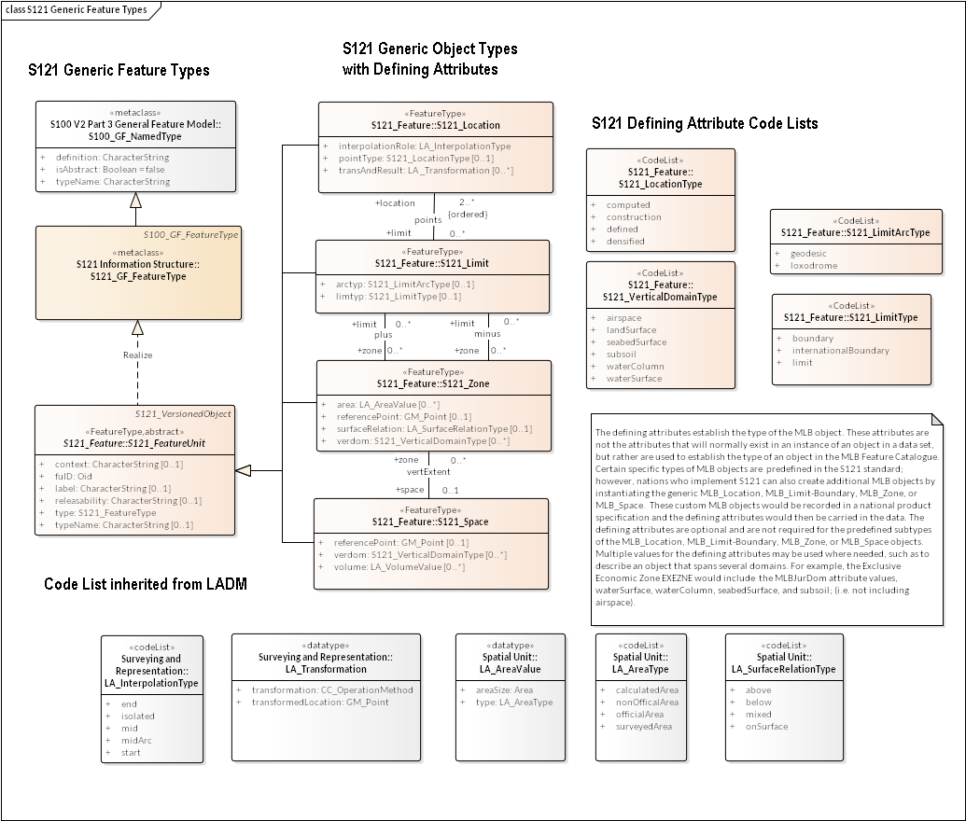

Figure F1 – S121 Generic Feature Types

* + 1. Feature Types

A set of predefined feature types have been established that include the normal objects required for Marine Limits and Boundaries. The stereotype <FeatureType> is used to identify the defining objects. The stereotype <MLB> (Maritime Limits and Boundaries) is used to identify the MLB Feature Types.

Figure F2 illustrates the relationship of the feature types to the defining objects. The realize relation is used because the feature types do not directly carry the defining attributes. The information contained in the defining attributes is included in the Feature Catalogue for each feature as applicable.

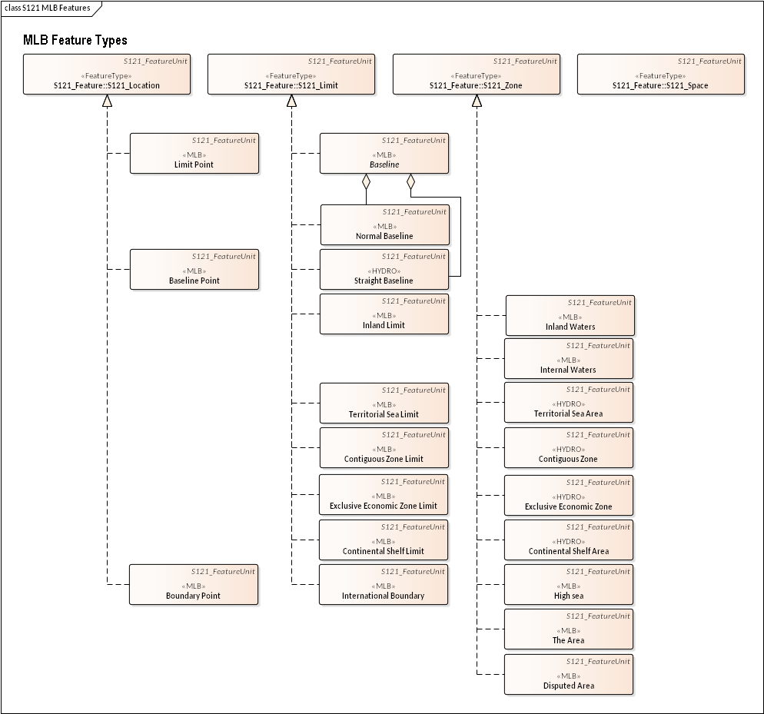

Figure F2 – MLB Features

The feature types are:

**Limit Point** - A limit point is point on a limit.

**Baseline Point** – A baseline point is part of the territorial sea baseline model or of an archipelagic baseline.

**Boundary Point** – A boundary point is point on a boundary (where a boundary is a limit shared by two zones).

**Baseline** – A baseline is the line from which the outer limits of the territorial sea and certain other outer limits are measured[10]. A baseline is generally composed of two components, a normal baseline and a straight baseline.

**Normal Baseline** – A normal baseline is part of the territorial sea baseline model. It is formed of the normal baseline points collected on low water elevations, drying rocks or on the coastline.

**Straight Baseline** – A baseline is the line from which the outer limits of the territorial sea and certain other outer limits are measured. Straight baselines are a system of straight lines joining specified or discrete points on the low-water line, usually known as straight baseline turning points[11]. Types of straight baseline are: archipelagic, bay closing, river mouth closing, historic bay closing or delta or dynamic coastal environment.

**Inland Limit** – Inland Limit is a segment of line used to delineate inland waters. It is a boundary between Internal Waters and Inland Waters.

**Territorial Sea Limit** – This object is used to express the outer limit of the State's territorial sea. (TESARE). TESLIM is used to express the outer extent of TESARE. TESARE is a zone that is bounded by the TESLIM (Territorial Sea limit), the baseline BASELN and or other limit objects such as an international boundary.

**Contiguous Zone Limit** –This object is used to express the outer limit of the contiguous zone (as describe in the convention of the Law of the Sea, Article 76.)

**Exclusive Economic Zone Limit** –The outer limit of the exclusive economic zone (as describe in the convention of the Law of the Sea, Article 76.)

**Continental Shelf Limit** – The outer limit of the State's Continental Shelf (as describe in the convention of the Law of the Sea, Article 76.)

**International Boundary** – International boundary is a boundary reflecting a treaty or other agreement between two or more sovereign states. Specific vertical domains can be assigned to this object to describe its role.

**Inland Waters** – An area describing waters found on the landward side of the Inland Waters limits.

**Internal Waters** – A zone describing waters on the landward side of the baseline of the territorial sea and landlocked waters within the State[12] - other than Inland Waters or Archipelagic Waters. (For legal definition see UNCLOS Article 8). It is a zone that is bounded by the inland water, the land area and the territorial sea.

**Territorial Sea Area** – The territorial sea is a belt of water of a defined breadth but not exceeding 12 nautical miles measured seaward from the territorial sea baseline[13]. The territorial sea area is a zone that is bounded by the TESLIM (Territorial Sea limit), the baseline BASELN and or other limit objects such as an international boundary.

**Contiguous Zone** – A zone contiguous to a coastal State's territorial sea, which may not extend beyond 24 nautical miles from the baselines from which the breadth of the territorial sea is measured. The coastal state may exercise certain control in this zone subject to the provisions of International Law[14]. A contiguous zone is a zone that is bounded by the TESLIM (Territorial Sea limit), the CONLIM and or other limit objects such as an international boundary.

**Exclusive Economic Zone** – An area, not exceeding 200 nautical miles from the baselines from which the breadth of the territorial sea is measured, subject to a specific legal regime established in the United Nations Convention on the Law of the Sea under which the coastal state has certain rights and jurisdiction[15]. The Exclusive Economic Zone is a zone that is bounded by the TESLIM (Territorial Sea limit), EEZLIM and or other limit objects such as an international boundary.

**Continental Shelf Area** – The continental shelf of a coastal State comprises the sea bed and subsoil of the submarine areas that extend beyond its territorial sea throughout the natural prolongation of its land territory to the outer edge of the continental margin, or to a distance of 200 nautical miles from the baselines from which the breadth of the territorial sea is measured where the outer edge of the continental margin does not extend out to that distance.

**High Sea** – A zone that consists of the open ocean, not part of the exclusive economic zone, territorial sea or internal waters of any state. A term of international and maritime law per UNCLOS article 86. The high sea is a zone that is bounded by the Exclusive Economic Zone.

**The Area** – The area of the seabed not under the jurisdiction of any state. This area lies beyond the extension of the continental shelf awarded to coastal States under Article 76 of UNCLOS. In the United Nations Law of the Sea terminology, the seabed and ocean floor and subsoil thereof, beyond the limits of national jurisdiction[16]. (For a legal definition see UNCLOS Part XI). The Area is a zone that is bounded by the states sovereign extent which may be the Continental Shelf or the Exclusive Economic Zone.

**Disputed Area** – An area of disputed jurisdiction. A disputed area can be any type of zone. The limit of the zone would correspond to the type of limit that would apply if the zone was not disputed.

* + 1. Feature Type Context

Four of the feature types already have definitions in the S-100 Feature Concept Dictionary. They have the stereotype <HYDRO>. These are: Territorial Sea Area, Contiguous Zone, Exclusive Economic Zone and Continental Shelf Area. These are cases where context is important. In the navigational context these features are shown to inform a navigator since it may have impact upon the rules of passage. Features in a navigational context may be deliberately adjusted to emphasise safety of navigation, so in the navigational context these features are not definitive. However in the Maritime Limits and Boundaries context these features may carry a legal status as part of a treaty or declaration of a nation's sovereign boundary. There is no problem having two uses for the same feature type as long as the context for the meaning is maintained. The context in which a feature may be used needs to be described in the Feature Concept Dictionary. The definition may be extended to impart additional meaning in different contexts.

* + 1. Attribute Types

The Rights, Restrictions, Responsibility and Party structure effectively provides attributes to the S121 feature types by reference. Each S121_BAUnit corresponds to a single feature instance and references the RRR structure through the object ID (OID) associated with each S121_Right, S121_Restriction, S121_Responsibility, S121_Party and S121_GroupParty information object.

* + - 1. Attributes of S121_FeatureUnit

The S121_FeatureUnit is a feature type and may take on any of the feature attributes described in the Feature Concept Dictionary. Specific attributes are bound to specific features in the product specification. Figure F3 shows S121_FeatureUnit and its attributes.

The S121_ FeatureUnit also has five built-in attributes. The first three are:

**typeName**: The name of the feature, i.e. the 6 characters or CamelCase code identifying the feature type (as defined in the Feature Concept Dictionary).

**Type**: A code from S121_FeatureType. This code list includes types that have a common characteristic related to the marine environment. The code list is registered in the Feature Concept Dictionary as listed values and as such can be expanded to include all aspects of the legal context. The initial contents are: **MLB** (Marine Limits and Boundaries), and **A76** (UNCLOS article 76).

**fuID**: Reference to information objects using the Oid (Object ID) attribute.

In addition there are two attributes inherited through the S121_VersionedObject structure. These are:

**beginLifespanVersion:** start time of a specific instance version.

**endLifespanVersion:** optional end time of a specific instance version.

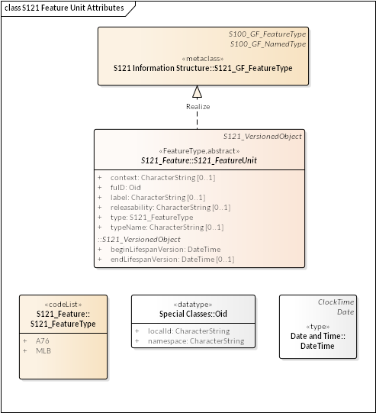

Figure F3 – S121_FeatureUnit Attributes

* + - 1. MLB Location Objects and Attributes

The S121 MLB Location Objects may take on any of the feature attributes described in the Feature Concept Dictionary. Specific attributes are bound to specific features in the product specification. In addition the S121 MLB Location Objects inherit the attributes from S121_FeatureUnit: *typeName*, *type* and *uID*.

**typeName**: The name of the feature, i.e. the 6 character or CamelCase code identifying the feature type (as defined in the Feature Concept Dictionary).

**Type**: A code from S121_FeatureType. This code list includes types that have a common characteristic related to the marine environment. The code list is registered in the Feature Concept Dictionary as listed values and as such can be expanded to include all aspects of the legal context. The initial contents are: **MLB** (Marine Limits and Boundaries), and **A76** (UNCLOS article 76).

**uID**: Reference to information objects using the Oid (Object ID) attribute.

In addition it inherits the S121_VersionedObject attributes. These are:

**beginLifespanVersion:** start time of a specific instance version.

**endLifespanVersion:** optional end time of a specific instance version.

The baseline point feature object may optionally take on the attribute *pointType* from the codelist S121_LocationType.

Figure F4 shows MLB Location Objects and attributes.

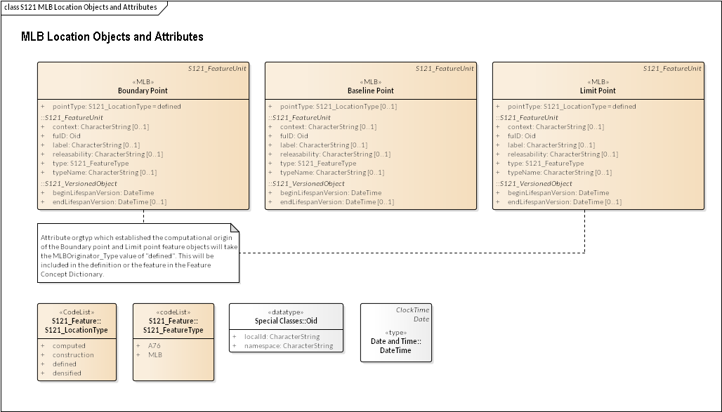

Figure F4 – MLB Location Objects and Attributes

* + - 1. MLB Limit Objects and Attributes

The S121 MLB Limit Objects may take on any of the feature attributes described in the Feature Concept Dictionary. Specific attributes are bound to specific features in the product specification. In addition the S121 MLB Limit Objects inherit the attributes from S121_BAUnit: *typeName*, *type* and *uID*.

**typeName**: The name of the feature, i.e. the 6 character or CamelCase code identifying the feature type (as defined in the Feature Concept Dictionary).

**Type**: A code from S121_FeatureType. This code list includes types that have a common characteristic related to the marine environment. The code list is registered in the Feature Concept Dictionary as listed values and as such can be expanded to include all aspects of the legal context. The initial contents are: **MLB** (Marine Limits and Boundaries), and **A76** (UNCLOS article 76).

**fuID**: Reference to information objects using the Oid (Object ID) attribute.

In addition they inherit the S121_VersionedObject attributes. These are:

**beginLifespanVersion:** start time of a specific instance version.

**endLifespanVersion:** optional end time of a specific instance version.

The feature objects Inland Limit, Territorial sea outer limit, Normal baseline, Straight baseline, Contiguous zone limit, Exclusive economic zone limit, and Continental Shelf limit may optionally take on the attribute *limtyp* from the codelist S121_LimitType.

The feature objects Inland Limit, Territorial sea outer limit, Normal baseline, Straight baseline, Contiguous zone limit, Exclusive economic zone limit, Continental shelf limit and International boundary may optionally take on the attribute *arctyp* from the codelist S121_LimitArcType.

The feature objects Normal baseline and Straight baseline take on the attribute *NBLType* and *NBLType* respectively. Both attributes are character strings.

The Figure F5 shows MLB Limit Objects and attributes.

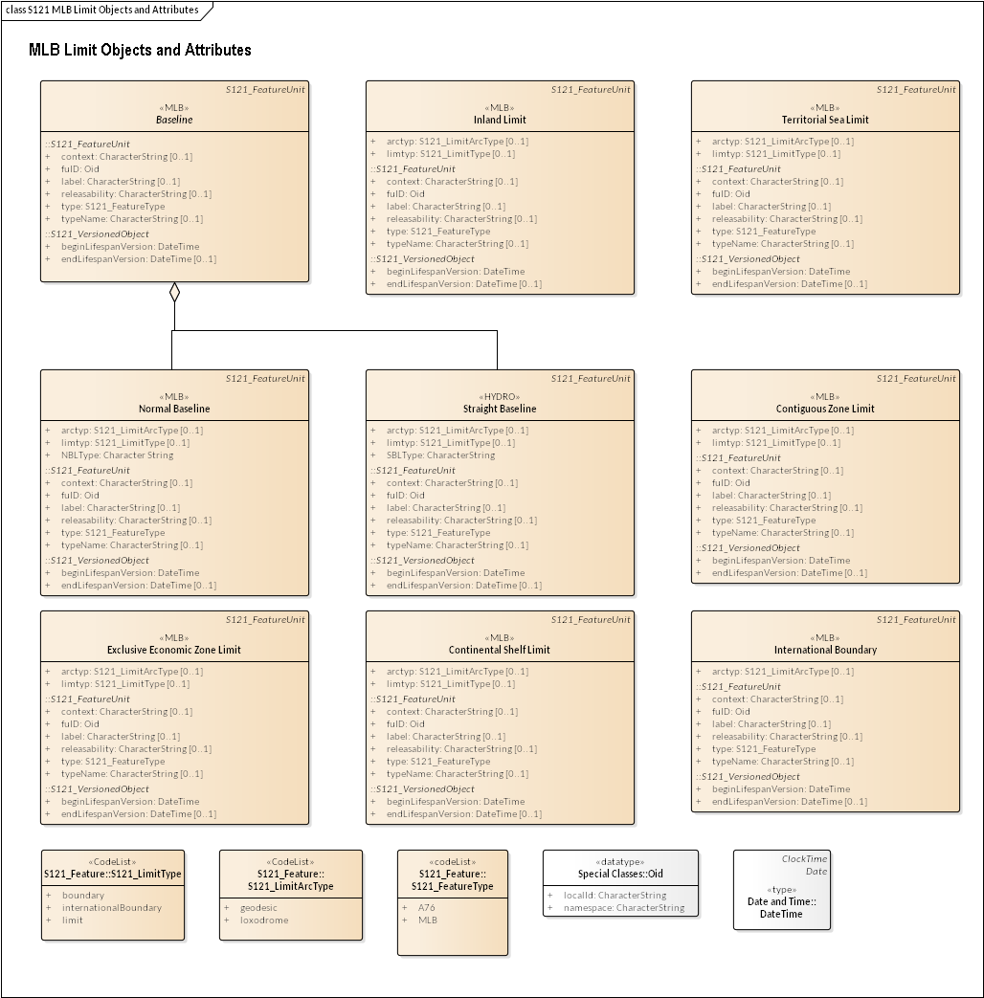

Figure F5 – MLB Limit Objects and Attributes

* + - 1. MLB Zone Objects and Attributes

The S121 MLB Zone Objects may take on any of the feature attributes described in the Feature Concept Dictionary. Specific attributes are bound to specific features in the product specification. In addition the S121 MLB Zone Objects inherit the attributes from S121_BAUnit: *typeName*, *type* and *uID*.

**typeName**: The name of the feature, i.e. the 6 character or CamelCase code identifying the feature type (as defined in the Feature Concept Dictionary).

**Type**: A code from S121_FeatureType. This code list includes types that have a common characteristic related to the marine environment. The code list is registered in the Feature Concept Dictionary as listed values and as such can be expanded to include all aspects of the legal context. The initial contents are: **MLB** (Marine Limits and Boundaries), and **A76** (UNCLOS article 76).

**fuID**: Reference to information objects using the Oid (Object ID) attribute.

In addition they inherit the S121_VersionedObject attributes. These are:

**beginLifespanVersion:** start time of a specific instance version.

**endLifespanVersion:** optional end time of a specific instance version.

The S121 MLB Zone Objects may optionally take on the attribute *verdom* from the codelist S121_VerticalDomainType.

The Figure F6 shows MLB Zone Objects and attributes.

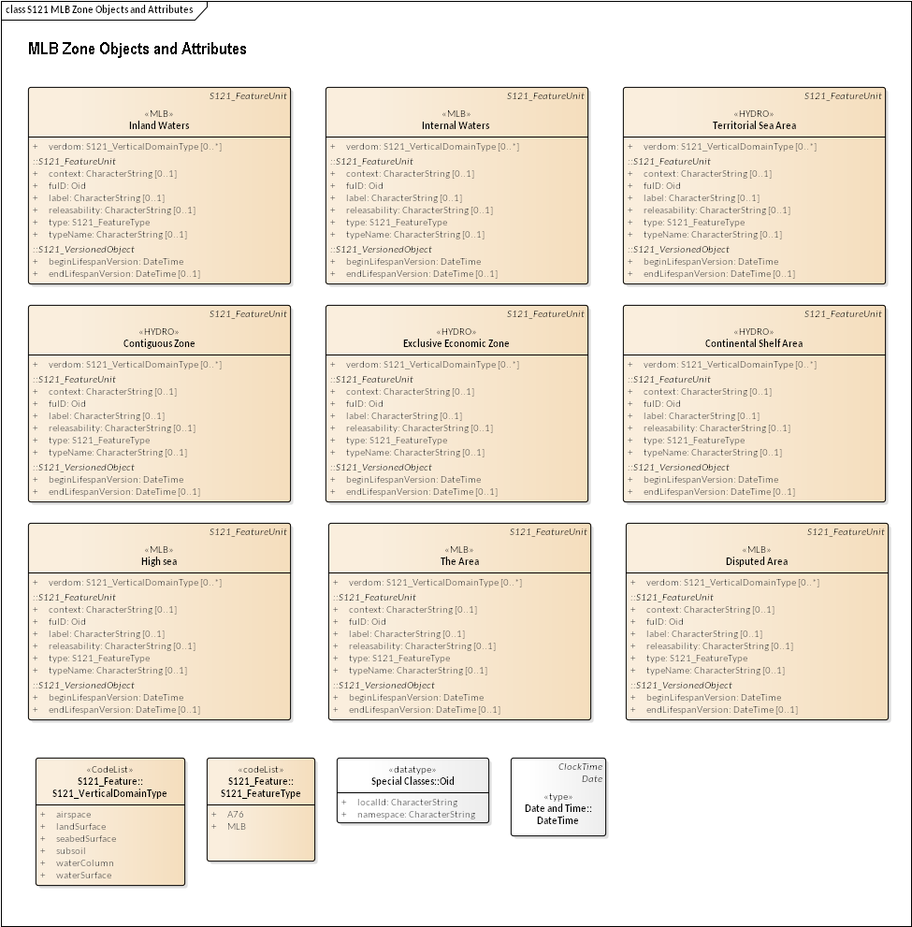

Figure F6 – MLB Zone Objects and Attributes

* + - 1. MLB Space Objects and Attributes

There no MLB Space objects defined. Any Space object will need to be generated from the generic object Space and registered in the Feature Catalogue for a particular product.

1. Feature Catalogue

**(Normative)**

Feature catalogue

* + 1. Name

S121 – Feature Catalogue

* + 1. Scope

This feature catalogue describes the feature objects used in the S121 product specification. It includes both standard features taken from the S-100 Feature Object Catalogue (S-100 Feature Concept Dictionary) and new features defined in this product specification. The new features will be introduced to the S-100 Object Catalogue through the normal processes within IHO.

* + 1. Version number

1.0

* + 1. Version Date

2016-12-09

* + 1. Producer

International Hydrographic Bureau

4b quai Antoine 1er

B.P. 445

MC 98011 MONACO CEDEX

Telephone: +377 93 10 81 00

Telefax: + 377 93 10 81 40

Email: info@iho.int

* + 1. Language

This feature catalogue is available in:

eng – English

* 1. Feature Catalogue Style
     1. Format for the Representation of Feature Objects and Information Objects

In alignment with the S-100 Feature Concept Dictionary, each object class is specified in a standardized way, under the following headings:

* Alpha Code: six-character Alpha Code for the object class
* Name: object class name
* Alias alternate name (if any)
* camelCase: camelCase code
* Numeric Code: integer code (available only for some objects from S-57)
* Use Type area of use of the feature object (theme objects relate to the MLB theme)
* Definition: definition of the feature object
* Permitted Primitives permitted spatial primitives (P, L, A)
* Remarks: Under ‘Remarks’ further comments and notes are given. Related but separate object classes are listed under the heading ‘Distinction’.
* Distinction: Similar but distinct objects.
* Attributes: Attributes associated with the object.
  + 1. Format for the Representation of Feature Object Attributes

In alignment with the format defined in S-100, each attribute is specified in a standardized way, under the following headings:

* Alpha Code: six character code for the Attribute.
* Name: Attribute name.
* Alias alternate name (if any)
* camelCase: camelCase code
* Numeric Code: integer code (where available)
* Data Type: Type of attribute (per S-100 Attribute data types).
* UOM: Unit of Measure (where applicable).
* Definition Description of the attribute.
* Remarks Additional information about the attribute.

Attribute listed values are described in a similar way, with a reference to the attribute to which they apply.

* 1. Feature Catalogue Entries

The objects and attributes identified for use in the S121 product specification are described using the same style as is used in the IHO S-57[17] Object Catalogue. This structure is compliant with the ISO 19110 standard for Object Catalogues and because it is already used by IHO for S-57 it means that it is easier to compare object and attribute entries with those in the IHO Register.

* + 1. S121 Feature Objects

Feature Type Register ID 4

|  |  |
| --- | --- |
| **Domain** | MLB |
| **Alpha Code** | DISARE |
| **Name** | **Disputed Area** |
| **Alias** |  |
| **camelCase** | DisputedArea |
| **Numeric Code** |  |
| **Use Type** | theme |
| **Definition** | An area of disputed jurisdiction. |
| **Permitted Primitives** | A |
| **Remarks** | A disputed area can be any type of zone. The limit of the zone would correspond to the type of limit that would apply if the zone was not disputed. |
| **Item Status** | proposed S121 |
| **Distinction** |  |
|  |  |

|  |  |
| --- | --- |
| **Attributes** | verdom |

Feature Type Register ID 33

|  |  |
| --- | --- |
| **Domain** | MLB |
| **Alpha Code** | BASEPT |
| **Name** | **Baseline Point** |
| **Alias** |  |
| **camelCase** | BaselinePoint |
| **Numeric Code** |  |
| **Use Type** | theme |
| **Definition** | A baseline point is part of the territorial sea baseline model or of an archipelagic baseline. |
| **Permitted Primitives** | P |
| **Remarks** |  |
| **Item Status** | proposed S121 |
| **Distinction** |  |
|  |  |

|  |  |
| --- | --- |
| **Attributes** | pointType |

Feature Type Register ID 35

|  |  |
| --- | --- |
| **Domain** | Hydro |
| **Alpha Code** | CONZNE |
| **Name** | **Contiguous Zone** |
| **Alias** |  |
| **camelCase** | ContiguousZone |
| **Numeric Code** |  |
| **Use Type** | geo, theme |
| **Definition** | A zone contiguous to a coastal State's territorial sea, which may not extend beyond 24 nautical miles from the baselines from which the breadth of the territorial sea is measured. The coastal state may exercise certain control in this zone subject to the provisions of International Law. |
| **Permitted Primitives** | A |
| **Remarks** | The coastal state may exercise certain control in this zone subject to the provisions of International Law. A contiguous zone is a zone that is bounded by the TESLIM (Territorial Sea limit), the CONLIM and or other limit objects such as an international boundary. |
| **Item Status** | proposed S121 |
| **Distinction** |  |
|  |  |

|  |  |
| --- | --- |
| **Attributes** | verdom |

Feature Type Register ID 36

|  |  |
| --- | --- |
| **Domain** | MLB |
| **Alpha Code** | CONLIM |
| **Name** | **Contiguous Zone Limit** |
| **Alias** |  |
| **camelCase** | ContiguousZoneLimit |
| **Numeric Code** |  |
| **Use Type** | theme |
| **Definition** | The outer limit of the State's Contiguous Zone. |
| **Permitted Primitives** | L |
| **Remarks** |  |
| **Item Status** | proposed S121 |
| **Distinction** | ADMARE, COSARE, EXEZNE, FSHZNE, TESARE |
|  |  |

|  |  |
| --- | --- |
| **Attributes** | limtyp, arctyp |

Feature Type Register ID 37

|  |  |
| --- | --- |
| **Domain** | MLB |
| **Alpha Code** | COSLIM |
| **Name** | **Continental Shelf Limit** |
| **Alias** | **Extended Continental Shelf Limit** |
| **camelCase** | ContinentalShelfLimit |
| **Numeric Code** |  |
| **Use Type** | theme |
| **Definition** | The outer limit of the State's Continental Shelf. |
| **Permitted Primitives** | L |
| **Remarks** |  |
| **Item Status** | proposed S121 |
| **Distinction** |  |
|  |  |

|  |  |
| --- | --- |
| **Attributes** | limtyp, arctyp |

Feature Type Register ID 39

|  |  |
| --- | --- |
| **Domain** | Hydro |
| **Alpha Code** | COSARE |
| **Name** | **Continental Shelf Area** |
| **Alias** |  |
| **camelCase** | ContinentalShelfArea |
| **Numeric Code** |  |
| **Use Type** | geo, theme |
| **Definition** | The continental shelf of a coastal State comprises the sea bed and subsoil of the submarine areas that extend beyond its territorial sea throughout the natural prolongation of its land territory to the outer edge of the continental margin, or to a distance of 200 nautical miles from the baselines from which the breadth of the territorial sea is measured where the outer edge of the continental margin does not extend out to that distance. |
| **Permitted Primitives** | A |
| **Remarks** | The Continental Shelf Area is a zone that is bounded by the EEZ and the COSLIM and / or other limit objects such as an international boundary. |
| **Item Status** | proposed S121 |
| **Distinction** | ADMARE, CONZNE, EXEZNE, FSHZNE, TESARE |
|  |  |

|  |  |
| --- | --- |
| **Attributes** | verdom |

Feature Type Register ID 42

|  |  |
| --- | --- |
| **Domain** | Hydro |
| **Alpha Code** | EXEZNE |
| **Name** | **Exclusive Economic Zone** |
| **Alias** | **EEZ** |
| **camelCase** | ExclusiveEconomicZone |
| **Numeric Code** | 50 |
| **Use Type** | geo, theme |
| **Definition** | An area, not exceeding 200 nautical miles from the baselines from which the breadth of the territorial sea is measured, subject to a specific legal regime established in the United Nations Convention on the Law of the Sea under which the coastal state has certain rights and jurisdiction |
| **Permitted Primitives** | A |
| **Remarks** | The Exclusive Economic Zone is a zone that is bounded by the TESLIM (Territorial Sea limit), EEZLIM or other limit objects such as an international boundary. |
| **Item Status** | proposed S121 |
| **Distinction** |  |
|  |  |

|  |  |
| --- | --- |
| **Attributes** | verdom |

Feature Type Register ID 43

|  |  |
| --- | --- |
| **Domain** | MLB |
| **Alpha Code** | EEZLIM |
| **Name** | **Exclusive Economic Zone Limit** |
| **Alias** |  |
| **camelCase** | ExclusiveEconomicZoneLimit |
| **Numeric Code** |  |
| **Use Type** | theme |
| **Definition** | The outer limit of the State's exclusive economic zone. |
| **Permitted Primitives** | L |
| **Remarks** |  |
| **Item Status** | proposed S121 |
| **Distinction** |  |
|  |  |

|  |  |
| --- | --- |
| **Attributes** | limtyp, arctyp |

Feature Type Register ID 47

|  |  |
| --- | --- |
| **Domain** | MLB |
| **Alpha Code** | HIGHSE |
| **Name** | **High Sea** |
| **Alias** |  |
| **camelCase** | HighSea |
| **Numeric Code** |  |
| **Use Type** | theme |
| **Definition** | A zone that consists of the open ocean, not part of the exclusive economic zone, territorial sea or internal waters of any state. A term of international and maritime law per UNCLOS article 86. |
| **Permitted Primitives** | A |
| **Remarks** | The high sea is a zone that is bounded by the Exclusive Economic Zone. |
| **Item Status** | proposed S121 |
| **Distinction** |  |
|  |  |

|  |  |
| --- | --- |
| **Attributes** | verdom |

Feature Type Register ID 48

|  |  |
| --- | --- |
| **Domain** | MLB |
| **Alpha Code** | INLLIM |
| **Name** | **Inland Limit** |
| **Alias** |  |
| **camelCase** | InlandLimit |
| **Numeric Code** |  |
| **Use Type** | theme |
| **Definition** | Inland Limit is a segment of line used to delineate inland waters. It is a boundary between Internal Waters and Inland Waters. |
| **Permitted Primitives** | L |
| **Remarks** |  |
| **Item Status** | proposed S121 |
| **Distinction** |  |
|  |  |

|  |  |
| --- | --- |
| **Attributes** | limtyp, arctyp |

Feature Type Register ID 49

|  |  |
| --- | --- |
| **Domain** | MLB |
| **Alpha Code** | INLWTR |
| **Name** | **Inland Waters** |
| **Alias** |  |
| **camelCase** | InlandWaters |
| **Numeric Code** |  |
| **Use Type** | theme |
| **Definition** | An area describing waters found on the landward side of the Inland Waters limits. |
| **Permitted Primitives** | A |
| **Remarks** | Synonymous with the EU Inspire Administrative Hierarchy Level |
| **Item Status** | proposed S121 |
| **Distinction** | INTWTR |
|  |  |

|  |  |
| --- | --- |
| **Attributes** | verdom |

Feature Type Register ID 50

|  |  |
| --- | --- |
| **Domain** | MLB |
| **Alpha Code** | INTWTR |
| **Name** | **Internal Waters** |
| **Alias** |  |
| **camelCase** | InternalWaters |
| **Numeric Code** |  |
| **Use Type** | theme |
| **Definition** | A zone describing waters found on the landward side of the baselines of a State other than Inland Waters or Archipelagic Waters. |
| **Permitted Primitives** | L,A |
| **Remarks** | A zone that is bounded by the inland water, the land area and the territorial sea. (For legal definition see UNCLOS Article 8). |
| **Item Status** | proposed S121 |
| **Distinction** | INLWTR |
|  |  |

|  |  |
| --- | --- |
| **Attributes** | verdom |

Feature Type Register ID 51

|  |  |
| --- | --- |
| **Domain** | MLB |
| **Alpha Code** | INTBND |
| **Name** | **International Boundary** |
| **Alias** |  |
| **camelCase** | InternationalBoundary |
| **Numeric Code** |  |
| **Use Type** | theme |
| **Definition** | International boundary is a boundary object reflecting a treaty or other agreement between two or more sovereign states. |
| **Permitted Primitives** | L |
| **Remarks** | Specific vertical domains can be assigned to this object to describe its role. |
| **Item Status** | proposed S121 |
| **Distinction** |  |
|  |  |

|  |  |
| --- | --- |
| **Attributes** | arctyp |

Feature Type Register ID 53

|  |  |
| --- | --- |
| **Domain** | MLB |
| **Alpha Code** | MLIMIT |
| **Name** | **Limit** |
| **Alias** |  |
| **camelCase** | Limit |
| **Numeric Code** |  |
| **Use Type** | theme |
| **Definition** | The S121_Limit object is an object that defines any limits or boundaries either relating to terrestrial, marine or both environments. |
| **Permitted Primitives** | P,L |
| **Remarks** |  |
| **Item Status** | proposed S121 |
| **Distinction** |  |
|  |  |

|  |  |
| --- | --- |
| **Attributes** | limtyp, arctyp |

Feature Type Register ID 54

|  |  |
| --- | --- |
| **Domain** | MLB |
| **Alpha Code** | MLOCTN |
| **Name** | **Location** |
| **Alias** |  |
| **camelCase** | Location |
| **Numeric Code** |  |
| **Use Type** | theme |
| **Definition** | The Location object is an object that defines the underlying structure of location. |
| **Permitted Primitives** | P |
| **Remarks** | To portray a geodesic or loxodrome curve correctly, additional vertices may be included in the dataset. These are densified locations. These vertices would not have formed part of the original source information. The pointType attribute can be used to differentiate between a defined vertex (e.g. declared in a treaty) with a vertex densified to ensure correct GIS depiction. A computed location is also not part of the original source information, but is calculated as the result of the original source guidance, such as the intersection between arcs, geodesics, or loxodromes. A construction vertex is any arbitrary position established to support computation. |
| **Item Status** | proposed S121 |
| **Distinction** |  |
|  |  |

|  |  |
| --- | --- |
| **Attributes** | pointType |

Feature Type Register ID 55

|  |  |
| --- | --- |
| **Domain** | MLB |
| **Alpha Code** | NBASLN |
| **Name** | **Normal Baseline** |
| **Alias** |  |
| **camelCase** | NormalBaseline |
| **Numeric Code** |  |
| **Use Type** | theme |
| **Definition** | A normal baseline is part of the territorial sea baseline model. |
| **Permitted Primitives** | L |
| **Remarks** |  |
| **Item Status** | proposed S121 |
| **Distinction** |  |
|  |  |

|  |  |
| --- | --- |
| **Attributes** | limtyp, arctyp, NBLType |

Feature Type Register ID 56

|  |  |
| --- | --- |
| **Domain** | MLB |
| **Alpha Code** | MSPACE |
| **Name** | **Space** |
| **Alias** |  |
| **camelCase** | Space |
| **Numeric Code** |  |
| **Use Type** | theme |
| **Definition** | The Space object is an object that defines a volume which is logically delimited by instances of zone objects. |
| **Permitted Primitives** | P,L,A |
| **Remarks** | A Space is an object of 2 dimensions with a height description located in 2 or 3 dimensional space. This is sometimes called 2 1/2 dimensions. A Space has the same geometry as a Zone with the attributes of vertical position. The vertical position may be explicit numerical attributes of height above a reference or a textual description. |
| **Item Status** | proposed S121 |
| **Distinction** |  |
|  |  |

|  |  |
| --- | --- |
| **Attributes** | verdom |

Feature Type Register ID 57

|  |  |
| --- | --- |
| **Domain** | Hydro |
| **Alpha Code** | STRLNE |
| **Name** | **Straight Baseline** |
| **Alias** |  |
| **camelCase** | StraightBaseline |
| **Numeric Code** | 132 |
| **Use Type** | geo, theme |
| **Definition** | A baseline is the line from which the outer limits of the territorial sea and certain other outer limits are measured. (IHO Dictionary, S-32, 5th Edition, 390)  Straight baselines are a system of straight lines joining specified or discrete points on the low-water line, usually known as straight baseline turning points. (IHO Dictionary, S-32, 5th Edition, 393) |
| **Permitted Primitives** | L |
| **Remarks** | A straight line used in place of the normal baseline. Types of straight baseline are: straight, archipelagic, bay closing, river mouth closing, historic bay closing. |
| **Item Status** | proposed S121 |
| **Distinction** |  |
|  |  |

|  |  |
| --- | --- |
| **Attributes** | limtyp, arctyp, SBLType |

Feature Type Register ID 59

|  |  |
| --- | --- |
| **Domain** | Hydro |
| **Alpha Code** | TESARE |
| **Name** | **Territorial Sea Area** |
| **Alias** |  |
| **camelCase** | TerritorialSeaArea |
| **Numeric Code** | 135 |
| **Use Type** | geo, theme |
| **Definition** | The territorial sea is a belt of water of a defined breadth but not exceeding 12 nautical miles measured seaward from the territorial sea baseline. |
| **Permitted Primitives** | A |
| **Remarks** | The territorial sea area is a zone that is bounded by the TESLIM (Territorial Sea limit), the baseline BASELN and or other limit objects such as an international boundary. |
| **Item Status** | proposed S121 |
| **Distinction** | ADMARE, CONZNE, COSARE, EXEZNE, FSHZNE, RESARE |
|  |  |

|  |  |
| --- | --- |
| **Attributes** | verdom |

Feature Type Register ID 60

|  |  |
| --- | --- |
| **Domain** | MLB |
| **Alpha Code** | TESLIM |
| **Name** | **Territorial Sea Limit** |
| **Alias** |  |
| **camelCase** | TerritorialSeaLimit |
| **Numeric Code** |  |
| **Use Type** | theme |
| **Definition** | This object is used to express the outer limit of the State's territorial sea. |
| **Permitted Primitives** | L |
| **Remarks** | TESLIM is used to express the outer extent of TESARE. TESARE is a zone that is bounded by the TESLIM (Territorial Sea limit), the baseline BASELN and or other limit objects such as an international boundary. |
| **Item Status** | proposed S121 |
| **Distinction** |  |
|  |  |

|  |  |
| --- | --- |
| **Attributes** | limtyp, arctyp |

Feature Type Register ID 61

|  |  |
| --- | --- |
| **Domain** | MLB |
| **Alpha Code** | ISAARE |
| **Name** | **The Area** |
| **Alias** |  |
| **camelCase** | TheArea |
| **Numeric Code** |  |
| **Use Type** | theme |
| **Definition** | The area of the seabed not under the jurisdiction of any state. This area lies beyond the extension of the continental shelf awarded to coastal States under Article 76 of UNCLOS. |
| **Permitted Primitives** | L,A |
| **Remarks** | In the United Nations Law of the Sea terminology, the sea-bed and ocean floor and subsoil thereof, beyond the limits of national jurisdiction. (IHO Hydrographic Dictionary, S-32, 5th Edition, 227) (For legal definition see UNCLOS Part XI). The Area is a zone that is bounded by the states sovereign extent which may be the Continental Shelf or the Exclusive Economic Zone. |
| **Item Status** | proposed S121 |
| **Distinction** | ADMARE, CONZNE, COSARE, FSHZNE, TESARE, EXEZNE, HIGHSE |
|  |  |

|  |  |
| --- | --- |
| **Attributes** | verdom |

Feature Type Register ID 62

|  |  |
| --- | --- |
| **Domain** | MLB |
| **Alpha Code** | MZONE |
| **Name** | **Zone** |
| **Alias** |  |
| **camelCase** | Zone |
| **Numeric Code** |  |
| **Use Type** | theme |
| **Definition** | The Zone object is an object that defines an area which is logically delimited by instances of delineation (limit) objects. |
| **Permitted Primitives** | P,L,A |
| **Remarks** | Maritime, terrestrial or inter-tidal zone objects are the three real objects that inherit from this object. |
| **Item Status** | proposed S121 |
| **Distinction** |  |
|  |  |

|  |  |
| --- | --- |
| **Attributes** | verdom |

Feature Type Register ID 66

|  |  |
| --- | --- |
| **Domain** | MLB |
| **Alpha Code** | LIMPNT |
| **Name** | **Limit Point** |
| **Alias** |  |
| **camelCase** | LimitPoint |
| **Numeric Code** |  |
| **Use Type** | theme |
| **Definition** | A limit Point is a point on a limit. |
| **Permitted Primitives** | P |
| **Remarks** | A point associated with one party. |
| **Item Status** | proposed S121 |
| **Distinction** | BDNPNT |
|  |  |

Feature Type Register ID 67

|  |  |
| --- | --- |
| **Domain** | MLB |
| **Alpha Code** | BNDPNT |
| **Name** | **Boundary Point** |
| **Alias** |  |
| **camelCase** | BoundaryPoint |
| **Numeric Code** |  |
| **Use Type** | theme |
| **Definition** | A Boundary Point is a point on a boundary. |
| **Permitted Primitives** | P |
| **Remarks** | A point associated with more than one party. |
| **Item Status** | proposed S121 |
| **Distinction** | LIMPNT |
|  |  |

Feature Type Register ID 68

|  |  |
| --- | --- |
| **Domain** | MLB |
| **Alpha Code** | BASELN |
| **Name** | **Baseline** |
| **Alias** |  |
| **camelCase** | Baseline |
| **Numeric Code** |  |
| **Use Type** | theme |
| **Definition** | A baseline is the line from which the outer limits of the territorial sea and certain other outer limits are measured. (IHO Dictionary, S-32, 5th Edition, 390). |
| **Permitted Primitives** | P,L |
| **Remarks** | A baseline is generally composed of two components, a normal baseline and a straight baseline. |
| **Item Status** | proposed S121 |
| **Distinction** |  |
|  |  |

* + 1. S121 Information Objects

Information Object Type Register ID 2001

|  |  |
| --- | --- |
| **Domain** | MLB |
| **Alpha Code** | BAUNIT |
| **Name** | **S121 Basic Administrative Unit** |
| **Alias** |  |
| **camelCase** | S121BAUnit |
| **Numeric Code** |  |
| **Definition** | The Basic Administrative is a feature type to “which (one or more) unique and homogeneous rights, responsibilities or restrictions are associated”. It is an information object since it does not directly take on spatial attributes. |
| **Remarks** | The S121_BAUnit is derived from both the S100_FeatureType and the LA_BAUnit defined in ISO 19152. |
| **Item Status** | proposed S121 |

Information Object Type Register ID 2002

|  |  |
| --- | --- |
| **Domain** | MLB |
| **Alpha Code** | RIGHT- |
| **Name** | **S121 Right** |
| **Alias** | Right |
| **camelCase** | S121Right |
| **Numeric Code** |  |
| **Definition** | S121_Right is an action, activity or class of actions that a system participant may perform on or using an associated resource. |
| **Remarks** | In the S-100 environment the RRR objects are information objects that carry an object identifier "Oid". They can be referenced as objects from the attributes associated with an S-100 Feature Object. |
| **Item Status** | proposed S121 |

Information Object Type Register ID 2003

|  |  |
| --- | --- |
| **Domain** | MLB |
| **Alpha Code** | RESPON |
| **Name** | **S121 Responsibility** |
| **Alias** | Responsibility |
| **camelCase** | S121Responsibility |
| **Numeric Code** |  |
| **Definition** | S121_Responsibility is a formal or informal obligation to do something |
| **Remarks** | In the S-100 environment the RRR objects are information objects that carry an object identifier "Oid". They can be referenced as objects from the attributes associated with an S-100 Feature Object. |
| **Item Status** | proposed S121 |

Information Object Type Register ID 2004

|  |  |
| --- | --- |
| **Domain** | MLB |
| **Alpha Code** | RESTRN |
| **Name** | **S121 Restriction** |
| **Alias** | Restriction |
| **camelCase** | S121Restriction |
| **Numeric Code** |  |
| **Definition** | S121_Restriction is a formal or informal entitlement to refrain from doing something. |
| **Remarks** | In the S-100 environment the RRR objects are information objects that carry an object identifier "Oid". They can be referenced as objects from the attributes associated with an S-100 Feature Object. |
| **Item Status** | proposed S121 |

Information Object Type Register ID 2005

|  |  |
| --- | --- |
| **Domain** | MLB |
| **Alpha Code** | IPARTY |
| **Name** | **S121 Party** |
| **Alias** | Party |
| **camelCase** | S121Party |
| **Numeric Code** |  |
| **Definition** | S121_Party is a person or organisation that plays a role in a rights transaction |
| **Remarks** |  |
| **Item Status** | proposed S121 |

Information Object Type Register ID 2006

|  |  |
| --- | --- |
| **Domain** | MLB |
| **Alpha Code** | GPARTY |
| **Name** | **S121 Group Party** |
| **Alias** | Group |
| **camelCase** | S121GroupParty |
| **Numeric Code** |  |
| **Definition** | S121_GroupParty is any number of parties, forming together a distinct entity, with each party registered. |
| **Remarks** |  |
| **Item Status** | proposed S121 |

Information Object Type Register ID 2007

|  |  |
| --- | --- |
| **Domain** | MLB |
| **Alpha Code** | ADMSRC |
| **Name** | **S121 Administrative Source** |
| **Alias** | Source |
| **camelCase** | S121AdministrativeSource |
| **Numeric Code** |  |
| **Definition** | S121_AdministrativeSource is a source with the administrative description (where applicable) of the parties involved, the rights, restrictions and responsibilities created and the basic administrative units affected. |
| **Remarks** |  |
| **Item Status** | proposed S121 |

Information Object Type Register ID 2008

|  |  |
| --- | --- |
| **Domain** | MLB |
| **Alpha Code** | SPAATT |
| **Name** | **S121 Spatial Attribute Type** |
| **Alias** | Spatial |
| **camelCase** | S121SpatialAttributeType |
| **Numeric Code** |  |
| **Definition** | The Spatial Attribute Type as defined for S121 is derived from the class LA_SpatialUnit defined in ISO 19152. It also inherits from S100_GF_SpatialAttributeType. This means that the geometry types inherited from S-100 apply. Only the geometry types GM_Point, GM_MultiPoint, GM_Curve, GM_Surface, CV_Coverage, GM_Curve (arcByCentrePoint and circleByCentrePoint may be used. |
| **Remarks** |  |
| **Item Status** | proposed S121 |

* + 1. S121 Feature Attributes

Attribute Type Register ID 1001

|  |  |
| --- | --- |
| **Domain** | MLB |
| **Alpha Code** | verdom |
| **Name** | **Vertical Domain** |
| **Alias** |  |
| **camelCase** | VerticalDomain |
| **Numeric Code** |  |
| **Data Type** | **S100_CodeList** |
| **UOM** |  |
| **Definition** | Category of vertical domain of the object delimited. (e.g. airspace, land_surface, water_surface, water_column, seabed_surface, subsoil). Any particular object may span more than one vertical domain. |
| **Remarks** |  |
| **Item Status** | proposed S121 |

Attribute Type Register ID 1002

|  |  |
| --- | --- |
| **Domain** | MLB |
| **Alpha Code** | pointType |
| **Name** | **Type of Point** |
| **Alias** |  |
| **camelCase** | PointType |
| **Numeric Code** |  |
| **Data Type** | S100_CodeList |
| **UOM** |  |
| **Definition** | Computational origin of the element (defined, densified, computed or construction) |
| **Remarks** |  |
| **Item Status** | proposed S121 |

Attribute Type Register ID 1003

|  |  |
| --- | --- |
| **Domain** | MLB |
| **Alpha Code** | limtyp |
| **Name** | **Limit Type** |
| **Alias** |  |
| **camelCase** | LimitType |
| **Numeric Code** |  |
| **Data Type** | S100_CodeList |
| **UOM** |  |
| **Definition** | Type of delineation (Boundary, Limit or Construction). |
| **Remarks** |  |
| **Item Status** | proposed S121 |

Attribute Type Register ID 1004

|  |  |
| --- | --- |
| **Domain** | MLB |
| **Alpha Code** | arctyp |
| **Name** | **Arc Type** |
| **Alias** |  |
| **camelCase** | ArcType |
| **Numeric Code** |  |
| **Data Type** | S100_CodeList |
| **UOM** |  |
| **Definition** | Type of computation used to define an arc (line). (Geodesic or loxodrome). |
| **Remarks** |  |
| **Item Status** | proposed S121 |

Attribute Type Register ID 1005

|  |  |
| --- | --- |
| **Domain** | MLB |
| **Alpha Code** | nbltyp |
| **Name** | **Normal Baseline Type** |
| **Alias** |  |
| **camelCase** | NormalBaselineType |
| **Numeric Code** |  |
| **Data Type** | S100_CodeList |
| **UOM** |  |
| **Definition** | Type of normal baseline (Normal, Low Tide Elevation) |
| **Remarks** |  |
| **Item Status** | proposed S121 |

Attribute Type Register ID 1006

|  |  |
| --- | --- |
| **Domain** | MLB |
| **Alpha Code** | sbltyp |
| **Name** | **Straight Baseline Type** |
| **Alias** |  |
| **camelCase** | StraightBaselineType |
| **Numeric Code** |  |
| **Data Type** | S100_CodeList |
| **UOM** |  |
| **Definition** | Type of straight baseline (Straight Baseline, Archipelagic Baseline, Delta Baseline, Unstable coast Baseline, Historic Bay Closing, River Closing, Historic Waters) |
| **Remarks** |  |
| **Item Status** | proposed S121 |

Attribute Type Register ID 1007

|  |  |
| --- | --- |
| **Domain** | MLB |
| **Alpha Code** | bautyp |
| **Name** | **BAUnitType** |
| **Alias** |  |
| **camelCase** | BAUnitType |
| **Numeric Code** |  |
| **Data Type** | S100_CodeList |
| **UOM** |  |
| **Definition** | Type of Basic Administrative Unit (MLB, A76, other) |
| **Remarks** |  |
| **Item Status** | proposed S121 |

Attribute Type Register ID 1008

|  |  |
| --- | --- |
| **Domain** | MLB |
| **Alpha Code** | blsver |
| **Name** | **Begin Lifespan Version** |
| **Alias** | begin |
| **camelCase** | beginLifespanVersion |
| **Numeric Code** |  |
| **Data Type** | S100_TruncatedDate |
| **UOM** |  |
| **Definition** | Begin of version object life span |
| **Remarks** |  |
| **Item Status** | proposed S121 |

Attribute Type Register ID 1009

|  |  |
| --- | --- |
| **Domain** | MLB |
| **Alpha Code** | elsver |
| **Name** | **End Lifespan Version** |
| **Alias** | end |
| **camelCase** | endLifespanVersion |
| **Numeric Code** |  |
| **Data Type** | S100_TruncatedDate |
| **UOM** |  |
| **Definition** | End of version object life span |
| **Remarks** |  |
| **Item Status** | proposed S121 |

* + 1. S121 Information Object Attributes

Attribute Type Register ID 1010

|  |  |
| --- | --- |
| **Domain** | MLB |
| **Alpha Code** | rghtyp |
| **Name** | **S121_RightType** |
| **Alias** |  |
| **camelCase** | RightType |
| **Numeric Code** |  |
| **Data Type** | S100_CodeList |
| **UOM** |  |
| **Definition** | Type of right (soverignRight, accessRight, harvestRight, easementRight) |
| **Remarks** |  |
| **Item Status** | proposed S121 |

Attribute Type Register ID 1011

|  |  |
| --- | --- |
| **Domain** | MLB |
| **Alpha Code** | rsttyp |
| **Name** | **S121_RestrictionType** |
| **Alias** |  |
| **camelCase** | RestrictionType |
| **Numeric Code** |  |
| **Data Type** | S100_CodeList |
| **UOM** |  |
| **Definition** | Type of restriction (timeBasedRestriction, passageRestriction, accessRestriction, useRestriction, jurisdictionRestriction, resourceRestriction) |
| **Remarks** |  |
| **Item Status** | proposed S121 |

Attribute Type Register ID 1012

|  |  |
| --- | --- |
| **Domain** | MLB |
| **Alpha Code** | restyp |
| **Name** | **S121_ResponsibilityType** |
| **Alias** |  |
| **camelCase** | ResponsibilityType |
| **Numeric Code** |  |
| **Data Type** | S100_CodeList |
| **UOM** |  |
| **Definition** | Type of responsibility (maintenanceResponsibility) |
| **Remarks** |  |
| **Item Status** | proposed S121 |

* + 1. S121 Listed Values

Attribute Type Register ID 4001

|  |  |
| --- | --- |
| **Domain** | MLB |
| **Name** | **Airspace** |
| **Alias** |  |
| **camelCase** | Airspace |
| **Numeric Code** |  |
| **Associated Attribute** | verdom |
| **Definition** | The airspace is a space composed of air . |
| **Remarks** |  |
| **Item Status** | proposed S121 |

Attribute Type Register ID 4002

|  |  |
| --- | --- |
| **Domain** | MLB |
| **Name** | **Land surface** |
| **Alias** |  |
| **camelCase** | LandSurface |
| **Numeric Code** |  |
| **Associated Attribute** | verdom |
| **Definition** | LandSurface is the interface between earth and air. |
| **Remarks** |  |
| **Item Status** | proposed S121 |

Attribute Type Register ID 4003

|  |  |
| --- | --- |
| **Domain** | MLB |
| **Name** | **Water surface** |
| **Alias** |  |
| **camelCase** | WaterSurface |
| **Numeric Code** |  |
| **Associated Attribute** | verdom |
| **Definition** | The waterSurface is the interface between the airspace and waterColumn. |
| **Remarks** |  |
| **Item Status** | proposed S121 |

Attribute Type Register ID 4004

|  |  |
| --- | --- |
| **Domain** | MLB |
| **Name** | **Water column** |
| **Alias** |  |
| **camelCase** | WaterColumn |
| **Numeric Code** |  |
| **Associated Attribute** | verdom |
| **Definition** | The waterColumn is a space (volume) from the seabedSurface up to the waterSurface. |
| **Remarks** |  |
| **Item Status** | proposed S121 |

Attribute Type Register ID 4005

|  |  |
| --- | --- |
| **Domain** | MLB |
| **Name** | **Seabed surface** |
| **Alias** |  |
| **camelCase** | SeabedSurface |
| **Numeric Code** |  |
| **Associated Attribute** | verdom |
| **Definition** | SeabedSurface is the interface between the submerged land and the ocean. |
| **Remarks** |  |
| **Item Status** | proposed S121 |

Attribute Type Register ID 4006

|  |  |
| --- | --- |
| **Domain** | MLB |
| **Name** | **Subsoil** |
| **Alias** |  |
| **camelCase** | Subsoil |
| **Numeric Code** |  |
| **Associated Attribute** | verdom |
| **Definition** | The subsoil is an area composed of earth (soil). |
| **Remarks** |  |
| **Item Status** | proposed S121 |

Attribute Type Register ID 4007

|  |  |
| --- | --- |
| **Domain** | MLB |
| **Name** | **Defined** |
| **Alias** |  |
| **camelCase** | Defined |
| **Numeric Code** |  |
| **Associated Attribute** | pointType |
| **Definition** | A point is derived from a legislative document or other definitive source. |
| **Remarks** |  |
| **Item Status** | proposed S121 |

Attribute Type Register ID 4008

|  |  |
| --- | --- |
| **Domain** | MLB |
| **Name** | **Densified** |
| **Alias** |  |
| **camelCase** | Densified |
| **Numeric Code** |  |
| **Associated Attribute** | pointType |
| **Definition** | A point is part of a densification of the vertices in a line to ensure the geometry of a feature is correctly represented. |
| **Remarks** |  |
| **Item Status** | proposed S121 |

Attribute Type Register ID 4009

|  |  |
| --- | --- |
| **Domain** | MLB |
| **Name** | **Computed** |
| **Alias** |  |
| **camelCase** | Computed |
| **Numeric Code** |  |
| **Associated Attribute** | pointType |
| **Definition** | A point is computed in accordance with the definition described in the source through proper geodetic calculations; for example, the intersection of two arcs over an ellipsoidal surface. A point may be established to support construction computations. |
| **Remarks** |  |
| **Item Status** | proposed S121 |

Attribute Type Register ID 4010

|  |  |
| --- | --- |
| **Domain** | MLB |
| **Name** | **Construction** |
| **Alias** |  |
| **camelCase** | Construction |
| **Numeric Code** |  |
| **Associated Attribute** | pointType |
| **Definition** | Construction |
| **Remarks** |  |
| **Item Status** | proposed S121 |

Attribute Type Register ID 4011

|  |  |
| --- | --- |
| **Domain** | MLB |
| **Name** | **International Boundary** |
| **Alias** |  |
| **camelCase** | InternationalBoundary |
| **Numeric Code** |  |
| **Associated Attribute** | limtyp |
| **Definition** | A type of boundary administered by two sovereign states (countries). This is a special case of boundary whose purpose is to allow the clear definition of critical sovereignty related elements. |
| **Remarks** |  |
| **Item Status** | proposed S121 |

Attribute Type Register ID 4012

|  |  |
| --- | --- |
| **Domain** | MLB |
| **Name** | **Boundary** |
| **Alias** |  |
| **camelCase** | InternationalBoundary |
| **Numeric Code** |  |
| **Associated Attribute** | limtyp |
| **Definition** | Element delimiting an object administered by a more than one owner; typically two sovereign states (countries). If there are two political entities involved, the delineated is a boundary, and if there is only one the delineation is a limit. |
| **Remarks** |  |
| **Item Status** | proposed S121 |

Attribute Type Register ID 4013

|  |  |
| --- | --- |
| **Domain** | MLB |
| **Name** | **Limit** |
| **Alias** |  |
| **camelCase** | Limit |
| **Numeric Code** |  |
| **Associated Attribute** | limtyp |
| **Definition** | Element delimiting an object administered by a single owner; e.g. boundary of a management zone, that pertains to only one political entity, such as oil lease areas within a management zone for oil exploration. If there are two political entities involved, the delineation is a boundary, and if there is only one the delineation is a limit. |
| **Remarks** |  |
| **Item Status** | proposed S121 |

Attribute Type Register ID 4014

|  |  |
| --- | --- |
| **Domain** | MLB |
| **Name** | **Geodesic** |
| **Alias** |  |
| **camelCase** | Geodesic |
| **Numeric Code** |  |
| **Associated Attribute** | arctyp |
| **Definition** | A path of shortest distance along the surface of an ellipsoid, namely a segment of a great circle. |
| **Remarks** |  |
| **Item Status** | proposed S121 |

Attribute Type Register ID 4015

|  |  |
| --- | --- |
| **Domain** | MLB |
| **Name** | **Loxodrome** |
| **Alias** |  |
| **camelCase** | Loxodrome |
| **Numeric Code** |  |
| **Associated Attribute** | arctyp |
| **Definition** | An arc crossing all meridians of longitude at the same angle; a path with constant bearing. |
| **Remarks** |  |
| **Item Status** | proposed S121 |

Attribute Type Register ID 4016

|  |  |
| --- | --- |
| **Domain** | MLB |
| **Name** | **Normal** |
| **Alias** |  |
| **camelCase** | Normal |
| **Numeric Code** |  |
| **Associated Attribute** | nbltyp |
| **Definition** | Normal baseline type |
| **Remarks** |  |
| **Item Status** | proposed S121 |

Attribute Type Register ID 4017

|  |  |
| --- | --- |
| **Domain** | MLB |
| **Name** | **Low Tide Elevation** |
| **Alias** |  |
| **camelCase** | InternationalBoundary |
| **Numeric Code** |  |
| **Associated Attribute** | nbltyp |
| **Definition** | Low Tide Elevation baseline type |
| **Remarks** |  |
| **Item Status** | proposed S121 |

Attribute Type Register ID 4018

|  |  |
| --- | --- |
| **Domain** | MLB |
| **Name** | **Straight baseline** |
| **Alias** |  |
| **camelCase** | StraightBaseline |
| **Numeric Code** |  |
| **Associated Attribute** | sbltyp |
| **Definition** | Straight Baselinetype |
| **Remarks** |  |
| **Item Status** | proposed S121 |

Attribute Type Register ID 4019

|  |  |
| --- | --- |
| **Domain** | MLB |
| **Name** | **Archipelagic Baseline** |
| **Alias** |  |
| **camelCase** | Archipelagic Baseline type |
| **Numeric Code** |  |
| **Associated Attribute** | sbltyp |
| **Definition** | Archipelagic Baseline type |
| **Remarks** |  |
| **Item Status** | proposed S121 |

Attribute Type Register ID 4020

|  |  |
| --- | --- |
| **Domain** | MLB |
| **Name** | **Delta Baseline** |
| **Alias** |  |
| **camelCase** | DeltaBaseline |
| **Numeric Code** |  |
| **Associated Attribute** | sbltyp |
| **Definition** | Delta Baseline type |
| **Remarks** |  |
| **Item Status** | proposed S121 |

Attribute Type Register ID 4021

|  |  |
| --- | --- |
| **Domain** | MLB |
| **Name** | **Unstable coast Baseline** |
| **Alias** |  |
| **camelCase** | UnstableCoastBaseline |
| **Numeric Code** |  |
| **Associated Attribute** | sbltyp |
| **Definition** | Unstable Coast Baseline type |
| **Remarks** |  |
| **Item Status** | proposed S121 |

Attribute Type Register ID 4022

|  |  |
| --- | --- |
| **Domain** | MLB |
| **Name** | **Historic Bay Closing** |
| **Alias** |  |
| **camelCase** | HistoricBayClosing |
| **Numeric Code** |  |
| **Associated Attribute** | sbltyp |
| **Definition** | Historic Bay Closing type |
| **Remarks** |  |
| **Item Status** | proposed S121 |

Attribute Type Register ID 4023

|  |  |
| --- | --- |
| **Domain** | MLB |
| **Name** | **River Closing** |
| **Alias** |  |
| **camelCase** | RiverClosing |
| **Numeric Code** |  |
| **Associated Attribute** | sbltyp |
| **Definition** | River Closing type |
| **Remarks** |  |
| **Item Status** | proposed S121 |

Attribute Type Register ID 4024

|  |  |
| --- | --- |
| **Domain** | MLB |
| **Name** | **Historic Waters** |
| **Alias** |  |
| **camelCase** | HistoricWaters |
| **Numeric Code** |  |
| **Associated Attribute** | sbltyp |
| **Definition** | Historic Waters type |
| **Remarks** |  |
| **Item Status** | proposed S121 |

Attribute Type Register ID 4025

|  |  |
| --- | --- |
| **Domain** | MLB |
| **Name** | **MLB BAUnit Type** |
| **Alias** |  |
| **camelCase** | MLB |
| **Numeric Code** |  |
| **Associated Attribute** | bautyp |
| **Definition** | Marine Limits and Boundaries BAUnit type |
| **Remarks** |  |
| **Item Status** | proposed S121 |

Attribute Type Register ID 4026

|  |  |
| --- | --- |
| **Domain** | MLB |
| **Name** | **A76 BAUnit Type** |
| **Alias** |  |
| **camelCase** | A76 |
| **Numeric Code** |  |
| **Associated Attribute** | bautyp |
| **Definition** | UNCLOS article 76 BAUnit type |
| **Remarks** |  |
| **Item Status** | proposed S121 |

Attribute Type Register ID 4027

|  |  |
| --- | --- |
| **Domain** | MLB |
| **Name** | **Other BAUnit Type** |
| **Alias** |  |
| **camelCase** |  |
| **Numeric Code** |  |
| **Associated Attribute** | bautyp |
| **Definition** |  |
| **Remarks** |  |
| **Item Status** | proposed S121 |

Attribute Type Register ID 4028

|  |  |
| --- | --- |
| **Domain** | MLB |
| **Name** | **Sovereign Right** |
| **Alias** |  |
| **camelCase** | Other |
| **Numeric Code** |  |
| **Associated Attribute** | rghtyp |
| **Definition** | The right of an exclusivity of jurisdiction (The coastal State has the exclusive right of decision in regard to the rules which are to apply within the zone) A handbook on the new law of the sea. RJ Dupuy, D Vignes, Martinus Nijhoff Publishers, Dordrecht, (1991) |
| **Remarks** |  |
| **Item Status** | proposed S121 |

Attribute Type Register ID 4029

|  |  |
| --- | --- |
| **Domain** | MLB |
| **Name** | **Access Right** |
| **Alias** |  |
| **camelCase** | AccessRight |
| **Numeric Code** |  |
| **Associated Attribute** | rghtyp |
| **Definition** | The right of access including passage |
| **Remarks** |  |
| **Item Status** | proposed S121 |

Attribute Type Register ID 4030

|  |  |
| --- | --- |
| **Domain** | MLB |
| **Name** | **Harvest Right** |
| **Alias** |  |
| **camelCase** | HarvestRight |
| **Numeric Code** |  |
| **Associated Attribute** | rghtyp |
| **Definition** | The right to harvest a marine resource such as fishing, mineral mining or oil |
| **Remarks** |  |
| **Item Status** | proposed S121 |

Attribute Type Register ID 4031

|  |  |
| --- | --- |
| **Domain** | MLB |
| **Name** | **Easement Right** |
| **Alias** |  |
| **camelCase** | EasementRight |
| **Numeric Code** |  |
| **Associated Attribute** | rghtyp |
| **Definition** | The right to establish infrastructure (e.g. lay a cable) |
| **Remarks** |  |
| **Item Status** | proposed S121 |

Attribute Type Register ID 4032

|  |  |
| --- | --- |
| **Domain** | MLB |
| **Name** | **Other Right** |
| **Alias** |  |
| **camelCase** | OtherRight |
| **Numeric Code** |  |
| **Associated Attribute** | rghtyp |
| **Definition** | Other right |
| **Remarks** |  |
| **Item Status** | proposed S121 |

Attribute Type Register ID 4033

|  |  |
| --- | --- |
| **Domain** | MLB |
| **Name** | **Maintenance Responsibility** |
| **Alias** |  |
| **camelCase** | MaintenanceResponsibility |
| **Numeric Code** |  |
| **Associated Attribute** | restyp |
| **Definition** | Responsibility to maintain a facility or other entity. |
| **Remarks** |  |
| **Item Status** | proposed S121 |

Attribute Type Register ID 4034

|  |  |
| --- | --- |
| **Domain** | MLB |
| **Name** | **Other Responsibility** |
| **Alias** |  |
| **camelCase** | OtherResponsibility |
| **Numeric Code** |  |
| **Associated Attribute** | restyp |
| **Definition** | Other responsibility |
| **Remarks** |  |
| **Item Status** | proposed S121 |

Attribute Type Register ID 4035

|  |  |
| --- | --- |
| **Domain** | MLB |
| **Name** | **Time Based Restriction** |
| **Alias** |  |
| **camelCase** | TimeBasedRestriction |
| **Numeric Code** |  |
| **Associated Attribute** | rsttyp |
| **Definition** | Restriction on any right based on time |
| **Remarks** |  |
| **Item Status** | proposed S121 |

Attribute Type Register ID 4036

|  |  |
| --- | --- |
| **Domain** | MLB |
| **Name** | **Passage Restriction** |
| **Alias** |  |
| **camelCase** | PassageRestriction |
| **Numeric Code** |  |
| **Associated Attribute** | rsttyp |
| **Definition** | Restriction on the right of access for passage |
| **Remarks** |  |
| **Item Status** | proposed S121 |

Attribute Type Register ID 4037

|  |  |
| --- | --- |
| **Domain** | MLB |
| **Name** | **Access Restriction** |
| **Alias** |  |
| **camelCase** | AccessRestriction |
| **Numeric Code** |  |
| **Associated Attribute** | rsttyp |
| **Definition** | Restriction on the right of access |
| **Remarks** |  |
| **Item Status** | proposed S121 |

Attribute Type Register ID 4038

|  |  |
| --- | --- |
| **Domain** | MLB |
| **Name** | **Use Restriction** |
| **Alias** |  |
| **camelCase** | UseRestriction |
| **Numeric Code** |  |
| **Associated Attribute** | rsttyp |
| **Definition** | Restriction on use (such as rules for safe anchorage) |
| **Remarks** |  |
| **Item Status** | proposed S121 |

Attribute Type Register ID 4039

|  |  |
| --- | --- |
| **Domain** | MLB |
| **Name** | **Jurisdiction Restriction** |
| **Alias** |  |
| **camelCase** | Jurisdiction Restriction |
| **Numeric Code** |  |
| **Associated Attribute** | rsttyp |
| **Definition** | Restriction on jurisdiction (e.g. limits on sovereign right) |
| **Remarks** |  |
| **Item Status** | proposed S121 |

Attribute Type Register ID 4040

|  |  |
| --- | --- |
| **Domain** | MLB |
| **Name** | **Resource Restriction** |
| **Alias** |  |
| **camelCase** | ResourceRestriction |
| **Numeric Code** |  |
| **Associated Attribute** | rsttyp |
| **Definition** | Restriction on the right of harvest of a resource |
| **Remarks** |  |
| **Item Status** | proposed S121 |

1. Encoding

(Normative)

* 1. Introduction

Encoding is the translation of information from a structure, such as an internal database, into a format that can be communicated. The converse is decoding in which the transmitted information is converted into a form that can be used in the end application.

This product specification has defined five use cases in Appendix C. These define different uses of the data so they imply different encoding / decoding strategies. In summary the output formats required are:

1) **Administration Dataset** – This dataset is comprehensive but it is aimed at internal use, so no formal encoding format is required. An implementation may use any format that is convenient including a spatial enabled database format or a GIS system format. Maintenance of the administration data is the responsibility of the state that is managing the data.

2) **Production Dataset** – Production data represents a selection of a portion of an agency's Maritime Limit and Boundaries data holdings so that the data can be used in a different data product in a different context. An example is the extraction of official data representing limits for the Contiguous Zone (CONZNE), Continental Shelf Area (COSARE), Exclusive Economic Zone (EXEZNE), and Territorial Sea Area TESLIM (TESARE) for use in an Electronic Nautical Chart product. Only some of the attributes may be extracted. This exchange may be internal to an agency or it may be between cooperating agencies. The exchange format may be a GIS system format, a custom XML [16] format or GML [10]. The detailed XML of GML schema will depend upon the exact content of the information required in the target product.

3) **Legal Declaration Dataset** – The output format required to support a legal declaration must be explicit and easy to read by not technical experts in a court of law or other similar environment. The output may be verbose since only portions of it may ever be read, but it needs to look closely like the information that is printed in treaties or national laws. This output must be textual so that there are no barriers to its understanding.

XML is a form of structured text and it can be read, with some difficulty even by non-experts, so there may be situations where XML [16] may be used however it is not suited to be the format to be read in court or other formal proceedings.

A structured text encoding is described in the following sub clauses that meet the requirements of being explicit and easy to read by not technical experts.

4) **Client Specific Dataset** – A client specific extraction from the administration environment at a specific date and time is very much like the Production Dataset case. The exact information that is exchanged depends upon the Memorandum of Understanding or other arrangement under which the information is exchanged. The difference from the Production Dataset case is that the arrangement will be more formally defined and possibly more information, especially metadata may be exchanged. The exchange format may be a GIS system format, a custom XML [16] format or GML [10]. The detailed XML of GML schema will depend upon agreement under which the information is exchanged.

5) **General Public Release Dataset** – The release of data to the general public will be a subset of the data holdings respecting confidentiality agreements concerning data sources and other restrictions. This dataset may be reduced in resolution, and have limited metadata. However, the use of this data may be widespread. The appropriate output format would be GML [10] or map images with XML [16] metadata. These formats support a Marine Spatial Data Infrastructure. Map images with XML metadata support the widely implemented Web Mapping Service (WMS) [8]. GML supports the more flexible Web Feature Service [11]. For both these outputs parallel metadata information is required to support a Discovery Service. This involved implementation of the metadata [7] required to drive the Catalogue Service for the Web (CSW) [13]. The detailed GML schema or map image plus XML schema will depend upon the detailed information that will be released and presented on a server such as an MSDI service or other public distribution service. Another avenue for public release would be the KML[18] format. KML [14] allows simple data to be overlaid on map backgrounds. This allows for very easy use of a generalized (lower resolution) of the data by the general public.

* 1. Explicit Text Format

A structured text encoding goes back in the history of computing to the early delimited formats that were suitable for record oriented media. Such a format is simple and easily readable. In early computer systems this simple approach was necessary because of the limitations of the early systems; however, a delimited record oriented approach has an advantage because it is very simple. Each piece of information forms a record and delimiters identify fields within the records. The information structure needs to be flexible and non-limiting, so the data fields need to be of variable length. Each record needs to be numbered so that fields in one record can point to other records. This is required to implement the Rights Restriction and Responsibility structure inherited from ISO 19152. Pointers may be conceptually simple but they can be difficult to follow. Good practise for readability would organize the data so that relevant modifiers and attributes follow the primary record that they describe. Spatial information also needs to be explicit. Coordinates need to be described as readable numbers, and lists of coordinates need to be lists of readable numbers.

* + 1. Record structure

Each record needs to begin with a record number and an identifier of the type and structure of the record. There also needs to be a record terminator which is explicit and which cannot appear anywhere in the data. Since the carriage return character may occur in text fields the terminator cannot be a carriage return (CR) character. In addition there is a need for a terminator for the end of the file.

The general record structure is shown in Figure H1.

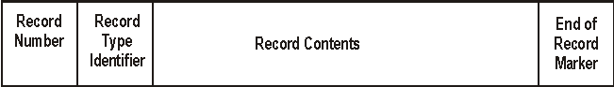

Figure H1 – Record Structure

The **Record Number** is unique for each record in a data file. For those record types that require a unique identifier uID (as defined in ISO 19152) the **Record Number** serves as the uID with the namespace corresponding to the data file. Other records that do not need a uID also use the same **Record Number** field. This second use of the record numbers does not conflict with the uID numbers since all records have unique numbers.

* + - 1. Delimiters

In order for the fields within a record to be clear there need to be explicit delimiters. Allowing for variable length data fields requires that the delimiters be imbedded in the data. This requires some special characters and data strings to be reserved[19]. These delimiters must be printable[20] characters that can be seen in the text. If in the very rare case that a character string appears in the data that mimics a delimiter an escape mechanism is required to allow the rare occurrence to be expressed.

The delimiters identified are:

|  |  |
| --- | --- |
| **Tab (character Hex Code 9[21])** | **- Field Separator** |
| **= (character Hex Code 3D)** | **- Sub-field Separator** |
| **, (character Hex Code 2C)** | **- Sub-sub-field Separator** |
| **/ (character Hex Code 2F)** | **- Lat / Long Separator** |
| **Tab<EOR>CR (character Hex Code 15)** | **- End of Record Indicator** |
| **Tab Tab<EOF>CR** | **- End of File Indicator** |

The Tab character is the primary delimiter. If a Tab character must be inserted in a text string (and there is very little reason to do so) then it can be replaced by the string **<TAB>**.

The tab character delimits fields. In some cases there is a need to identify sub-fields. In this case the delimiter **=** can be used. The character **=** would separate a sub-field header from a value. The character **/** would separate two numbers in a numeric attribute such as a Latitude and Longitude. The use of subfields is limited to certain record types as identified below. Some subfields, such as attributes may take on a string of attribute values. These attribute values may be separated by a sub-sub-field delimiter **,** .

Figure H2 shows the general record structure from Figure H1 as a text string with imbedded Tab character delimiters.

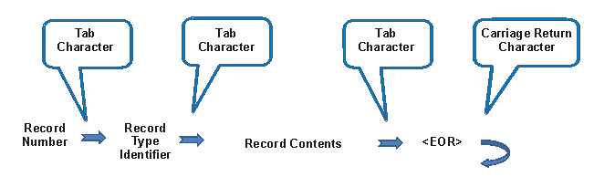

Figure H2 – Delimited Record

This record structure has the advantage that it can be read by common office word processing software and easily read into a spread sheet. It is often called a "Tab delimited file". The only variation is the allowance for Carriage Return characters within the body of the record for certain types of records that contain an unstructured text field. Also to make the information more readable extraneous SPACE characters should be ignored except in attributes that are character strings (text).

* + - 1. Encoded Records

The following Records are identified:

* Feature Type Record
* Information Object Record
* Spatial Attribute Record
* Spatial Source Record
  + - * 1. Feature Type Record

The Feature Type Record allows one to express the features and attributes identified in Appendix G.3.1 Feature Objects together with the attributes from Appendix G.3.3 Feature Attributes. The listed values from Appendix G.3.5 provide attribute values. Figure H3 shows a feature record with the type Feature separated from the Feature code by the sub-field delimiter **=**. The attribute field contains an attribute code from the feature catalogue followed by a sub-field delimiter and an attribute value. The attribute field can repeat and each field is separated by a **TAB** character. The feature code and attribute code can be either the six character "alphaCode" or the "CamelCaseCode" or an alias. Since they are unique and non-interfering they could be mixed with some records using one kind and other records using the other, but good practise would be to use only one kind in a data set.

The ID is an integer number encoded as a text string assigned uniquely to each record in the file.

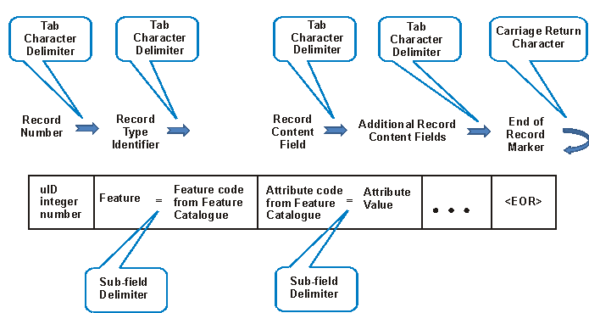

Figure H3 – Feature Record

The way this would look in a printed text would be very readable. For example:

1023 Feature= ExclusiveEconomicZone verdom= water_surface, water_column, seabed_surface, subsoil <EOR>

The space between the "1023" and "Feature= ExclusiveEconomicZone" and " verdom= water_surface, water_column, seabed_surface, subsoil" and "<EOR>" are TAB characters.

* + - * 1. Information Object Record

The object structure for legal objects derived from ISO 19152 makes use of the Information Objects defined in Appendix G.3.4. The record structure follows the same form. Figure H4 shows an Information Object record separated from the Information Object (Information) code by the sub-field delimiter **=**. The attribute field contains an attribute code from the feature catalogue followed by a sub-field delimiter and an attribute value.

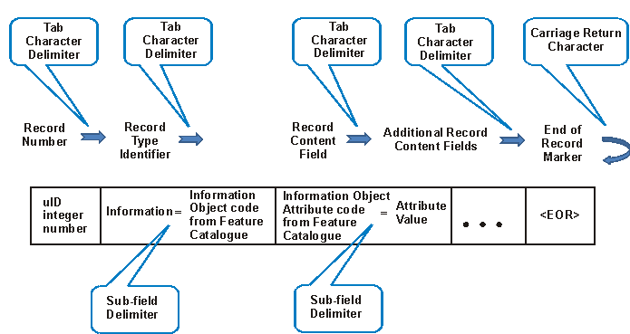

Figure H4 – Information Object Record

An example would be an Information Object record with the type "S121Right" (shown as "Right" using the alias name) and the attribute "RightType" with the value "soverignRight". In this example other attributes such as a mandatory reference to the Party object are not shown, nor are the many possible optional attributes. The alias names are used for the objects and attributes where it makes the data more readable.

1079 Information= Right RightType= soverign_Right <EOR>

* + - * 1. References Between Objects

References may occur between Information Object Records implementing the Rights, Restriction, Responsibility and Party structure and with Feature Object Records. These references make use of the ID on the record types. The references are treated as another attribute with the attribute type defined by the role identified for the relation. These relations are given in the model such as is illustrated in Figure E12. An example would be an S121_Right object record referencing an associated A121_AdministrativeSource record by the rrrSource relation. The example is shown again with the relation rrrParty implemented as an attribute with the ID (partyID also the Record Number of the party record) as the attribute value.

1079 Information= Right type= Soverign_Right rrrParty=2017 <EOR>

The use of record number pointers is readable, though it may be tedious to follow. Good practise would be to make objects that are closely related to other objects follow the other object.

The list of relation attributes are:

* rrrSource - Reference from Information Object Records of type S121_Right, S121_Responsibility or S121_Restriction to S121_AdministrativeSource Record.
* rrrParty - Reference from Information Object Records of type S121_Right, S121_Responsibility or S121_Restriction to S121_Party Record.
* members - Reference from Information Object Records of type S121_Party Record to S121_GroupParty.
* conveyancer Reference from S121_AdministrativeSource to S121_Party.
* geometry Reference from Feature Object (BAUnit) to S121_SpatialAttributeType.
  + - * 1. Spatial Attribute

The S121_SpatialAttributeType is a separate record type that takes on the spatial geometry defined in S-100. The type of geometry is identified as an attribute. The geometry data values are expressed as numerical values. This is illustrated in Figure H5.

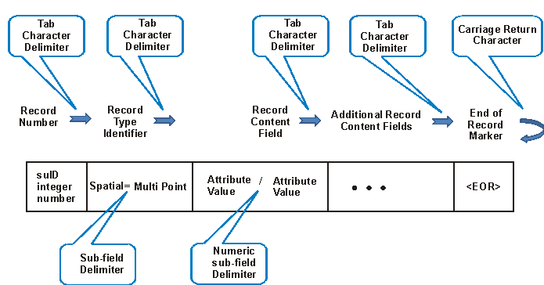

Figure H5 – Spatial Object Record

The linkage to the spatial object is by reference through an attribute from the feature (S121_FeatureUnit) object.

An example of a set of limit points is shown below as a LimitPoint record followed by a Spatial record. The linkage is through the attribute "geometry" with a reference to the Record Number. In this example the coordinate positions are a structured latitude/longitude position.

749 Feature= LimitPoint pointType= defined geometry=750 <EOR>

750 Spatial= pointSet 52°15′30″N./55°32′58″W 52°26′37″N/55°37′40″W 52°40′20″N/55°44′43″W … <EOR>

Note that a long list of positions is very human readable and looks like the text found in treaties and legal documents, with a little additional structure.

The spatial attribute types allowed are given in S-100, not in the feature catalogue. They are shown below with the associated geometry entity from the ISO 19107 Spatial Schema [5] standard:

point : GM_Point

pointSet : GM_MultiPoint

curve : GM_Curve

surface : GM_Surface

coverage : CV_Coverage

arcByCentrePoint : GM_Curve (to define an arc by centre)

circleByCentrePoint : GM_Curve (to define a circle)

* + - * 1. Source and Spatial Source

Every object may include a reference source. For Right, Restriction, Responsibility and Party objects this is done through the "Source" information object (S121AdministrativeSource) which behaves like other information objects described in the record shown in H.2.1.2.2.

Spatial objects may also describe a source. This is an additional record type referenced through attribute "suSource" describing the relationship from the Spatial record to the SpatialSource record.



Figure H6 – Spatial Source Record

There are many attributes that can describe source. These are identified in the object S121_Source and in the object S121_SpatialSource as attributes. These are not attributes described in the Feature Catalogue, but in the model, and in the ISO standards. See Figures E8 and E9 where these attributes and their values are described. The encoding format operates the same way with the attribute name and the attribute value.

The example shows the spatial source record with the attribute "organizationName" (from CI_ResponsibleParty) and "acceptance" date, describing the source and date.

291 SpatialSource organizationName= Geoscience Australia acceptance=2016:02:03 <EOR>

* + - * 1. Versioned Objects

All of the S121 objects may be versioned. Versioning is simply another attribute, defined in the feature catalogue as an attribute that can be used with any object.

* + - * 1. End of File

This record oriented format needs an explicit end of file. This is shown in Figure H7.

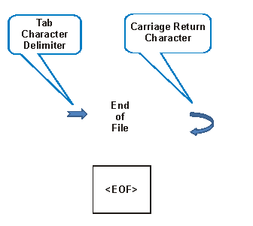

Figure H6 – End of File Record

1. Bibliography

**(Informative)**

1. IHO S-100 IHO Universal Hydrographic Data Model (June 2015)
2. ISO 3166-1:1997 - Codes for the representation of names of countries and their subdivisions,
3. ISO 19101:2003 - Geographic Information – Reference model,
4. ISO 19103:2003 - Geographic Information – Conceptual schema language,
5. ISO 19107:2003 - Geographic Information – Spatial Schema,
6. ISO 19110:2005 - Geographic information – Methodology for feature cataloguing,
7. ISO 19115:2003 - Geographic information – Metadata
8. ISO 19128:2005 - Geographic information – Web map server interface,
9. ISO 19131:2007 - Geographic Information – Data product specifications,
10. ISO 19136:2007 - Geographic Information – Geography Markup Language,
11. ISO 19142:2010 - Geographic information – Web Feature Service
12. NIMA Technical Report TR8350.2 Department of Defense World Geodetic System 1984, Its Definition and Relationships with Local Geodetic Systems, Third Edition, National Geospatial-Intelligence Agency.
13. OGC Catalogue Service for the Web <http://www.opengeospatial.org/standards/cat>
14. OGC (Keyhole Markup Language) KML 2.2 Document 07-147r2 <http://www.opengeospatial.org/standards/kml>
15. EPSG Geodetic Parameter Registry Version: 8.3.3, <http://www.epsg-registry.org/>.
16. WC3 Extensible Markup Language (XML) <https://www.w3.org/XML/>

1. The normative reference is to the base ISO 19115:2003 metadata standard. Although ISO 19115-2 exists for Imagery, this part is not applicable here. The base ISO metadata standard has been revised. The revised standard ISO 19115-1:2014 is backward compatible with ISO 19115:2003 with respect to the metadata elements used in this standard.
2. Future development is pending in Web portrayal.
3. In addition to GML, the Google Keyhole Markup Language (KML) has been identified as an encoding.
4. As is required by a Treasury Board Directive, by April 2014. This will link to the DFO Aggregate Metadata Register (under development).
5. Water Level References may sometimes be used as non-geodetic vertical datums.
6. International Standard ISO 19152:2012 Geographic information -- Land Administration Domain Model (LADM), Clause 1 <https://www.iso.org/obp/ui/#iso:std:51206:en>
7. UNCLOS UN Convention on the Law Of the Sea
8. ISO 19152 LADM clause 4.1.13
9. ISO 19152 LADM clause 5.3
10. IHO Dictionary, S-32, 5th Edition, 390
11. IHO Dictionary, S-32, 5th Edition, 393
12. IHO Dictionary, S-32, 5th Edition, 2484
13. IHO Dictionary, S-32, 5th Edition, 5360
14. IHO Dictionary, S-32, 5th Edition, 993
15. IHO Dictionary, S-32, 5t h Edition, 1723
16. IHO Hydrographic Dictionary, S-32, 5th Edition, 227
17. The current IHO register and most of the commercial tools are S-57 compatible. The format of the feature catalogue can easily be updated to align with the newer style used in S-100 when the IHO register is updated.
18. KML was originally developed by Google but has recently been standardized by the Open Geospatial Consortium (OGC).
19. This is the same mechanism used in XML, but the selection of delimiters is different.
20. The ISO standard character code includes a set of unprintable delimiter's, and these have been used in a number of record oriented data formats. These unprintable "invisible" characters cannot be used here because a human reader cannot see them and would perceive that something was going on "behind in the background". Everything must be explicit in a legal environment. TAB has a visual effect and therefore can be seen.
21. Character codes are in accordance with ISO 646 the basic international character set, which is equivalent to ASCII the American Standard Code for Information Interchange supported by all modern computing systems. ISO 646 also forms the base page of ISO 10646 equivalent to the Unicode "Universal Character Set" and the UTF 8 encoding used by Web Services.